PROJECT REPORT OF

INDIRA GANDHI NATIONAL OPEN UNIVERSITY

BCSP-064

ON

E-LEARNING MANAGEMENT SYSTEM

By

Lavanya Goyal (176231510)

UNDER GUIDANCE

OF

Mr. Suman Sankar Jha

Submitted to the Shyamlal College (0769) in

Partial fulfilment of the Requirements for the degree of

BachelorOf

Computer Applications



Indira Gandhi National Open University

MaidanGarhi

New Delhi-110068

Table of Content

|  |  |  |
| --- | --- | --- |
| S.NO. | CONTENT | PAGE NO. |
| 1. | INDEX | 1 |
| 1. | SYNOPSIS | **2-38** |
| 2. | PROJECT REPORT | **39-210** |

Project Proposal (Synopsis)

Synopsis Table of Content

|  |  |  |
| --- | --- | --- |
| S.NO. | CONTENT | PAGE NO. |
| 1. | Title of the Project | 4 |
| 2. | Introduction and Objectives of the Project | 5-6 |
| 3. | Project Category | 7 |
| 4. | Analysis | 8-14 |
| 5. | A complete structure | 15-35 |
| 6. | Tools / Platform, Hardware and Software Requirement specifications | 36 |
| 7. | Are you doing this project for any Industry/Client? | 37 |
| 8. | Future scope and further enhancement of the project. | 37 |
| 9. | Bibliography | 38 |

1. Title of Project

E-Learning Management System



2.1 Introduction of the Project

The "E-learning Management System" has been developed to override the problems prevailing in the practicing manual system. This software is supported to eliminate and in some cases reduce the hardships faced by this existing system. Moreover this system is designed for the particular need of the company to carry out operations in a smooth and effective manner.

The application is reduced as much as possible to avoid errors while entering the data. It also provides error message while entering invalid data. No formal knowledge is needed for the user to use this system. Thus by this all it proves it is user-friendly. E- Learning Management System, as described above, can lead to error free, secure, reliable and fast management system. It can assist the user to concentrate on their other activities rather to concentrate on the record keeping. Thus it will help organization in better utilization of resources.

Every organization, whether big or small, has challenges to overcome and managing the information of Student, Assignment, QUIZ, CLASS, and QUESTION. Every E-learning Management System has different Assignment needs, therefore we design exclusive employee management systems that are adapted to your managerial requirements. This is designed to assist in strategic planning, and will help you ensure that your organization is equipped with the right level of information and details for your future goals. Also, for those busy executive who are always on the go. These systems will ultimately allow you to better manage resources.

2.2 Objective of the Project

The main objective behind this project is to provide a user friendly environment to provide knowledge and give everyone a chance to learn, irrespective of where they are, provided they register themselves with the system.

The main features that the system provides can be made use of, once the registered people select their interested subject and take a starter test. This helps to establish incremental learning process. After taking this, based on their level of competence, they can take available tutorials, take online tests and also discuss an issue/topic by posting messages in the discussion forum. Along with this they can also take real time simulations of the most widely known competitive exams.

Project on E-learning Management System is to manage the details of Assignment, Student, TEACHER, QUIZ, and QUESTION. It manages all the information about Assignment, CLASS, QUESTION, and Assignment. The project is totally built at administrative end and thus only the administrator is guaranteed the access. The purpose of the project is to build an application program to reduce the manual work for managing the Assignment, Student, CLASS, and TEACHER. It tracks all the details about the TEACHER, QUIZ, and QUESTION.

3. Project Category:

This project **“LEARNING MANAGEMENT SYSTEM*”*** falls in the category of Relational Database Management System (RDBMS) project**.** This project aims to provide improved functionality and better user interactive environment. With **“HTML,CSS,JS,jQuery and BootStrap”** as a Front End and JSP, Servlet and MySQL as a Back End.

HTML provides a structure of our site while CSS provides styling and JS for validation and jQuery for slider and animations or bootstrap providing the responsiveness, moodles and etc. MySQL on the other hand, provides better functionality and effectiveness to the system while maintaining the database records. And JSP and Servlet act as a bridge between the front-end and the database. All the tables are being used in this project are inter-related and fully normalized, so this project “LEARNING MANAGEMENT SYSTEM” is a “Web Based Application Project” using Relational Database Management System (RDBMS).

**4. Analysis:**

STUDENT

Get Result

Add/Delete Course

E-LEARNING

MANAGEMENT

SYSTEM

FACULTY

ADMIN

Add/Delete Instructor

Manage Student/Tutor

Registration

Register

Add Forum

Check Grades

Take Course, Exam

And Submit

Assignments

View Students

Get Results

Gives Tests,

Assignments and Exams

Upload Course Material

**: - Zero Level DFD (CONTEXTUAL DIAGRAM)**

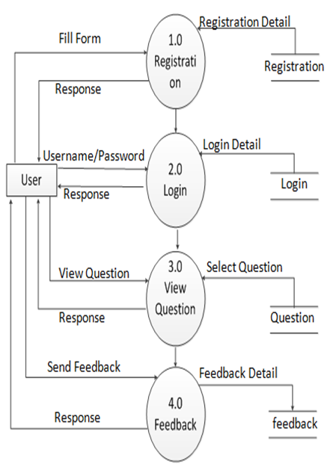

**: - FIRST LEVEL DFD FOR USER**

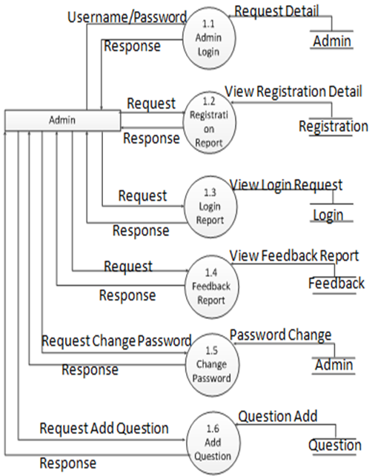

**: - FIRST LEVEL DFD FOR ADMIN**

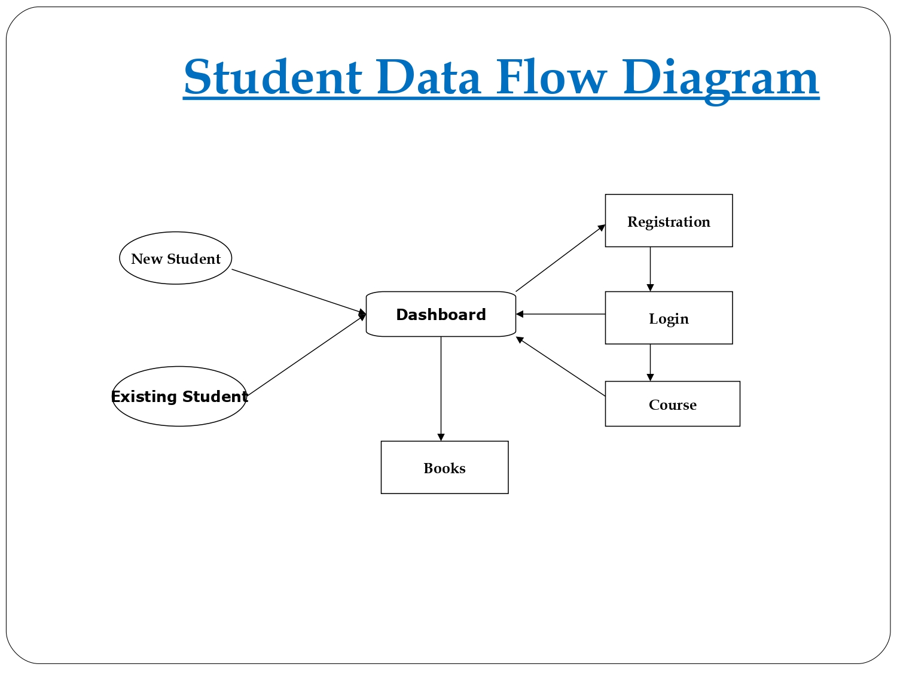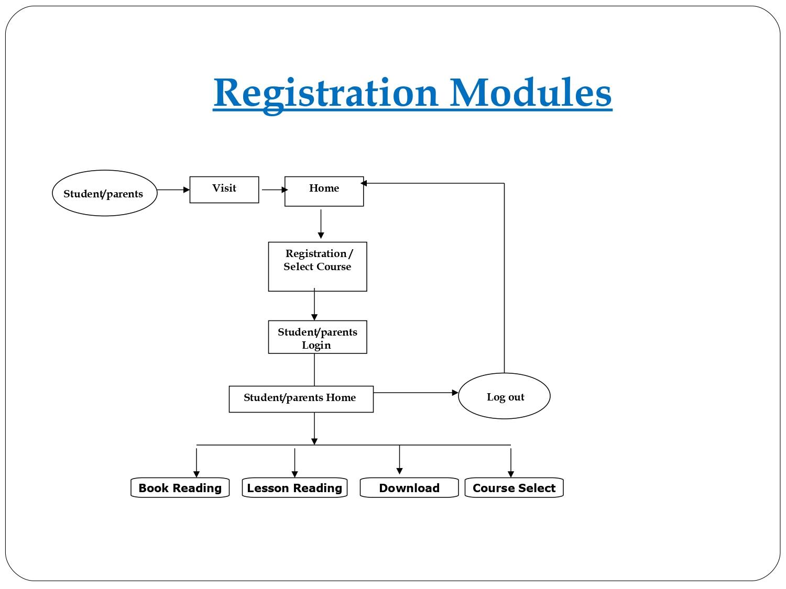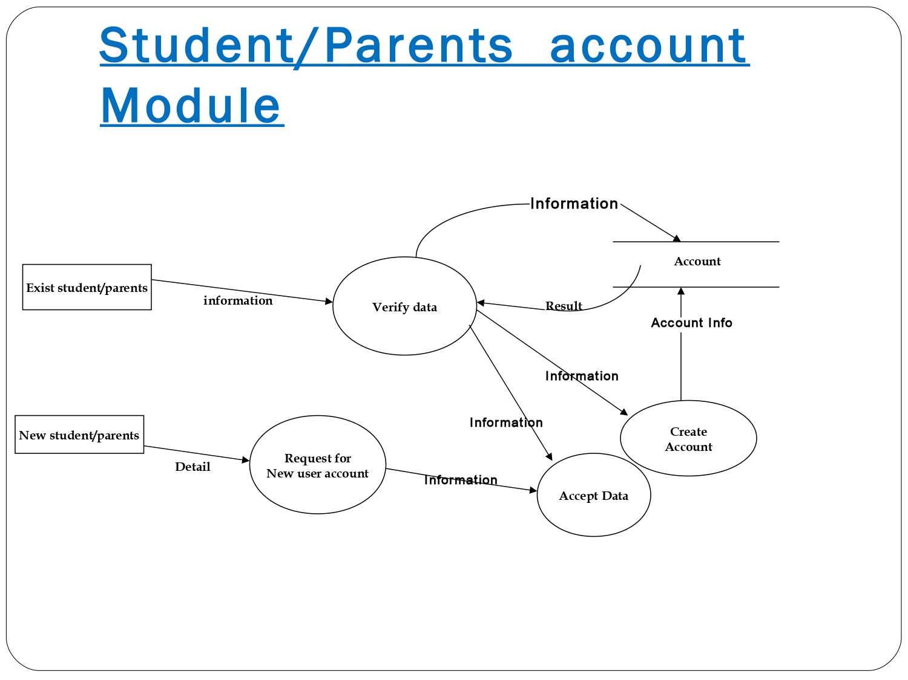

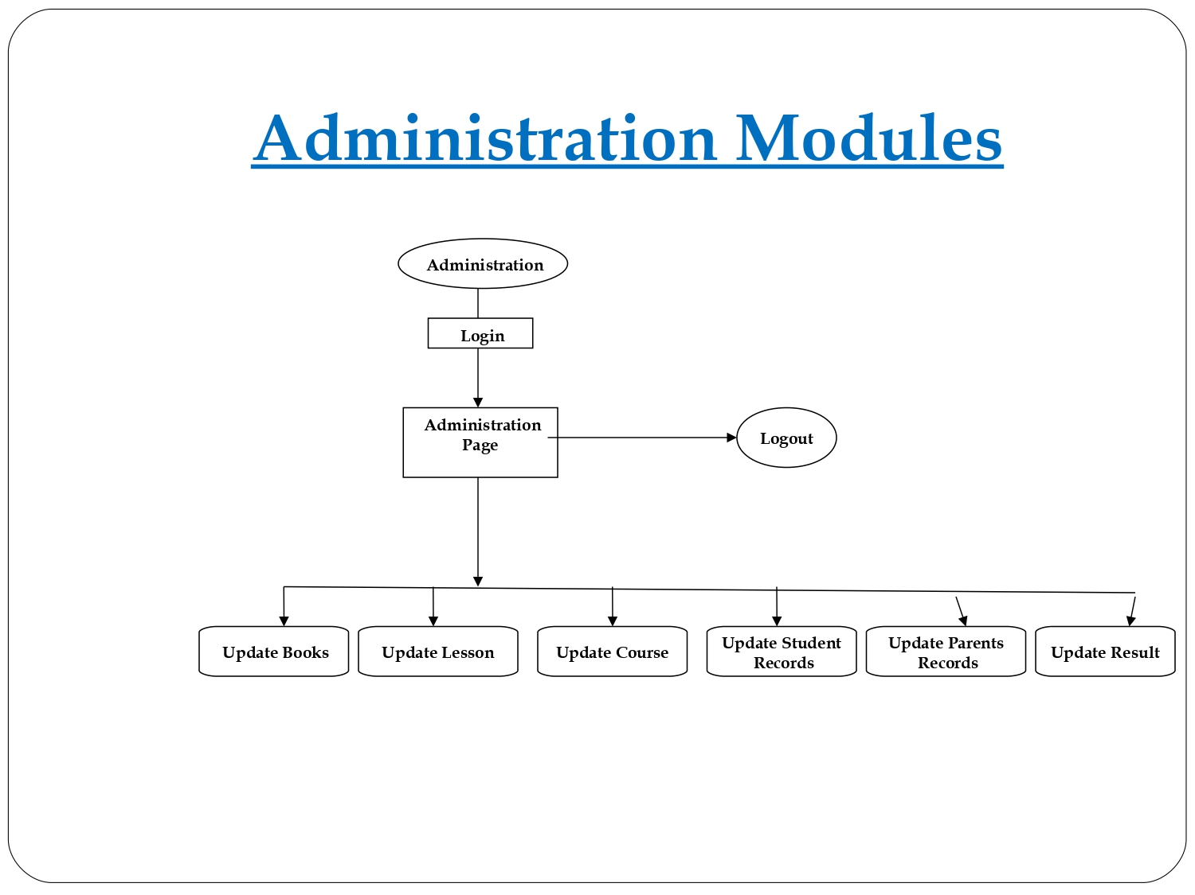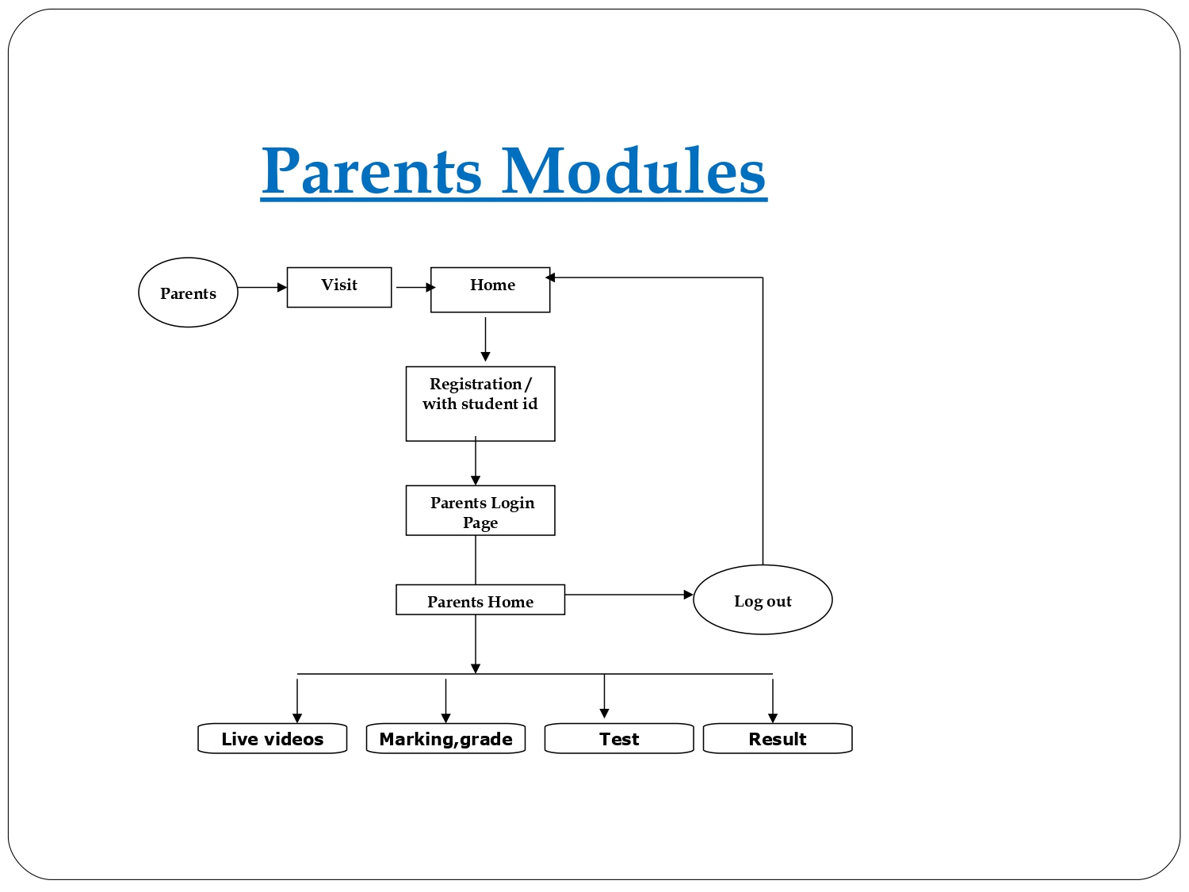

**: - SECOND LEVEL DFD**

**4.2 E-R Diagram**

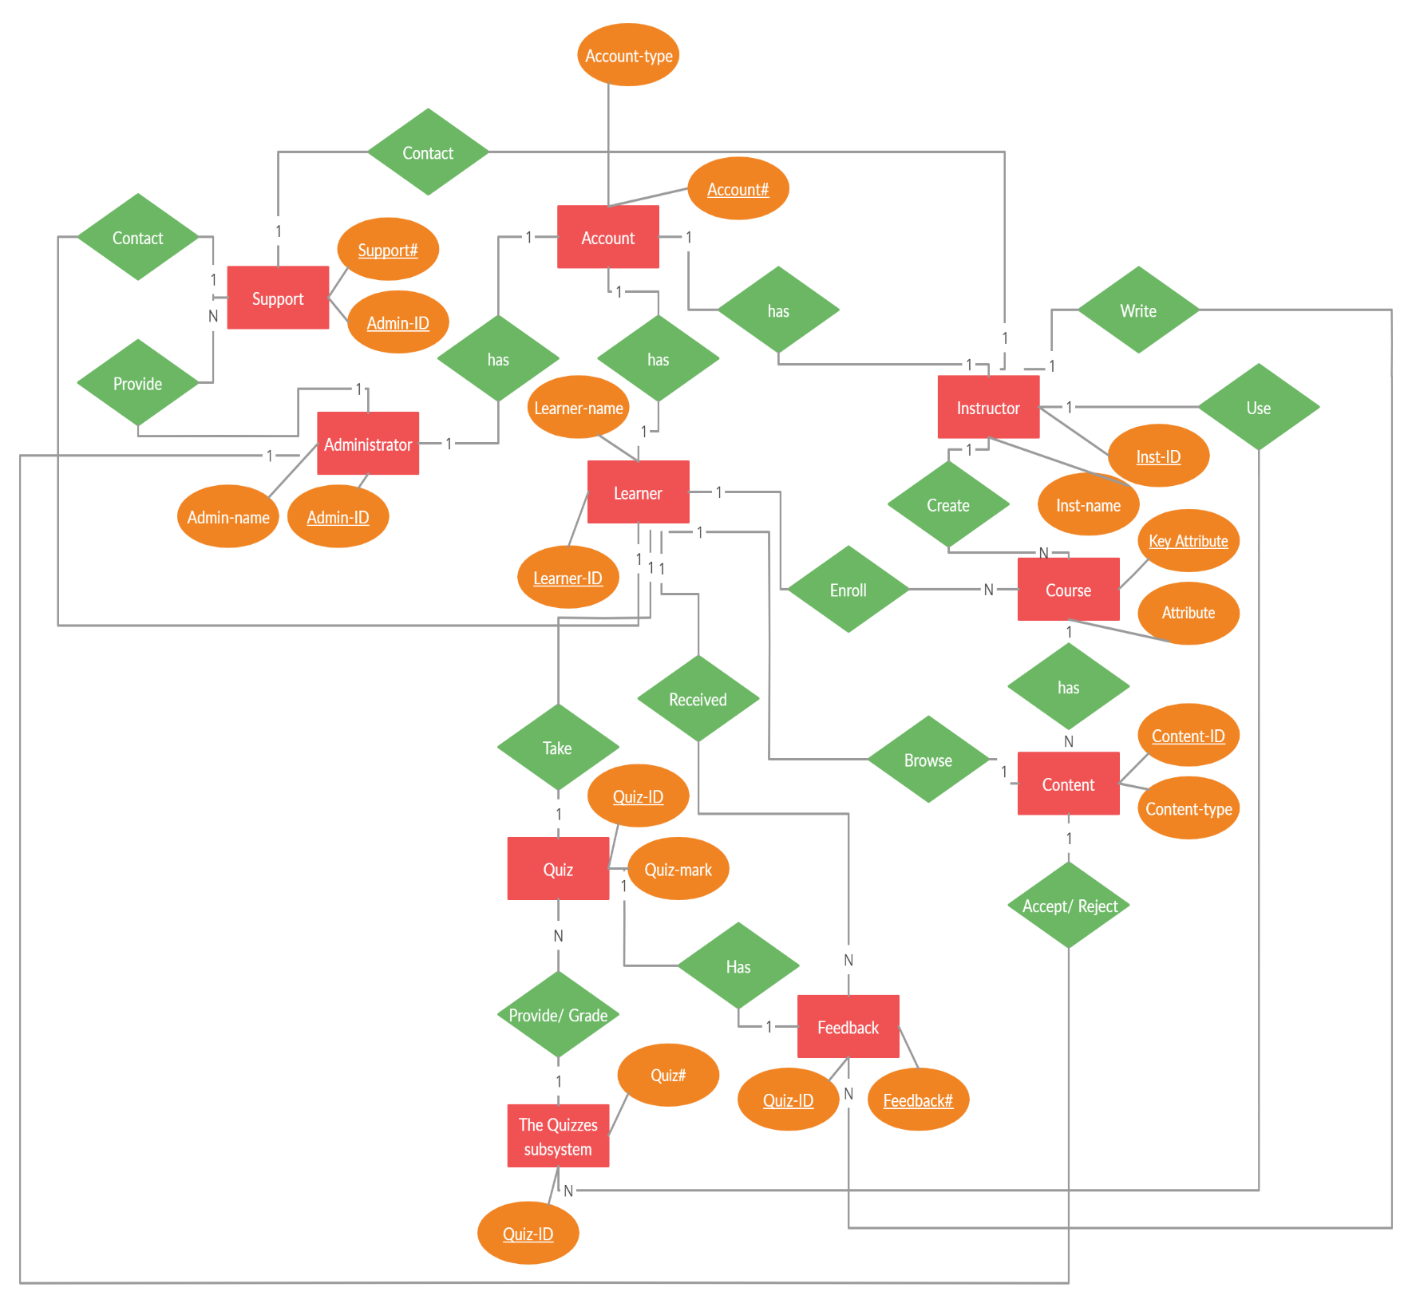

5. A complete structure

**5.1 NUMBER OF MODULES AND THEIR DESCRIPTION**

The E-learning management System Project Core functional elements:

*Student management Module, Faculty management module, Developer/Admin management module.*

1. **Developer/Admin Management module**

The system administrator will be able to perform the following functions:

* Edit his own profile (credentials and personal details).
* view the list of pending users and approve user registration with tutor or student permission
* Have privileges to activate or deactivate course or user, if and when required.
* Create, edit or delete department structure and add or remove programmes.
* Create, edit or delete course structure and assign learning resources.
* Define course activities (forum, quizzes, chat, assignments, etc.).
* Monitors users and oversees variety of department and course’s activities.
* Trains department personnel and students to use the online web application.

1. **Faculty Management Module**

Can perform the following functions:

* Enable manual self-registration and redirection to guest user’s dashboard.
* Access tutors’ dashboard after admin approves registration.
* View and update his own profile (sign in credentials and personal details).
* View registered student and add or remove one or group of students to the course.
* View students’ report and provide remarks.
* Create course and set a unique enrolment key.
* Create, edit or delete course structure and assign learning resources.
* Define course activities (forum, quizzes, assignments, etc.)
* Display teaching feedback.

1. **Students management Module**

The students are regular student or special student for short term training. The student users are permitted to perform following functions:

* Enable manual self-registration and redirection to guest user’s dashboard.
* Access student’s dashboard after admin approves registration.
* View and update his own profile (sign in credentials and personal details).
* View all the list of courses and their description.
* Subscribe to the courses after entering unique enrolment key and then view course’s assigned content resources.
* Participate in discussion forum and chat.
* Test the knowledge of subject through attempting numerous quizzes.
* View grades and remarks from tutor.
* Provide feedbacks to tutor.

**Other Sub Modules:**

* Admin login: Admin is the one who administers the system by adding or removing e-books into and from the system respectively.
* User login: Students have to register themselves into the system to create an account. After registering successfully, they can then login into the system by entering 10 digit mobile number and their email id.
* Categories of books: The e-books are organized according to categories. Thus this classifies the books and students can view the list of references books available.
* View Videos: Students can watch videos with ease due to efficient streaming on cloud infrastructure
* Search option: Students can even search for books according to subjects and authors.
* Students can then download the required e-book on selecting it.
* Feedback form: Students can even provide their feedback into the system by filling up feedback form.

5.2 DATA STRUCTURES OF PROJECT

*AI = AUTO INCREMENT

*PK = PRIMARY KEY

*FK = FOREIGN KEY

|  |  |  |
| --- | --- | --- |
| **Students** | | |
| **Field_name** | **Data_Type** | **Constraints** |
| **Student_Id** | **VARCHAR(20)** | **Pk / AI** |
| **Student_Course** | **VARCHAR(20)** | **NULL** |
| **Student_Email** | **VARCHAR(20)** | **unique/not null** |
| **Date_of_joining** | **DATE** | **NULL** |
| **Student_Name** | **VARCHAR(20)** | **NULL** |
| **Student_fathername** | **VARCHAR(20)** | **NULL** |
| **Student_DOB** | **DATE** | **NULL** |
| **Student_mobile** | **VARCHAR(20)** | **NULL** |
| **Student_photo** | **blob** | **NULL** |
| **Student_Password** | **VARCHAR(20)** | **not NULL** |

|  |  |  |
| --- | --- | --- |
| **COURSES** | | |
| **Field_name** | **Data_Type** | **Constraints** |
| **REGISTRATION_ID** | **VARCHAR(20)** | **PK/AI** |
| **COURSE_name** | **VARCHAR(20)** | **NULL** |
| **COURSE_time** | **VARCHAR(20)** | **NULL** |
| **COURSE_type** | **VARCHAR(20)** | **NULL** |
| **course_description** | **VARCHAR(20)** | **NULL** |

|  |  |  |
| --- | --- | --- |
| **COURSE_TUTOR** | | |
| **Field_name** | **Data_Type** | **Constraints** |
| **Teacher_id** | **VARCHAR(20)** | **Pk/AI** |
| **Teacher_name** | **VARCHAR(20)** | **NULL** |
| **Teacher_Email** | **VARCHAR(20)** | **not null/unique** |
| **Teacher_qualification** | **VARCHAR(20)** | **NULL** |
| **Teacher_joining** | **DATE** | **NULL** |
| **Teacher_DOB** | **DATE** | **NULL** |
| **Teacher_photo** | **BLOB** | **NULL** |

|  |  |  |
| --- | --- | --- |
| **Student_Course_ENROLLMENT** | | |
| **Field_name** | **Data_Type** | **Constraints** |
| **Registration_id** | **VARCHAR(20)** | **PK/AI** |
| **Student_Id** | **VARCHAR(20)** | **FK** |
| **Course_joining_date** | **DATE** | **NULL** |
| **Course_type** | **VARCHAR(20)** | **NULL** |

|  |  |  |
| --- | --- | --- |
| **Quiz** | | |
| **Field_name** | **Data_Type** | **Constraints** |
| **REGISTRATION_id** | **VARCHAR(20)** | **F.K** |
| **QUIZ_ID** | **VARCHAR(20)** | **P.K** |
| **Quiz_total_number** | **VARCHAR(20)** | **NULL** |
| **Quiz_solution** | **VARCHAR(20)** | **NULL** |
| **Quiz_mark** | **VARCHAR(20)** | **NULL** |
| **Quiz_rank** | **VARCHAR(20)** | **NULL** |

|  |  |  |
| --- | --- | --- |
| **SUPPORT** | | |
| **Field_name** | **Data_Type** | **Constraints** |
| **TICKET_Id** | **VARCHAR(20)** | **PK/AI** |
| **student_name** | **VARCHAR(20)** | **NULL** |
| **student_id** | **VARCHAR(20)** | **NULL** |
| **Contact_time** | **date** | **NULL** |
| **Problem** | **VARCHAR(20)** | **NULL** |
| **student_id** | **VARCHAR(20)** | **FK** |

|  |  |  |
| --- | --- | --- |
| **ADMIN** | | |
| **Field_name** | **Data_Type** | **Constraints** |
| **ADMIN_ID** | **VARCHAR(20)** | **PK/AI** |
| **ADMIN_TYPE** | **VARCHAR(20)** | **NULL** |
| **ADMIN_Password** | **VARCHAR(20)** | **NOT NULL** |

5.3 PROCESS LOGIC FOR EACH MODULE

Here in the project there will be a number of modules and each module is based on respective process logic. The process logic will be both, batch process and on line processing for the respective modules and related tables. For different query purpose the logic will be online type. But different updating processes will be batched type.

Admin manages user and its role assignment. Admin can display the list of courses and its detail information. Admin enables tutor and student’s admission and support them in troubleshooting simple account usage problem. They monitor users and oversee variety of department and course’s activities. Admin trains department personnel and students to use the web application.

The admin dashboard providing management and administration of user, courses, programmes, department, results and the content resources is represents in Admin’s Dashboard. As shown here:

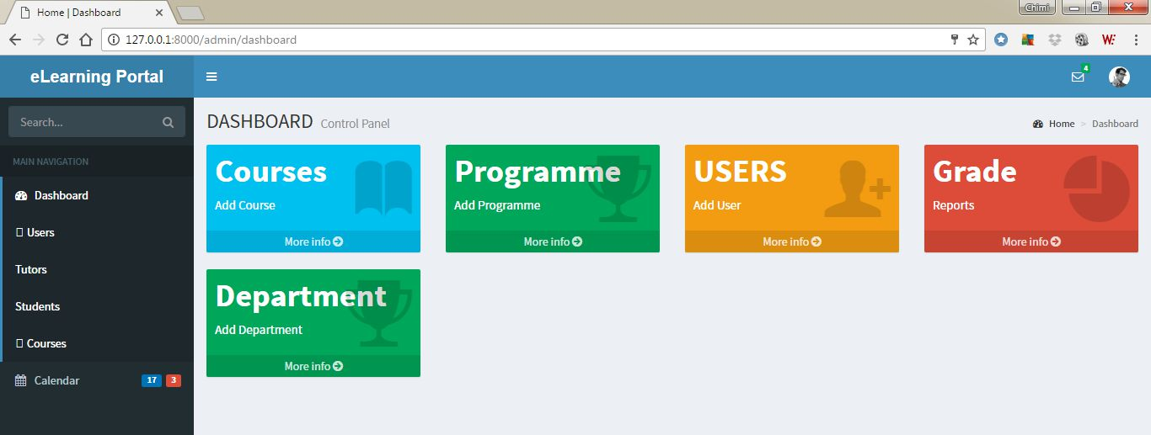

The system provides simplified course list with edit and delete action buttons. It does not require a person to be computer elite now to create and share learning materials. An individual does not need to remember the complex mechanism and thus, an individual unfamiliar with computer application can simply access public resources easily with one click of button.

An ER-diagram that provided the basis to implement normalized database structure for the e-learning system is presented above.

A use case diagram identifying three actors namely Admin, Tutor and Students is also presented above. The associated functionalities and the required processes to achieve goals are captured in this diagram.

The Course page includes general information such as hour per day commitment required to complete the course, at which semester is the course being taught and how many ECTs credit does the course have. It displays button to add the content to the course. Each content can be edited or deleted and the various resources (learning materials, forum, assignments, quizzes, etc.) can be assigned to the contents. Admin can view course page for all the courses. However Tutor has privilege to access this page for only the courses that he has created.

The contents do not particularly follow some content structure. It allows easily customizable course structure according to the interest of a university or institution. The course page can be implemented by the university with basic course structure that includes Syllabus, Lectures, Labs Tests, Assignments and Forum.

Planning and scheduling

**PROJECT CONTROL SYSTEMS:**

The purpose of controlling a project is to monitor the progress of the activities against the plans, to ensure that the goals are being approached and eventually achieved. Other aspects of control are to detect, as soon as possible, when deviations from the plan are occurring so that corrective action may be taken. Most project control techniques are based on breaking down the goal of the project into several Intermediate goals. Each Intermediate goal can turn be broken further. This process can be repeated until each goal can turn be broken further. This process can be repeated until each goal is small enough to be understood. We can plan for each goal individually – its resource requirements, assignments of responsibility, scheduling, etc.

Two general scheduling techniques are GANTT charts and PERT Charts as discussed below.

**GANTT CHART:**

A bar chart is perhaps the simplest form of formal project management. The bar chart also known as GANTT CHART is used almost exclusively for scheduling purpose and therefore controls only the time dimension of projects. Gantt chart is a project control technique that can be used for several purposes, including scheduling, budgeting and resource planning. A Gantt chart is a bar chart, with each bar representing an activity. The bars are drawn against a time line. The length of each bar is proportional to the length of time planned for the activity. Gantt chart can take different forms depending on their Intended use. They are best for resource scheduling. Gantt charts are useful for resource planning and scheduling. Gantt chart they show the tasks and their duration clearly. However they do not show Inter task dependencies plainly.

**PERT CHART:**

Unlike the bar chart, PERT can be both cost and a time management system PERT is organized by events and activities or tasks. PERT has several advantages over bar charts and is likely to be used with more complex projects. One advantage of PERT is that it is a scheduling device that also shows graphically which tasks must be completed before others are begun. PERT enable the calculation of a Critical path. Each path and cost associated with each task along a path is calculated, and the path that requires the greatest amount of elapsed time is the Critical path. Calculation of the critical path enables project manager to monitor this series of tasks more closely. PERT controls time and cost during the project the project and also facilities finding the right balance between completing a project on time and completing it within budget. PERT recognizes that projects are complex that some task must be completed before other can be started and that the appropriate way to manage a project is to be defined and control each task. Because projects often fall behind schedule, PERT is designed to facilitate getting back schedule. PERT is based in part on the premise that subjective estimates of the total completion time for a project are usually greatly inferior to the sum of subjective estimates for each task. The PERT chart gives a graphical representation of this information.

**Advantages of PERT**

* It forces the manager to plan.
* It shows an Interrelationship among the tasks in the project, in particular, clearly identifies the critical path of the project, thus helping to focus on it.
* It exposes all possible parallelism in the activities and thus helps in allocating resources.
* It allows scheduling and simulation of alternative schedule.
* It enables the manager to monitor and control the project.

Despite these advantages, PERT is just a tool, and its use does not automatically guarantee the success of the project. Gantt chart can be derived automatically from PERT charts.

The charts are shown in figure A (Gantt chart) and B (PERT Chart).

**GANTT CHART**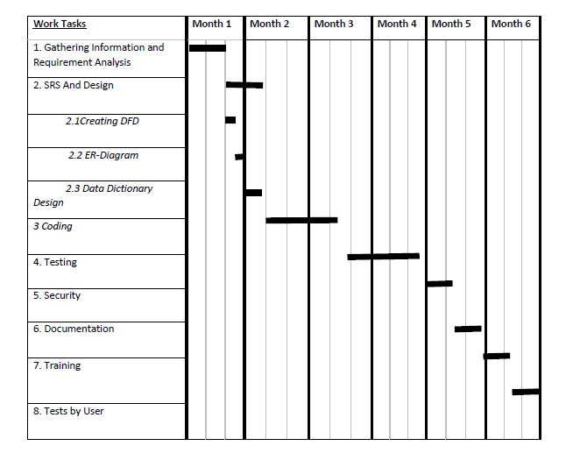

**Figure A: - GRANTT CHART**

PERT CHART

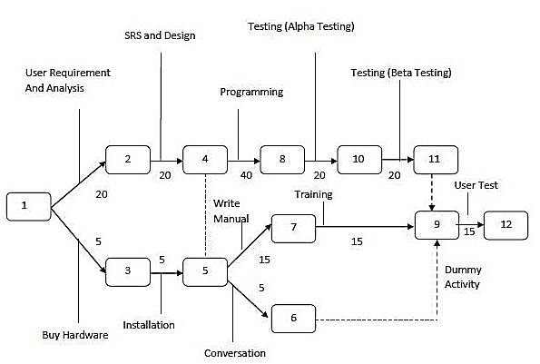

**Figure B: - PERT CHART**

SOFTWAR ENGINEERING APPROACH:

The field of software engineering is related to the development software in systematic manner unlike simple programs which can be developed in isolation and there may not be any systematic approach being followed. As there is large difference between programming and software engineering. As it provides models that lead to the production of well documented software in a manner that is predictable. For a mature process, it should be possible to determine in advance how much time and effort will be required to produce the final product. To develop successful software, I have to follow some models, which act as guidelines.

The model I have used is Waterfall Model or Classic Life Cycle. In this model first of all the existed system is observed. Then customer requirements are taken in consideration then planning, modelling, construction and finally deployment.

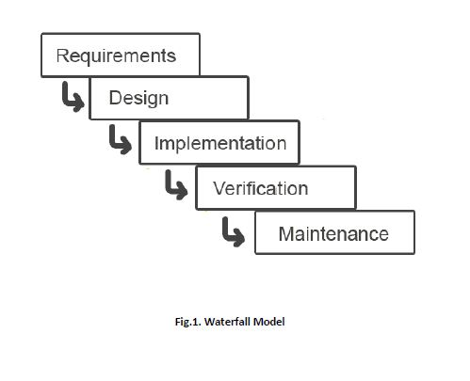

**Fig 1:- Waterfall Model**

SYSTEM ANALYSIS AND DESIGN:

System Analysis:

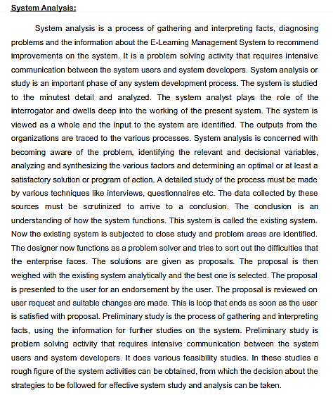

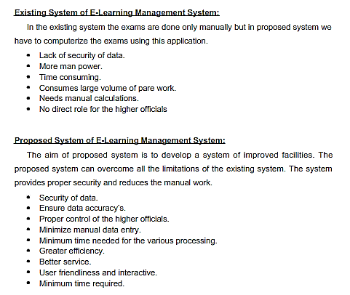

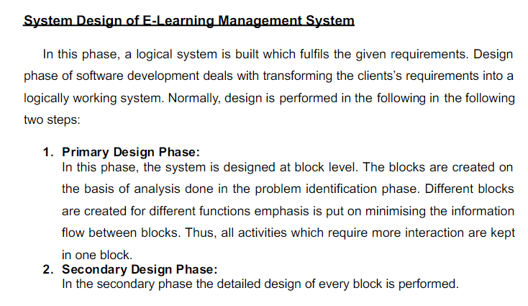

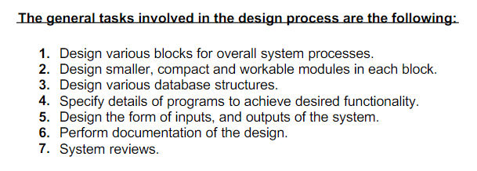

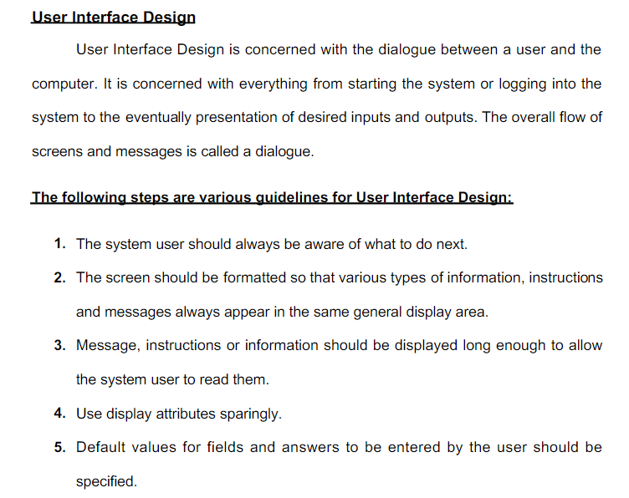

5.4 TESTING AND DEBUGGING:

Testing is the process of executing the program with the intent of finding errors and it establishes confidence that the program does what it is supposed to do. It can be done in many ways:

***Unit Testing:***It is testing of individual module. Before initiating unit testing, it must be ensured that the code is peer previewed.

***Integration Testing****:* It is performed after all the software units are combined together. The objective here is to test the software interfaces. Project team conducts the integration testing. Before entering integration testing, it may be ensured that code review and unit testing have been performed on the individual software modules.

**System Testing:** The software is compiled as product and then it is tested as a whole. This can be accomplished using one or more of the following tests:

* **Functionality testing** - Tests all functionalities of the software against the requirement.
* **Performance testing** - This test proves how efficient the software is. It tests the effectiveness and average time taken by the software to do desired task. Performance testing is done by means of load testing and stress testing where the software is put under high user and data load under various environment conditions.
* **Security & Portability** - These tests are done when the software is meant to work on various platforms and accessed by number of persons.
* **Regression Testing:** Whenever a software product is updated with new code, feature or functionality, it is tested thoroughly to detect if there is any negative impact of the added code. This is known as regression testing.

**Input Data and Validation of Project on E- Learning Management System**

* All the fields such as course , facility type are validated and does not take invalid values
* Each from for course, student ,quiz cannot accept blank fields
* Avoiding errors in data
* Controlling amount of input
* Integration of all the modules forms in the system
* Preparation of the test cases
* Preparation of the possible test data with all the validation checks
* Actual testing done manually
* Recording of all the reproduced error
* Modification done for the error found during testing
* Prepared the test result scripts after rectification of the errors
* Functionality of the entire module forms.
* Validations for user input
* Checking of the coding standards to be maintained during coding
* Testing the module with all the possible test data
* Testing of the functionality involving all type of calculation etc.

**5.5 REPORT GENERATION:**

Any project or program is required what input it is giving. It is the input, which matters the most and any managements, which is decided for computerization of pay bills for their organization. Spending some money on it does the project designing of the organization. So a cost analysis is also involved to see what benefits the organization can get out of the project.

The Input of the project **“ E-LEARNING MANAGEMENT SYSTEM** **”** has a Main Page containing the list of Different Forms i.e. admin/developer form, Teacher/faculty form, student form, login form, new user form, personal information form, reporting form, feedback form and many other forms. The Project also includes the Topic description of the Courses offered by Faculty/Admin and per course Fee/cost description, transaction report(s) of individual student and Teacher. The Current system has been made so versatile that any School/University/Organization can implement it.

Any project or program is required on what output it is giving. Output is compulsory for any organization for management to take the decision for computerization of their organization. Spending money on it, the organization needs in what respect the project can be benefited, which is possible by viewing the output. So a cost analysis is also involved to see what benefits the organization to give the output of the project.

The System has the facility to view different reports. It also contains the pages, which display the list of courses offered by our faculty/admin, their performances etc. which is the outputs of the project and our web Application also able to generates these types of records as follows :

* On different Pages it generates the report on course, student, quiz and etc.
* Provides filter reports on faculty assignment, course type etc.
* You can easily export pdf for the course, quiz, assignment and etc.
* Application also provides excel export for student, faculty, course type etc.
* You can also export the report into csv format for course, student and etc.

**6. TOOLS, SOFTWARE & HARDWARE REQUIREMENTS**

We have a wide range of options of languages. From these options we can choose appropriate platform/ tools and languages for development of the project. Some of these are as follows:-

Project Category: Web-Based Application

**SOFTWARE REQUIREMENTS:**

**IDE:** Eclipse oxygen or higher, VS Code.

**Front End:** HTML, CSS, JavaScript, AJAX, Bootstrap, jQuery

**Programming Language:** JAVA

**Back End:** JSP, Servlet, Hibernate

**RDBMS:** MySQL 8.0 or Higher

**Server:** Apache Tomcat 8.0 or Higher

**Browser:** Chrome, Firefox etc. (latest version)

**Operating System:** Windows, Linux, UNIX etc.

**HARDWARE REQUIREMENTS:**

**Processor:** Intel Pentium, Core duo or more

**RAM:** 2GB or more

**Cache:** 512 KB

**Hard-disk:** 50 GB hard disk recommended

**Monitor :** Normal Monitor  
**Mouse :** Normal Mouse

**Keyboard :** Normal Keyboard

**7. Are you doing this project for any Industry/Client?**

**Ans. NO.**

**8. FUTURE SCOPE AND ENHANCEMENT OF PROJECT**

In a nutshell, it can be summarized that the future scope of the project circles around maintaining information regarding:

* We can add printer in future.
* We can give more advance software for E-learning Management System including more facilities
* We will host the platform on online servers to make it accessible worldwide
* Integrate multiple load balancers to distribute the loads of the system
* Create the master and slave database structure to reduce the overload of the database queries
* Implement the backup mechanism for taking backup of codebase and database on regular basis on different servers

The above mentioned points are the enhancements which can be done to increase the applicability and usage of this project. Here we can maintain the records of Assignment and Student. Also, as it can be seen that now-a-days the players are versatile, i.e. so there is a scope for introducing a method to maintain the E-learning Management System. Enhancements can be done to maintain all the Assignment, Student, TEACHER, QUIZ, and QUESTION.

We have left all the options open so that if there is any other future requirement in the system by the user for the enhancement of the system then it is possible to implement them. In the last we would like to thanks all the persons involved in the development of the system directly or indirectly. We hope that the project will serve its purpose for which it is develop there by underlining success of process.

9.BIBLIOGRAPHY

**Websites**

* <https://docs.jboss.org/hibernate/orm/5.4/userguide/html_single/Hibernate_User_Guide.html/>
* <https://www.mysqltutorial.org/>
* <https://www.tutorialspoint.com/>
* <https://javatpoint.com/>
* <https://W3schools.com/>
* <https://edureka.co/>

**Books**

* Black book Core and Advance java
* Head First (JAVA)
* HTML & CSS: Design and Build Web Sites
* Head First SQL: Your Brain on SQL
* SQL Bible, 2nd Edition (Paperback)
* Java The Complete Reference, 11th Edition - Herbert Scheldt

**Project Report**

Table of Content

|  |  |  |
| --- | --- | --- |
| S.NO. | CONTENT | PAGE NO. |
| 1. | Title of project | 42 |
| 2. | Introduction of the Project | 43 |
| 3. | Objective of the Project | 44 |
| 4. | Tools/Environment Used | 45-46 |
| 5. | Analysis Documents | 47-75 |
| 6. | Design Document | 76-81 |
| 7. | Program Code | 82-175 |
| 8. | Testing | 176-185 |
| 9. | Input and Output Screens | 186-201 |
| 10. | Implementation of Security | 202-207 |
| 11. | Limitation of the Project | 208 |
| 12. | Future Application of the Project | 209 |
| 13. | Bibliography | 210 |

1. Title of Project

E-Learning Management System



2. Introduction of the Project

The "E-learning Management System" has been developed to override the problems prevailing in the practicing manual system. This software is supported to eliminate and in some cases reduce the hardships faced by this existing system. Moreover this system is designed for the particular need of the company to carry out operations in a smooth and effective manner.

The application is reduced as much as possible to avoid errors while entering the data. It also provides error message while entering invalid data. No formal knowledge is needed for the user to use this system. Thus by this all it proves it is user-friendly. E- Learning Management System, as described above, can lead to error free, secure, reliable and fast management system. It can assist the user to concentrate on their other activities rather to concentrate on the record keeping. Thus it will help organization in better utilization of resources.

Every organization, whether big or small, has challenges to overcome and managing the information of Student, Assignment, QUIZ, CLASS, and QUESTION. Every E-learning Management System has different Assignment needs, therefore we design exclusive employee management systems that are adapted to your managerial requirements. This is designed to assist in strategic planning, and will help you ensure that your organization is equipped with the right level of information and details for your future goals. Also, for those busy executive who are always on the go. These systems will ultimately allow you to better manage resources.

3. Objective of the Project

The main objective behind this project is to provide a user friendly environment to provide knowledge and give everyone a chance to learn, irrespective of where they are, provided they register themselves with the system.

The main features that the system provides can be made use of, once the registered people select their interested subject and take a starter test. This helps to establish incremental learning process. After taking this, based on their level of competence, they can take available tutorials, take online tests and also discuss an issue/topic by posting messages in the discussion forum. Along with this they can also take real time simulations of the most widely known competitive exams.

Project on E-learning Management System is to manage the details of Assignment, Student, TEACHER, QUIZ, and QUESTION. It manages all the information about Assignment, CLASS, QUESTION, and Assignment. The project is totally built at administrative end and thus only the administrator is guaranteed the access. The purpose of the project is to build an application program to reduce the manual work for managing the Assignment, Student, CLASS, and TEACHER. It tracks all the details about the TEACHER, QUIZ, and QUESTION.

**4. TOOLS / ENVIRONMENT USED**

We have a wide range of options of languages. From these options we can choose appropriate platform/ tools and languages for development of the project. Some of these are as follows:-

**Project Category:** *Web-Based Application Available Technologies:*

***Languages:*** HTML,CSS,JavaScript, JSP and Servlet

***RDBMS***: MySQL

***Web Server***: Apache Tomcat 8.5 and above

***Development Platform:*** *Eclipse Oxygen*

***Tools Used:***

***Editor Used:*** Eclipse for JSP servlet or VS code for HTML,CSS,JS

***Operating System:*** Windows XP, Vista, 7, 8, 10

***Hardware Used:***

***Processor:*** Intel Core i3/i5 and above

***RAM:*** 8 GB

***Hard Disk:*** 500 GB

**Programming Languages:** JAVA

**Relational Database:** MySQL

**Others Technology:** HTML, CSS, JavaScript, JQuery, Bootstrap.

**SOFTWARE REQUIREMENTS:**

**Operating System :** Windows 7, 8, 10

**Front End :** JSP

**Back End :** MySQL

**Markup Languages :** HTML

**Other Technologies :** CSS, JQuery, Ajax, JavaScript, Bootstrap, Servlet

**HARDWARE REQUIREMENTS:**

**Processor :** Intel or AMD processor with min. 2GHz

**Ram :** 1GB or more

**Cache :** 512 KB

**Hard disk :** 50 GB hard disk recommended

**External Devices :** Monitor, Keyboard & mouse

**5.ANALYSIS DOCUMENT**

**1. ANALYSYS STUDY:**

Systems analysis the process of observing systems for troubleshooting or development purposes. It is applied to information technology, where computer-based systems require defined analysis according to their makeup and design.

An E-Learning Management System is almost a necessity in day to day services and also due to covid .if all parts of operations are consolidated within one software system so that:

* Manual Learning System not needed
* Communication between Students and their Teacher is facilitated through an integrated database
* Functionality is improved
* Control is facilitated
* Security is enhanced
* Contactless Learning

Analysis study is presented in the form of Software Requirement Specification. Review of SRS is conducted to determine the suitability and the adequacy of the software requirement. The review addresses the following questions/issues:

* Are the requirements appropriate to the user needs or project objectives?
* Are the requirements complete?
* Are the requirements defined unambiguously?
* Are the requirements self-consistent?
* Is every requirement testable?

**2. USER REQUIREMENTS:**

One must know what the problem is before it can be solved. General approaches for determining user requirements are:

* Preliminary investigation – asking general questions
* Analysis of existing System – getting information from existing System

**2.1. PRELIMINARY INVESTIGATION:**

For this, the need arises to understand the viewpoint of two important entities:

* Top management
* Users

In order to gather pertinent information, I interviewed the Top Management (Students and Teachers) and asked the following questions:

* How the present Education System works and what are its drawbacks?
* What is their vision about the new System and what new facilities they want from the new System?
* How will data flow in the System?
* Who will be authenticated to access data and his/her access rights?
* Will users be accustomed to the new system?

To find more about present System’s working mechanism such as the ways of getting inputs and providing outputs, I interviewed the Current Users of the System or Teachers by asking following question:

* Are they comfortable with the present System and flaws exist in it?
* Do they feel the necessity of new System?
* What will be their requirements from new System?
* Are they satisfied with their services in present System?
* Will they be comfortable to use the new System?

After carrying out these interviews, I drew conclusion about the Top Management’s requirements and Users are in support of the new System.

**2.2. ANALYSIS OF THE EXSISTING SYSTEM:**

The existing version of the software was created in JSP, Servlet and MySQL.

This version will also have the same software and hardware specification as the existing one but certain new features will be introduced such as:

* Student Management
* Teacher management
* Course Management
* Manage Employees, Students, Courses etc

**2.3. SYSTEM REQUIREMENT:**

The techniques which were used to collect data in order to determine the System requirements:

* Reviewing organization documents
* Onsite observations
* Conducting interviews

**2.3.1. REVIEWING ORGANIZATION DOCUMENTS:**

I first learnt about how the Schools and Coaching Centers involved in the project. I then, got to know how the department works and the User were directly involved with the application. Teacher records and Student records and the documentation of their system helped me to understand the working of the system.

**2.3.2. ONSITE OBSERVATIONS:**

It is a process of recognizing and observing people, objects and their occurrence to obtain the information. The major objective of the Onsite Observation is to get as close as possible to real System being studied.

Here, I observed the activities of the System directly. I saw the office environment, workload on the System and on the users. The physical layout of the current System along with the location and movement of staff was analysed. In this way, the information about the present workflow, objects and people was gathered.

This helped me to understand various procedures & processes, which were to be developed in the new System.

**2.3.3. CONDUCTING INTERVIEWES:**

Written documents and onsite observation just tell that how the System should operate. They do not include enough details to allow a decision to be made about the merits of System proposal and do not present the user views about the current system.

I conducted interviews of the staff, which were directly involved with the application. Also the regular users of the application were interviewed. Based on their viewpoints, crystal clear System requirements were jolted down.

**2.4. HARDWARE REQUIREMENTS:**

**Processor :** Intel or AMD processor with min. 2GHz

**Ram :** 1GB or more

**Cache :** 512 KB

**Hard disk :** 50 GB hard disk recommended

**External Devices :** Monitor, Keyboard, mouse

**SOFTWARE REQUIREMENTS:**

**Operating System :** Windows 7, 8, 10

**Front End :** JSP

**Back End :** MySQL

**Markup Languages :** HTML

**Other Technologies :** CSS, JQuery, JavaScript, Bootstrap, Servlet

**3. FEASIBILITY STUDY:**

Feasibility Study is the test of the System proposal according to its workability, impact on the current System, ability to meet the needs of the current users and effective use of the resources.

Its main objective is not to solve the problem, but to acquire its scope. It focuses on following:

* Meet user requirements
* Best utilization of available resources
* Develop a cost effective System
* Develop a technically feasible System

**There are three aspects in the feasibility study:**

* Technical Feasibility
* Economical Feasibility
* Operational Feasibility

**3.1. TECHNICAL FEASIBILITY**

Issues to be studied are, whether the work for the project will be done with current equipment, existing S/W technology and available personnel? If the new technology is required, then what is the likelihood that it can be developed?

This software is technically feasible. The primary technical requirement includes the availability of Windows 7 or higher version of operating Systems installed in the network. MySQL is also required which was already installed. To develop programs NetBeans 8.1 or higher was required which was also available. Reliability, access power and data security was also available. Thus, through all the ends technical feasibility was met.

**3.2. ECONOMICAL FEASIBILITY**

Issues to be studied are, whether the new System is cost effective or not? The benefits in the form of reduced cost?

This software is economically feasible. As the hardware was installed from quite beginning, the cost on project of hardware is low. Similarly, the software loaded for this project was used for many other applications. The software cost was under budget. As student trainees were developing the application, there were no major personnel costs associated. Moreover, the technical requirements were already available so there was no further expenditure for buying software packages.

**3.3. OPERATIONAL FEASIBILITY**

Issues to be studied are, is there sufficient support for management and users? Is the current method acceptable to users? Will the proposed system cause any harm?

This software is operationally feasible. This application provides the necessary information to the user such as how to enter the information regarding different operations performed on the database. The application was planned in such a way that no prior knowledge was required to go through the various operations. The user just needed to have the basic knowledge of computers.

**4. SOFTWARE REQUIREMENT SPECIFICATION:**

Among all the documents produced during a software development life cycle, writing the SRS document is probably the toughest. One reason behind this difficulty is that the SRS document is expected to cater to the needs of a wide variety of audience. Different people need the SRS document for very different purposes.

Characteristics of a Good SRS Document

Some of the identified desirable qualities of the SRS documents are following:-

**Concise:** The SRS document should be concise and at the same time unambiguous.

**Structured:** The SRS document should be well structured.

**Black-box view:** It should only specify what the System should do and refrain from stating how to do.

**Conceptual integrity:** The SRS document should exhibit conceptual integrity so that the reader can easily understand the contents.

**Response to undesired events:** The document should characterize acceptable responses to undesired events.

**Verifiable:** All requirements of the System as documented in SRS document should be verifiable. This means that it should be possible to determine whether or not requirements have been met in an implementation.

The SRS of E-Learning Management System is as follows:

**4.1. INTRODUCTION:**

**4.1.1. PURPOSE:**

The purpose of this document is to present a detailed description of the E-Learning Management System. It will explain the purpose and features of the system, the interfaces of the system, what the system will do, the constraints under which it must operate and how the system will react to external stimuli. This document is intended for both the Teachers and the developers of the system and will be liable for the approval or disapproval of the project by the community of the Teachers.

**4.1.2. SCOPE:**

An E-Learning Management system will be applicable everywhere, where education exists. It will be more efficient and easier way to have a record on systems through which everyone can easily access it according to his rights as compared to the traditional Learning system. Every institution will prefer the E-Learning Mnagement system instead of the traditional Education system as it contains many useful features and fastest methods for the education.

**4.1.3. DEFINITIONS AND ABBREVIATIONS:**

|  |  |
| --- | --- |
| Following are the definitions for the jargoned words.  **TERMS** | **DEFINITIONS** |
| MySQL | Structure query language for the database purposes. Used to define procedures to store and retrieve data. |
|  |  |
| Database | Collection of all the information monitored by this system. |
| JSP | JSP Hypertext Pre-processor, A server side scripting language, is used to connect the html with the databases. |

**4.1.4. REFERENCES:**

This web application has been prepared on the basis of discussion with Team members, faculty members and also taken information from following books & website.

**Websites:**

➢ www.google.co.in

➢ www.wikipedia.org

➢ www.youtube.com

**Books:**

➢ Fundamental of Software Engineering by Rajiv Mall.

➢ Software Engineering: A practitioner’s approach Ed. by Pressman, Roger.

➢ Software Engineering Seventh Edition Ian Somerville.

➢ Software Engineering Ed.2 by Jalota & Pankaj.

➢ Schaum’s Series, “Software Engineering”.

**4.2. GENERAL DESCRIPTION:**

**4.2.1. PRODUCT PERSPECTIVE:**

In traditional system, Students should have to go the School physically for the Knowledge or some other task. It wastes time.

After implementing the E-Learning Mnagement System Users will be able to connect to his account through the internet connection. Time usage will be minimized, task will be done fast instead of waiting someone other to complete his task.

**4.2.2. FUNCTIONALITIES:**

**a) Online Learning of Concepts:**

Customer will be able Read online while sitting at home by accessing the database of or site using his/her password and account no. allotted him during registration.

**b) Manage the Students :**

It will be easy for the manage the Students. It will provide him/her the opportunity to manage Students.

**c) Manage the Teachers :**

It will be easy for the manage the Teachers. It will provide him/her the opportunity to manage Teachers.

**d) Online record Entry:**

Users will input and maintain their record online. It will be easy and efficient for them to serve more and more people in less time.

**e) Online record search:**

Users will easily search a record and update it if needed. Learning will be faster even physically from the center because it will be very easy for the Students to check the detail of a specific person and update its record if necessary.

**4.2.3. USER CHARACTERISTICS:**

There are various kinds of users for the Courses. Usually web Courses are Learned by various users for different reasons.

The users include:

a) Admin who will be acting as the controller and he will have all the privileges of administrator.

b) Teacher who will handle the operations of the Teacher of that particular batch.

c) Student who will handle the request’s and queries to Teachers and Learn online.

**4.2.4. GENERAL CONSTRAINTS:**

Some general constraints should be defined which will have a great part in the overall succession of the E-Learning project.

**a) HARDWARE REQUIREMENTS:**

As this system is an online Web-based application so a client server will be the most suitable Organizational style for this system. Computer systems will be needed by each of the actor as well as that user must be connected to the internet. So, concisely following hardware will be needed.

1) Computer systems

2) Internet availability

**b) SAFETY AND SECURITY:**

This Project must be safe and secure because users will directly contact their account through the internet. Software will have to identify the valid customer according to his/her bank details and password. So it is a difficult task to prevent the system by major disasters by preventing the unauthorized access to the system.

**4.2.5. ASSUMPTIONS AND DEPENDECIES:**

Following are the assumptions and dependencies which are related to this online banking project.

➢ This project is a stand-alone project so it will not affect the system where it will be embedded.

➢ This project is a web-based project while the staff was addict of using traditional methods of data storage and retrieval so they will be trained a bit to jump to it.

➢ This system will not depend on any other module. It will be a web-based so everyone will independently contact it.

➢ It is will not affect the environment at all.

➢ Educational Institutions will feel free to adopt it because it will not be so much expensive.

➢ As this project contains valuable and new features so it will probably remove the previous online Learning systems embedded in some Schools.

**4.3. SPECIFIC REQUIREMENTS:**

How the E-Learning website will interact with the environment, what will be the functional and non-functional requirement. These all the steps should be defined here for providing a powerful base to the design phase. The design of the project will completely depend on the functional and non-functional requirements. So these should be defined clearly and accurately for the effectiveness.

**4.3.1. FUNCTIONAL REQUIREMENTS:**

Following are the services which this system will provide. These are the facilities and functions required by the customer.

i. Online Learning.

ii. Online books shopping opportunity.

iii. Online data entry by the staff.

iv. Updating the data.

**4.3.2. EXTERNAL INTERFACE REQUIREMENTS:**

These requirements are discussed under the following categorization:

**4.3.2.1. USER INTERFACE:**

Application will be accessed through a Browser Interface. The interface would be viewed best using 1024 x 768 and 800 x 600 pixels resolution setting. The software would be fully compatible with Microsoft Internet Explorer for version 6 and above.

No user would be able to access any part of the application without logging on to the system.

**4.3.2.2. HARDWARE INTERFACE:**

**a) SERVER SIDE:**

* **Operating System:** Windows 7 or higher.
* **Processor:** Pentium 3.0 GHz or higher.
* **RAM:** 256 Mb or more.
* **Hard Drive:** 10 GB or more.

**b) CLIENT SIDE:**

* **Operating System:** Windows 7 or above, MAC or UNIX.
* **Processor:** Pentium III or 2.0 GHz or higher.
* **RAM:** 256 Mb or more.

**4.3.2.3. SOFTWARE INTERFACE:**

**a) CLIENT SIDE:**

HTML, JavaScript, Web Browser, Flash Player, MS Office,

Windows XP or higher.

**b) WEB SERVER:**

HTML, MS Office, Windows XP or above.

**4.3.2.4. COMMUNICATION INTERFACE:**

The Customer must connect to the Internet to access the Website:

* Dialup Modem of 52 kbps.
* Broadband Internet.
* Dialup or Broadband Connection with an Internet Provider.

**4.3.3. NON-FUNCTIONAL REQUIREMENTS:**

Those requirements which are not the functionalities of a system but are the characteristics of a system are called the non-functionalities. Every software system has some non-functionalities. Just fulfilling the requirements of the user is not a good task, keeping the system accurate, easy to maintain, reliable and secure is also a basic part of software engineering. Our site must have the following non-functional requirements so that I could be said as a complete system.

**a) PERFORMANCE CONSTRAINTS:**

This system must be fit according to the performance wise. It should use less memory and will be easily accessible by the user. Memory management should be done wisely so that none of the memory part goes wasted.

**b) HARDWARE LIMITATIONS:**

It should be designed in such a way that cheap hardware must be installed to access and use it effectively. It should be platform independent. There should be no hardware limitations. In should be designed to work with the low specification hardware so that it could easily work with the high specification hardware.

**c) MAINTAINABLE:**

Each of the modules should be designed in such a way that a new module can easily be integrated with it.

**d) RELIABLE:**

It should be consistent in it performance and provide secure transactions.

**e) TESTABLE:**

Each module should be made in such a way to make it easy for all kinds of testing and debugging.

**5. DATA FLOW DIAGRAMS (DFD):**

Data Flow Diagramming is a means of representing a System at any level of detail with a graphic network of symbols showing data flows, data stores, data processes, and data sources/destinations.

The purpose of data flow diagrams is to provide a semantic bridge between users and System developers.

The diagrams are:

* Graphical, eliminating thousands of words;
* Logical representations, modelling ‘WHAT’ a System does, rather than physical models showing ‘HOW’ it does it;
* Hierarchical, showing System s at any level of detail; and Jargon less, allowing user understanding and reviewing.

The goal of data flow diagramming is to have a commonly understood model of a System. The diagrams are the basis of structured System’s analysis. Data flow diagrams are supported by other techniques of structured System s analysis such as data structure diagrams, data dictionaries, and procedure-representing techniques such as decision tables, decision trees, and structured English.

The objective of Data flow diagrams is avoiding the cost of user/developer misunderstanding of a System, resulting in a need to redo System’s or in not using the System.

Having to start documentation from scratch when the physical System changes since the logical System, ‘WHAT’ gets done, often remains the same when technology changes.

It helps in removing inefficiencies of System because a System gets "computerized" before it gets "Systematized". Also helps enabling to evaluate System project boundaries or degree of automation, resulting in a project of inappropriate scope.

## DFD SYMBOLS

1. A SQUARE defines a source or destination of system data
2. An ARROW identifies data flow or data in motion. It is a pipeline through which information flow.

3.A CIRCLE or a BUBBLE (Some people use an over bubble) represents a process transforms in coming data flow into outgoing data flow.

4.An OPEN RECTANGLE is a data store or data at rest or a temporary rest repository of data.

**Contextual Diagram :**

STUDENT

Get Result

Add/Delete Course

E-LEARNING

MANAGEMENT

SYSTEM

FACULTY

ADMIN

Add/Delete Instructor

Manage Student/Tutor

Registration

Register

Add Forum

Check Grades

Take Course, Exam

And Submit

Assignments

View Students

Get Results

Gives Tests,

Assignments and Exams

Upload Course Material

**: - Zero Level DFD (CONTEXTUAL DIAGRAM)**



**: - FIRST LEVEL DFD FOR USER**



**: - FIRST LEVEL DFD FOR ADMIN**





**: - SECOND LEVEL DFD**

**ER-DIAGRAM:**

E-R (Entity – Relationship) Model Diagram.

In software engineering an entity relationship model diagram (E-R model diagram) is a data model for describing a database in an abstract way. An ER diagram shows the relationship among entity sets. An entity set is a group of similar entities and these entities can have attributes. In terms of DBMS, an entity is a table or attribute of a table in database, so by showing relationship among tables and their attributes, ER diagram shows the complete logical structure of a database. It is widely used to develop an initial design of a database. It describes data as a collection of entities, relationship and attributes.

E-R Diagram are composed of:

**a) ENTITY:**

An entity is an object or component of data. An entity is represented as rectangle in an ER diagram.

**ENTITY**

Entity

**b) ATTRIBUTE:**

An attribute describes the property of an entity. An attribute is represented as Oval in an ER diagram. There are four types of attributes:

➢ Key attribute

Attribute

➢ Composite attribute

➢ Multivalued attribute

➢ Derived attribute

**c) RELATIONSHIP:**

A relationship is represented by diamond shape in ER diagram, it shows the relationship among entities. There are four types of relationships:

➢ One to One

➢ One to Many

IS-A /

HAS-A

➢ Many to One

➢ Many to Many

**E-R Diagram E-Learning Management System**

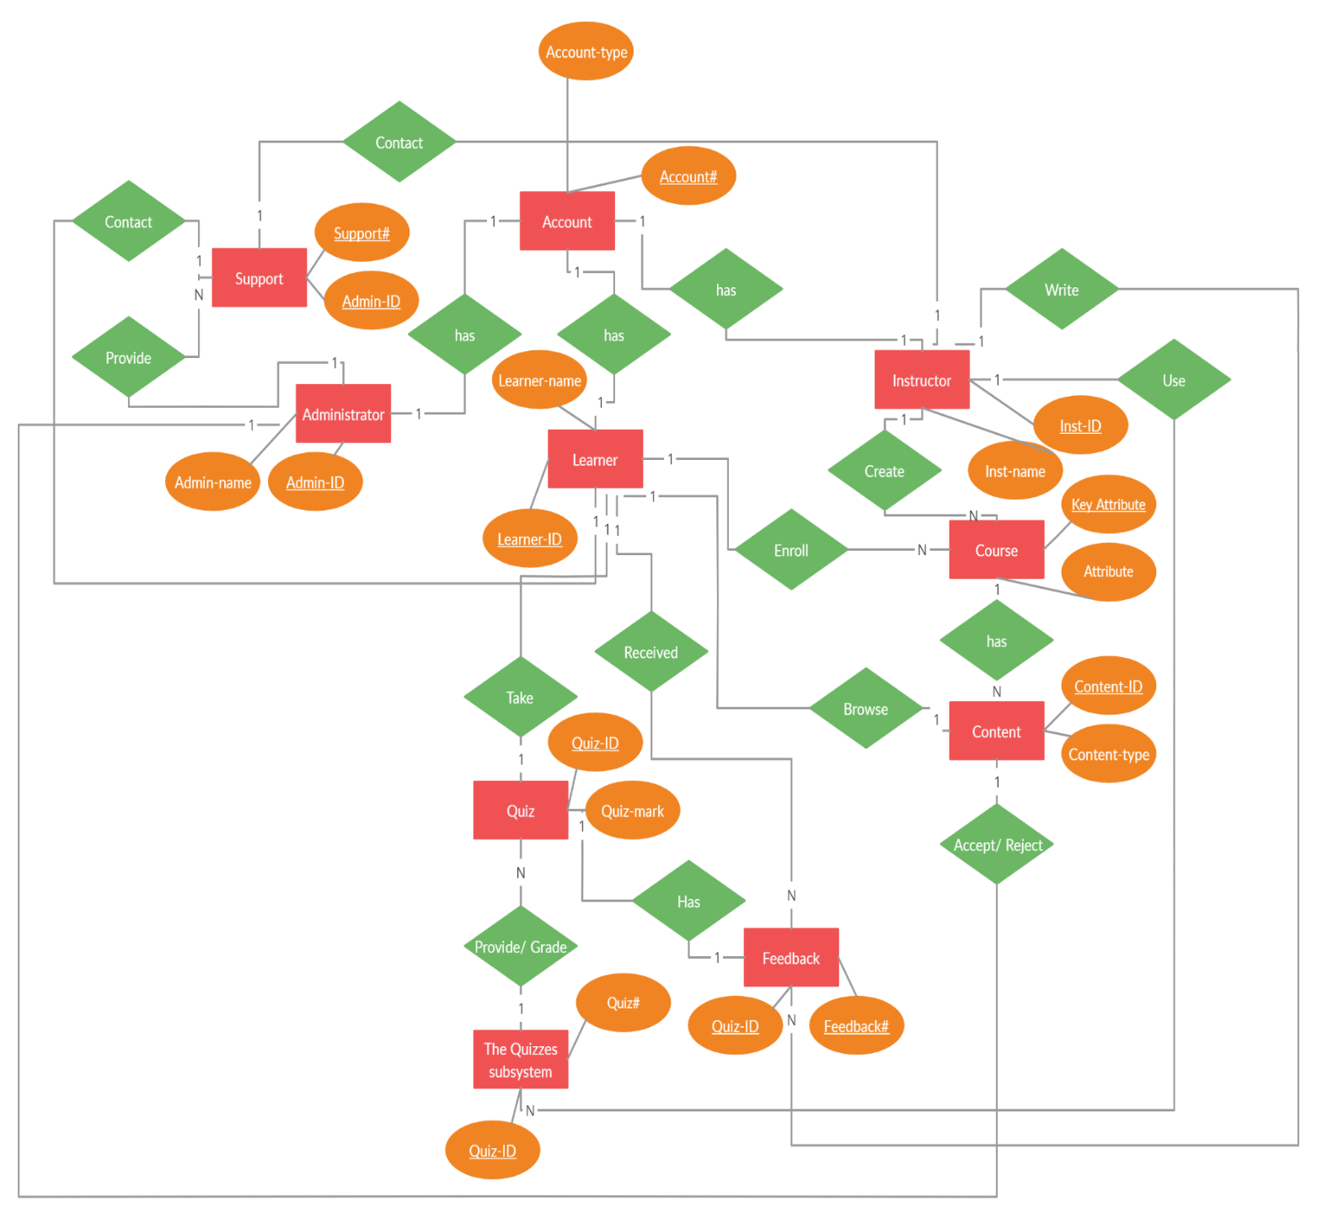

**7. DATA DICTIONARY:**

A Data Dictionary is a collection of names, definitions, and attributes about data elements that are being used or captured in a database, information system, or part of a research project. It describes the meanings and purposes of data elements within the context of a project, and provides guidance on interpretation, accepted meanings and representation. A Data Dictionary also provides metadata about data elements. The metadata included in a Data Dictionary can assist in defining the scope and characteristics of data elements, as well the rules for their usage and application.

Data Dictionaries are useful for a number of reasons. In short, they:

* Assist in avoiding data inconsistencies across a project.
* Help define conventions that are to be used across a project.
* Provide consistency in the collection and use of data across multiple members of a research team.
* Make data easier to analyse.
* Enforce the use of Data Standards.

**6.Design**

**5.1 NUMBER OF MODULES AND THEIR DESCRIPTION**

The E-learning management System Project Core functional elements:

*Student management Module, Faculty management module, Developer/Admin management module.*

1. **Developer/Admin Management module**

The system administrator will be able to perform the following functions:

* Edit his own profile (credentials and personal details).
* view the list of pending users and approve user registration with tutor or student permission
* Have privileges to activate or deactivate course or user, if and when required.
* Create, edit or delete department structure and add or remove programmes.
* Create, edit or delete course structure and assign learning resources.
* Define course activities (forum, quizzes, chat, assignments, etc.).
* Monitors users and oversees variety of department and course’s activities.
* Trains department personnel and students to use the online web application.

1. **Faculty Management Module**

Can perform the following functions:

* Enable manual self-registration and redirection to guest user’s dashboard.
* Access tutors’ dashboard after admin approves registration.
* View and update his own profile (sign in credentials and personal details).
* View registered student and add or remove one or group of students to the course.
* View students’ report and provide remarks.
* Create course and set a unique enrolment key.
* Create, edit or delete course structure and assign learning resources.
* Define course activities (forum, quizzes, assignments, etc.)
* Display teaching feedback.

1. **Students management Module**

The students are regular student or special student for short term training. The student users are permitted to perform following functions:

* Enable manual self-registration and redirection to guest user’s dashboard.
* Access student’s dashboard after admin approves registration.
* View and update his own profile (sign in credentials and personal details).
* View all the list of courses and their description.
* Subscribe to the courses after entering unique enrolment key and then view course’s assigned content resources.
* Participate in discussion forum and chat.
* Test the knowledge of subject through attempting numerous quizzes.
* View grades and remarks from tutor.
* Provide feedbacks to tutor.

**Other Sub Modules:**

* Admin login: Admin is the one who administers the system by adding or removing e-books into and from the system respectively.
* User login: Students have to register themselves into the system to create an account. After registering successfully, they can then login into the system by entering 10 digit mobile number and their email id.
* Categories of books: The e-books are organized according to categories. Thus this classifies the books and students can view the list of references books available.
* View Videos: Students can watch videos with ease due to efficient streaming on cloud infrastructure
* Search option: Students can even search for books according to subjects and authors.
* Students can then download the required e-book on selecting it.
* Feedback form: Students can even provide their feedback into the system by filling up feedback form.

5.2 DATA STRUCTURES OF PROJECT

*AI = AUTO INCREMENT

*PK = PRIMARY KEY

*FK = FOREIGN KEY

|  |  |  |  |
| --- | --- | --- | --- |
| **UserDetails** | | | |
| **Attribute** | **Data Type** | **Key** | **Default** |
| username | Varchar | pk/AI | NOT NULL |
| Role | Varchar |  | NULL |
| password | Varchar |  | NULL |
| contact_id | Varchar | F.K | NULL |

|  |  |  |  |
| --- | --- | --- | --- |
| **StudentDetails** | | | |
| **Attribute** | **Data Type** | **Key** | **Default** |
| Student_Id | Varchar | Pk/AI | NOT NULL |
| gender | Varchar |  | NULL |
| Student_Email | Varchar | unique | NOT NULL |
| Date_of_joining | DATE |  | NULL |
| Student_Name | Varchar |  | NULL |
| Student_Qualification | Varchar |  | NULL |
| Student_DOB | DATE |  | NULL |
| Student_mobile | Varchar |  | NULL |
| Student_photo | Varchar |  | NULL |
| username | Varchar |  | NULL |
| Password | Varchar |  | NULL |
| city | Varchar |  | NULL |
| country | Varchar |  | NULL |

|  |  |  |  |
| --- | --- | --- | --- |
| **TeacherDetails** | | | |
| **Attribute** | **Data Type** | **Key** | **Default** |
| Teacher_id | Varchar | Pk/AI | NOT NULL |
| Teacher_name | Varchar |  | NULL |
| Teacher_Email | Varchar |  | NULL |
| Teacher_qualification | Varchar |  | NULL |
| Date_of__joining | DATE |  | NULL |
| Teacher_DOB | DATE |  | NULL |
| Teacher_photo | BLOB |  | NULL |
| username | Varchar |  | NULL |
| gender | Varchar |  | NULL |
| city | Varchar |  | NULL |
| country | Varchar |  | NULL |
| course_id | Varchar | F.K | NULL |

|  |  |  |  |
| --- | --- | --- | --- |
| **CourseDetails** | | | |
| **Attribute** | **Data Type** | **Key** | **Default** |
| COURSE_ID | Varchar | Pk/AI | NOT NULL |
| COURSE_name | Varchar |  | NULL |
| COURSE_time | DATE |  | NULL |
| COURSE_type | Varchar |  | NULL |
| Course_level | Varchar |  | NULL |
| course_description | Varchar |  | NULL |

|  |  |  |  |
| --- | --- | --- | --- |
| **Student Course** | | | |
| **Attribute** | **Data Type** | **Key** | **Default** |
| Student_Id | Varchar | pk/ai | NOT NULL |
| Course_joining_date | DATE |  | NULL |
| Course_id | Varchar | F.K | NULL |

|  |  |  |  |
| --- | --- | --- | --- |
| **QuizDetails** | | | |
| **Attribute** | **Data Type** | **Key** | **Default** |
| Quiz_id | VARCHAR | P.K/A.I | NOT NULL |
| Quiz_total_number | VARCHAR |  | NULL |
| Quiz_solution | blob |  | NULL |
| Quiz_paper | blob |  | NULL |
| Quiz_category | VARCHAR |  | NULL |

|  |  |  |  |
| --- | --- | --- | --- |
| **Feedback** | | | |
| **Attribute** | **Data Type** | **Key** | **Default** |
| Contact_Id | Varchar | P.K/A.I | NOT NULL |
| email | Varchar | UNIQUE | NOT NULL |
| Contact_time | date |  | NULL |
| Problem | Varchar |  | NULL |

**7.Program code**

**1.LoginBean.java**

**package com.bean;**

**public class LoginBean {**

**private String userName;**

**private String password;**

**private String role;**

**public String getUserName() {**

**return userName;**

**}**

**public void setUserName(String userName) {**

**this.userName = userName;**

**}**

**public String getPassword() {**

**return password;**

**}**

**public void setPassword(String password) {**

**this.password = password;**

**}**

**public String getRole() {**

**return role;**

**}**

**public void setRole(String role) {**

**this.role = role;**

**}**

**}**

**2 . RegisterBean**

**package com.bean;**

**public class RegisterBean**

**{**

**String name,password,email,gender,city,country,username,role;**

**String dob,Qualification;**

**int id;**

**String contact;**

**public String getName() {**

**return name;**

**}**

**public void setName(String name) {**

**this.name = name;**

**}**

**public String getUserName() {**

**return username;**

**}**

**public void setUserName(String username) {**

**this.username =username;**

**}**

**public String getPassword() {**

**return password;**

**}**

**public void setPassword(String password) {**

**this.password = password;**

**}**

**public String getEmail() {**

**return email;**

**}**

**public void setEmail(String email) {**

**this.email = email;**

**}**

**public String getContact() {**

**return contact;**

**}**

**public void setContact(String contact) {**

**this.contact = contact;**

**}**

**public String getUsername() {**

**return username;**

**}**

**public void setUsername(String username) {**

**this.username = username;**

**}**

**public int getId() {**

**return id;**

**}**

**//      public void setId(int id) {**

**//          this.id = id;**

**//      }**

**public String getGender() {**

**return gender;**

**}**

**public void setGender(String gender) {**

**this.gender = gender;**

**}**

**public String getCity() {**

**return city;**

**}**

**public void setCity(String city) {**

**this.city = city;**

**}**

**public String getCountry() {**

**return country;**

**}**

**public void setCountry(String country) {**

**this.country = country;**

**}**

**public String getDob() {**

**return dob;**

**}**

**public void setDob(String dob) {**

**this.dob = dob;**

**}**

**public String getQualification() {**

**return Qualification;**

**}**

**public void setQualification(String qualification) {**

**Qualification = qualification;**

**}**

**public String getRole() {**

**return role;**

**}**

**public void setRole(String role) {**

**this.role = role;**

**}**

**}**

**3.ConnectionProvider**

**package com.dao;**

**import java.sql.*;**

**public class ConnectionProvider**

**{**

**static Connection con = null;**

**public static Connection getConnection()**

**{**

**try**

**{**

**Class.forName("com.mysql.cj.jdbc.Driver");**

**con = DriverManager.getConnection("jdbc:mysql://localhost:3306/elearn","root","1234");**

**}catch(Exception e)**

**{**

**e.printStackTrace();**

**}**

**return con;**

**}**

**}**

**4. LoginDao**

**package com.dao;**

**import java.sql.Connection;**

**import java.sql.ResultSet;**

**import java.sql.SQLException;**

**import java.sql.Statement;**

**import com.bean.LoginBean;**

**public class LoginDao {**

**public String authenticateUser(LoginBean loginBean)**

**{**

**String userName = loginBean.getUserName();**

**String password = loginBean.getPassword();**

**Connection con = null;**

**Statement statement = null;**

**ResultSet resultSet = null;**

**String userNameDB = "";**

**String passwordDB = "";**

**String roleDB = "";**

**try**

**{**

**con = ConnectionProvider.getConnection();**

**statement = con.createStatement();**

**resultSet = statement.executeQuery("select username,password,role from userDetails");**

**while(resultSet.next())**

**{**

**userNameDB = resultSet.getString("username");**

**passwordDB = resultSet.getString("password");**

**roleDB = resultSet.getString("role");**

**if((userName.equals(userNameDB) )&& password.equals(passwordDB) && roleDB.equals("Admin"))**

**return "Admin_Role";**

**else if(userName.equals(userNameDB) && password.equals(passwordDB) && roleDB.equals("Teacher"))**

**return "Teacher_Role";**

**else if(userName.equals(userNameDB) && password.equals(passwordDB) && roleDB.equals("Student"))**

**return "Student_Role";**

**}**

**}**

**catch(SQLException e)**

**{**

**e.printStackTrace();**

**}**

**return "Invalid user credentials";**

**}**

**}**

**5. StudentDao**

**package com.dao;**

**import java.util.*;**

**import com.bean.RegisterBean;**

**import java.sql.*;**

**public class StudentDao {**

**public static int save(RegisterBean e){**

**int status=0;**

**try{**

**Connection con=ConnectionProvider.getConnection();**

**PreparedStatement ps2=con.prepareStatement("insert into Userdetails(username,password,role) values(?,?,?)");**

**ps2.setString(1, e.getUsername());**

**ps2.setString(2, e.getPassword());**

**ps2.setString(3,"Student");**

**ps2.executeUpdate();**

**PreparedStatement ps=con.prepareStatement("insert into StudentDetails(username,student_email,Student_name,student_qualification,student_dob,student_mobile,gender,city,country) values (?,?,?,?,?,?,?,?,?)");**

**ps.setString(1,e.getUsername());**

**ps.setString(2,e.getEmail());**

**ps.setString(3,e.getName());**

**ps.setString(4,e.getQualification());**

**ps.setString(5, e.getDob());**

**ps.setString(6, e.getContact());**

**ps.setString(7, e.getGender());**

**ps.setString(8, e.getCity());**

**ps.setString(9, e.getCountry());**

**status=ps.executeUpdate();**

**con.close();**

**}catch(Exception ex){ex.printStackTrace();}**

**return status;**

**}**

**public static int update(RegisterBean e){**

**int status=0;**

**try{**

**Connection con=ConnectionProvider.getConnection();**

**PreparedStatement ps2=con.prepareStatement("update Userdetails set username=?,password=? values(?,?)");**

**ps2.setString(1, e.getUsername());**

**ps2.setString(2, e.getPassword());**

**ps2.executeUpdate();**

**PreparedStatement ps=con.prepareStatement("update StudentDetails set city=?,country=?,Student_name=?,student_qualification=?,student_dob=?,student_mobile=?,gender=?,city=?, where username=?");**

**ps.setString(1,e.getCity());**

**ps.setString(2,e.getCountry());**

**ps.setString(3,e.getName());**

**ps.setString(4,e.getQualification());**

**ps.setString(5, e.getDob());**

**ps.setString(6, e.getContact());**

**ps.setString(7, e.getGender());**

**status=ps.executeUpdate();**

**con.close();**

**}catch(Exception ex){ex.printStackTrace();}**

**return status;**

**}**

**public static int delete(String username){**

**int status=0;**

**try{**

**Connection con=ConnectionProvider.getConnection();**

**PreparedStatement ps=con.prepareStatement("delete from userDetails where username=?");**

**ps.setString(1,username);**

**status=ps.executeUpdate();**

**con.close();**

**}catch(Exception e){e.printStackTrace();}**

**return status;**

**}**

**public static RegisterBean getEmployeeByUsername(String username){**

**RegisterBean e=new RegisterBean();**

**try{**

**Connection con=ConnectionProvider.getConnection();**

**PreparedStatement ps=con.prepareStatement("select * from studentdetails where username=?");**

**ps.setString(1,username);**

**ResultSet rs=ps.executeQuery();**

**if(rs.next()){**

**e.setName(rs.getString("student_name"));**

**e.setEmail(rs.getString("student_email"));**

**e.setCountry(rs.getString("country"));**

**e.setCity(rs.getString("city"));**

**e.setContact(rs.getString("student_mobile"));**

**e.setDob(rs.getString("Student_dob"));**

**e.setGender(rs.getString("gender"));**

**e.setQualification(rs.getString("Student_qualification"));**

**e.setUsername(rs.getString("username"));**

**}**

**PreparedStatement ps2=con.prepareStatement("select * Userdetails where username=?");**

**ps2.setString(1, username);**

**ResultSet rs2=ps.executeQuery();**

**e.setPassword(rs2.getString("password"));**

**e.setRole(rs.getString("role"));**

**con.close();**

**}catch(Exception ex){ex.printStackTrace();}**

**return e;**

**}**

**public static List<RegisterBean> getAllRegisterBean(){**

**List<RegisterBean> list=new ArrayList<RegisterBean>();**

**try{**

**Connection con=ConnectionProvider.getConnection();**

**PreparedStatement ps=con.prepareStatement("select * from Studentdetails inner join Userdetails using('username');");**

**ResultSet rs=ps.executeQuery();**

**while(rs.next()){**

**RegisterBean e=new RegisterBean();**

**e.setName(rs.getString("student_name"));**

**e.setEmail(rs.getString("student_email"));**

**e.setCountry(rs.getString("country"));**

**e.setCity(rs.getString("city"));**

**e.setContact(rs.getString("student_mobile"));**

**e.setDob(rs.getString("Student_dob"));**

**e.setGender(rs.getString("gender"));**

**e.setQualification(rs.getString("Student_qualification"));**

**e.setUsername(rs.getString("username"));**

**e.setPassword(rs.getString("password"));**

**e.setRole(rs.getString("role"));**

**list.add(e);**

**}**

**con.close();**

**}catch(Exception e){e.printStackTrace();}**

**return list;**

**}**

**}**

**6.LoginServlet**

**package com.login.controller;**

**import java.io.IOException;**

**import javax.servlet.ServletException;**

**import javax.servlet.http.HttpServlet;**

**import javax.servlet.http.HttpServletRequest;**

**import javax.servlet.http.HttpServletResponse;**

**import javax.servlet.http.HttpSession;**

**import com.bean.LoginBean;**

**import com.dao.LoginDao;**

**public class LoginServlet extends HttpServlet {**

**private static final long serialVersionUID = 1L;**

**public LoginServlet() {}**

**protected void doPost(HttpServletRequest request, HttpServletResponse response) throws ServletException, IOException**

**{**

**String userName = request.getParameter("username");**

**String password = request.getParameter("password");**

**String Role="";**

**LoginBean loginBean = new LoginBean();**

**loginBean.setUserName(userName);**

**loginBean.setPassword(password);**

**LoginDao loginDao = new LoginDao();**

**try**

**{**

**Role=loginDao.authenticateUser(loginBean);**

**loginBean.setRole(Role);**

**if(Role.equals("Admin_Role"))**

**{**

**HttpSession session = request.getSession(); //Creating a session**

**session.setAttribute("Name", userName);**

**session.setAttribute("Role", "Admin");**

**request.setAttribute("userName", userName);**

**request.getRequestDispatcher("AdminDashboard.jsp").forward(request, response);**

**}**

**else if(Role.equals("Teacher_Role"))**

**{**

**HttpSession session = request.getSession();**

**session.setAttribute("Name", userName);**

**request.setAttribute("userName", userName);**

**request.getRequestDispatcher("TeacherDashboard.jsp").forward(request, response);**

**}**

**else if(Role.equals("Student_Role"))**

**{**

**HttpSession session = request.getSession();**

**session.setMaxInactiveInterval(10*60);**

**session.setAttribute("Name", userName);**

**request.setAttribute("userName", userName);**

**request.getRequestDispatcher("StudentDashboard.jsp").forward(request, response);**

**}**

**else**

**{**

**System.out.println("Error message = "+Role);**

**request.setAttribute("errMessage", Role);**

**request.getRequestDispatcher("Login.jsp").forward(request, response);**

**}**

**System.out.println(userName+password+Role);**

**}**

**catch (IOException e1)**

**{**

**e1.printStackTrace();**

**}**

**catch (Exception e2)**

**{**

**e2.printStackTrace();**

**}**

**}**

**}**

**7.LogoutServlet**

**package com.login.controller;**

**import java.io.IOException;**

**import javax.servlet.RequestDispatcher;**

**import javax.servlet.ServletException;**

**import javax.servlet.annotation.WebServlet;**

**import javax.servlet.http.HttpServlet;**

**import javax.servlet.http.HttpServletRequest;**

**import javax.servlet.http.HttpServletResponse;**

**import javax.servlet.http.HttpSession;**

**public class LogoutServlet extends HttpServlet**

**{**

**private static final long serialVersionUID = 1L;**

**protected void doGet(HttpServletRequest request, HttpServletResponse response) throws ServletException, IOException**

**{**

**HttpSession session = request.getSession(false); //Fetch session object**

**if(session!=null) //If session is not null**

**{**

**session.removeAttribute("Role");**

**session.invalidate(); //removes all session attributes bound to the session**

**request.setAttribute("errMessage", "You have logged out successfully");**

**RequestDispatcher requestDispatcher = request.getRequestDispatcher("./Login.jsp");**

**requestDispatcher.forward(request, response);**

**}**

**}**

**}**

**8.RegisterServlet**

**package com.register;**

**import java.io.IOException;**

**import javax.servlet.ServletException;**

**import javax.servlet.annotation.WebServlet;**

**import javax.servlet.http.HttpServlet;**

**import javax.servlet.http.HttpServletRequest;**

**import javax.servlet.http.HttpServletResponse;**

**import com.bean.RegisterBean;**

**import com.dao.StudentDao;**

**@WebServlet("/RegisterServlet")**

**public class RegisterServlet extends HttpServlet {**

**private static final long serialVersionUID = 1L;**

**public RegisterServlet() {**

**super();**

**}**

**RegisterBean user=new RegisterBean();**

**protected void doPost(HttpServletRequest request, HttpServletResponse response) throws ServletException, IOException {**

**int flag=0;**

**user.setName(request.getParameter("name"));**

**user.setUsername(request.getParameter("username"));**

**user.setPassword(request.getParameter("password"));**

**user.setEmail(request.getParameter("email"));**

**user.setGender(request.getParameter("gender"));**

**user.setDob(request.getParameter("dob"));**

**user.setCity(request.getParameter("city"));**

**user.setCountry(request.getParameter("country"));**

**user.setQualification(request.getParameter("qualification"));**

**user.setContact(request.getParameter("mobile"));**

**String role=request.getParameter("role");**

**if(role.equals("Student"))**

**{**

**flag=StudentDao.save(user);**

**System.out.println("flag="+flag);**

**}**

**else if(role.equals("Teacher"))**

**{**

**flag=TeacherDao.save(user);**

**}**

**else**

**{**

**request.getRequestDispatcher("Register.jsp").forward(request, response);**

**}**

**if(flag!=0){**

**request.getRequestDispatcher("Success.jsp").forward(request, response);**

**}**

**else**

**{**

**request.getRequestDispatcher("Error.jsp").forward(request, response);**

**}**

**}**

**}**

**9.SaveFeedback**

**package com.register;**

**import javax.servlet.*;**

**import java.sql.*;**

**import java.io.IOException;**

**import javax.servlet.ServletException;**

**import javax.servlet.annotation.WebServlet;**

**import javax.servlet.http.HttpServlet;**

**import javax.servlet.http.HttpServletRequest;**

**import javax.servlet.http.HttpServletResponse;**

**import com.dao.ConnectionProvider;**

**@WebServlet("/SaveFeedback")**

**public class SaveFeedback extends HttpServlet {**

**private static final long serialVersionUID = 1L;**

**protected void doPost(HttpServletRequest request, HttpServletResponse response) throws ServletException, IOException {**

**response.setContentType("text/html;charset=UTF-8");**

**String name = request.getParameter("name");**

**String email = request.getParameter("email");**

**String text= request.getParameter("query");**

**try {**

**Connection con =ConnectionProvider.getConnection();**

**PreparedStatement ps = con.prepareStatement("insert into Savefeedback (name,email,query)  values(?,?,?)");**

**ps.setString(1, name);**

**ps.setString(2, email);**

**ps.setString(3, text);**

**int i=0;**

**i = ps.executeUpdate();**

**if(i > 0) {**

**RequestDispatcher rs = request.getRequestDispatcher("Success.jsp");**

**rs.forward(request,response);**

**}**

**else {**

**RequestDispatcher rs = request.getRequestDispatcher("Error.jsp");**

**rs.forward(request,response);**

**}**

**}**

**catch(Exception se) {**

**se.printStackTrace();**

**System.out.print(se);**

**}**

**}**

**}**

**10.index.jsp**

**<!DOCTYPE html>**

**<html lang="en">**

**<head>**

**<title>E-Learning Management System</title>**

**<meta name="viewport" content="width=device-width, initial-scale=1">**

**<meta http-equiv="Content-Type" content="text/html; charset=utf-8" />**

**<script type="application/x-javascript"> addEventListener("load", function() { setTimeout(hideURLbar, 0); }, false);**

**function hideURLbar(){ window.scrollTo(0,1); } </script>**

**<link href="css/bootstrap.css" rel="stylesheet" type="text/css" media="all" />**

**<link href="css/style.css" rel="stylesheet" type="text/css" media="all" />**

**<script type="text/javascript" src="js/jquery-2.1.4.min.js"></script>**

**<link href="css/popuo-box.css" rel="stylesheet" type="text/css" media="all" />**

**<link href="css/font-awesome.css" rel="stylesheet">**

**<link href="//fonts.googleapis.com/css?family=Prata" rel="stylesheet">**

**<link href="https://fonts.googleapis.com/css?family=Noto+Serif:400,400i,700,700i" rel="stylesheet">**

**<link href='//fonts.googleapis.com/css?family=Open+Sans:400,300,300italic,400italic,600,600italic,700,700italic,800,800italic' rel='stylesheet' type='text/css'>**

**<link href = "https://code.jquery.com/ui/1.10.4/themes/ui-lightness/jquery-ui.css" rel = "stylesheet">**

**</head>**

**<body>**

**<div class="header-w3ls-agileinfo">**

**<div class="wthree_agile_top_header">**

**<div class="logo-agileits">**

**<h1><a href="index.jsp"><span>E</span>-learning <i class="fa fa-graduation-cap" aria-hidden="true"></i></a></h1>**

**</div>**

**<div class="agileits_w3layouts_sign_in">**

**<ul>**

**<li><a class="active" href="./Login.jsp"  >Sign In</a></li>**

**<li><a href="./Register.jsp">Sign Up</a></li>**

**</ul>**

**</div>**

**<div class="clearfix"> </div>**

**</div>**

**<div class="container">**

**<div class="w3layouts_agileits_nav_section">**

**<nav class="navbar navbar-default">**

**<div class="navbar-header navbar-left">**

**<button type="button" class="navbar-toggle collapsed" data-toggle="collapse" data-target="#bs-example-navbar-collapse-1">**

**<span class="sr-only">Toggle navigation</span>**

**<span class="icon-bar"></span>**

**<span class="icon-bar"></span>**

**<span class="icon-bar"></span>**

**</button>**

**</div>**

**<!-- Collect the nav links, forms, and other content for toggling -->**

**<div class="collapse navbar-collapse navbar-right" id="bs-example-navbar-collapse-1">**

**<nav>**

**<ul class="nav navbar-nav">**

**<li class="active"><a href="index1.html">Home</a></li>**

**<li><a href="#about" class="hvr-rectangle-out scroll">About</a></li>**

**<li><a href="#services" class="hvr-rectangle-out scroll">Objectives</a></li>**

**<li><a href="#team" class="hvr-rectangle-out scroll">Team</a></li>**

**<li><a href="#news" class="hvr-rectangle-out scroll">Latest Arrival</a></li>**

**<li><a href="#gallery" class="hvr-rectangle-out scroll">Gallery</a></li>**

**<li><a href="#contact" class="hvr-rectangle-out scroll">Contact</a></li>**

**</ul>**

**</nav>**

**</div>**

**</nav>**

**</div>**

**</div>**

**</div>**

**<!-- //header -->**

**<!-- banner -->**

**<div class="w3ls_banner_section">**

**<div class="container">**

**<h2>Education Needs Complete <span>Solution</span></h2>**

**<p> for Enrollment Coming soon</p>**

**<div class="wthree-counter-agile">**

**<!--timer-->**

**<section class="examples">**

**<div class="simply-countdown-losange" id="simply-countdown-losange"></div>**

**<div class="clearfix"></div>**

**</section>**

**<!--//timer-->**

**</div>**

**<div class="agileits_more">**

**<ul>**

**<li><a href="Register.jsp" data-toggle="modal" data-target="#myModal4" class="w3ls_banner_more hvr-icon-hang scroll ">Enroll Now !</a></li>**

**<li><a href="#" class="hvr-icon-hang" data-toggle="modal" data-target="#myModal">Read More</a></li>**

**</ul>**

**</div>**

**</div>**

**</div>**

**<!-- //banner -->**

**<!-- bootstrap-pop-up -->**

**<div class="modal video-modal fade" id="myModal" tabindex="-1" role="dialog" aria-labelledby="myModal">**

**<div class="modal-dialog" role="document">**

**<div class="modal-content">**

**<div class="modal-header">**

**<button type="button" class="close" data-dismiss="modal" aria-label="Close"><span aria-hidden="true">&times;</span></button>**

**</div>**

**<section>**

**<div class="modal-body">**

**<h3 class="agileinfo_sign">Brilliance</h3>**

**<img src="images/abc.jpg" alt=" " class="img-responsive" />**

**<p>Your work is not to drag the world kicking and screaming into a new awareness. Your job is to simply do your work... sacredly, secretly, silently... and those with "eyes to see and ears to hear' will respond.**

**<i> - The Arturians</i></p>**

**</div>**

**</section>**

**</div>**

**</div>**

**</div>**

**<!-- //bootstrap-pop-up -->**

**<!-- banner-down-->**

**<div class="wthree_banner_grids">**

**<div class="container">**

**<div class="col-md-3 wthree_banner_grid">**

**<i class="fa fa-user" aria-hidden="true"></i>**

**<h4>BEST REAL LEADERS</h4>**

**<div class="clearfix"> </div>**

**</div>**

**<div class="col-md-3 wthree_banner_grid">**

**<i class="fa fa-globe" aria-hidden="true"></i>**

**<h4>LEARN COURSES ONLINE</h4>**

**<div class="clearfix"> </div>**

**</div>**

**<div class="col-md-3 wthree_banner_grid">**

**<i class="fa fa-book" aria-hidden="true"></i>**

**<h4>BOOKS LIBRARY</h4>**

**<div class="clearfix"> </div>**

**</div>**

**<div class="col-md-3 wthree_banner_grid">**

**<i class="fa fa-globe" aria-hidden="true"></i>**

**<h4>AVAILABLE EVERYWHERE</h4>**

**<div class="clearfix"> </div>**

**</div>**

**<div class="clearfix"> </div>**

**</div>**

**</div>**

**<!-- //banner-down-->**

**<!-- banner-bottom -->**

**<!-- gallery -->**

**<div class="gallery" id="gallery">**

**<div class="w3ls-heading">**

**<h3>Courses We Offer</h3>**

**<p class="sub">Learning never exhausts the Mind.</p>**

**</div>**

**<div class="w3layouts-grids gal-wthree-agileits">**

**<div id="jzBox" class="jzBox">**

**<div id="jzBoxNextBig"></div>**

**<div id="jzBoxPrevBig"></div>**

**<img src="#" id="jzBoxTargetImg" alt=""/>**

**<div id="jzBoxBottom">**

**<div id="jzBoxTitle"></div>**

**<div id="jzBoxMoreItems">**

**<div id="jzBoxCounter"></div>**

**<i class="arrow-left" id="jzBoxPrev"></i>**

**<i class="arrow-right" id="jzBoxNext"></i>**

**</div>**

**<i class="close" id="jzBoxClose"></i>**

**</div>**

**</div>**

**<div class="gallery-grids-row">**

**<div class="col-md-3 gallery-grid">**

**<div class="wpf-demo-4">**

**<a href="https://www.google.co.in/" title="C" target="_blank">**

**<img src="images/g1.jpg" alt=" " class="img-responsive" />**

**<div class="view-caption">**

**<p>Full View</p>**

**</div>**

**</a>**

**</div>**

**</div>**

**<div class="col-md-3 gallery-grid">**

**<div class="wpf-demo-4">**

**<a href="images/g2.JPG" class="jzBoxLink item-hover" title="C++">**

**<img src="images/g2.JPG" alt=" " class="img-responsive" />**

**<div class="view-caption">**

**<p>Full View</p>**

**</div>**

**</a>**

**</div>**

**</div>**

**<div class="col-md-3 gallery-grid">**

**<div class="wpf-demo-4">**

**<a href="images/g3.JPG" class="jzBoxLink item-hover" title="java">**

**<img src="images/g3.JPG" alt=" " class="img-responsive" />**

**<div class="view-caption">**

**<p>Full View</p>**

**</div>**

**</a>**

**</div>**

**</div>**

**<div class="col-md-3 gallery-grid">**

**<div class="wpf-demo-4">**

**<a href="images/g4.JPG" class="jzBoxLink item-hover" title="python">**

**<img src="images/g4.JPG" alt=" " class="img-responsive" />**

**<div class="view-caption">**

**<p>Full View</p>**

**</div>**

**</a>**

**</div>**

**</div>**

**<div class="col-md-3 gallery-grid">**

**<div class="wpf-demo-4">**

**<a href="images/g5.jpg" class="jzBoxLink item-hover" title="Education">**

**<img src="images/g5.jpg" alt=" " class="img-responsive" />**

**<div class="view-caption">**

**<p>Full View</p>**

**</div>**

**</a>**

**</div>**

**</div>**

**<div class="col-md-3 gallery-grid">**

**<div class="wpf-demo-4">**

**<a href="images/g6.jpg" class="jzBoxLink item-hover" title="Education">**

**<img src="images/g6.jpg" alt=" " class="img-responsive" />**

**<div class="view-caption">**

**<p>Full View</p>**

**</div>**

**</a>**

**</div>**

**</div>**

**<div class="col-md-3 gallery-grid">**

**<div class="wpf-demo-4">**

**<a href="images/g7.JPG" class="jzBoxLink item-hover" title="Education">**

**<img src="images/g7.JPG" alt=" " class="img-responsive" />**

**<div class="view-caption">**

**<p>Full View</p>**

**</div>**

**</a>**

**</div>**

**</div>**

**<div class="col-md-3 gallery-grid">**

**<div class="wpf-demo-4">**

**<a href="images/g8.jpg" class="jzBoxLink item-hover" title="Education">**

**<img src="images/g8.jpg" alt=" " class="img-responsive" />**

**<div class="view-caption">**

**<p>Full View</p>**

**</div>**

**</a>**

**</div>**

**</div>**

**<div class="clearfix"> </div>**

**</div>**

**</div>**

**</div>**

**<!-- //gallery -->**

**<!-- //banner-bottom -->**

**<!-- services -->**

**<div class="services" id="services">**

**<div class="container">**

**<div class="w3ls-heading">**

**<h3 class="h-two">Learning Objectives</h3>**

**<p class="sub two">A teacher affects eternity: he can never tell where his influence stops.</p>**

**</div>**

**<div class="w3layouts-grids">**

**<div class="services-right-grids">**

**<div class="col-sm-4 services-right-grid">**

**<div class="services-icon hvr-radial-in">**

**<i class="fa fa-bar-chart" aria-hidden="true"></i>**

**</div>**

**<div class="services-icon-info">**

**<h5>Skills</h5>**

**<p>I cannot teach anybody anything, I can only make them think.</p>**

**</div>**

**</div>**

**<div class="col-sm-4 services-right-grid">**

**<div class="services-icon hvr-radial-in">**

**<i class="fa fa-lightbulb-o" aria-hidden="true"></i>**

**</div>**

**<div class="services-icon-info">**

**<h5>Self Learning</h5>**

**<p>Those who know, do. Those that understand, teach.</p>**

**</div>**

**</div>**

**<div class="col-sm-4 services-right-grid">**

**<div class="services-icon hvr-radial-in">**

**<i class="fa fa-book" aria-hidden="true"></i>**

**</div>**

**<div class="services-icon-info">**

**<h5>Knowledge</h5>**

**<p>Knowledge is the main thing which will be with you lifetime not the GF so Study Hard.</p>**

**</div>**

**</div>**

**<div class="clearfix"> </div>**

**</div>**

**<div class="services-right-grids">**

**<div class="col-sm-4 services-right-grid">**

**<div class="services-icon hvr-radial-in">**

**<i class="fa fa-comments" aria-hidden="true"></i>**

**</div>**

**<div class="services-icon-info">**

**<h5>Discussion</h5>**

**<p>Discussion is the best way to Clear the doubts.it also removes the ambiguity from user end.</p>**

**</div>**

**</div>**

**<div class="col-sm-4 services-right-grid">**

**<div class="services-icon hvr-radial-in">**

**<i class="fa fa-usd" aria-hidden="true"></i>**

**</div>**

**<div class="services-icon-info">**

**<h5>International Payments</h5>**

**<p>we accepts payments from all over the world,which ease our users to be comfortable</p>**

**</div>**

**</div>**

**<div class="col-sm-4 services-right-grid">**

**<div class="services-icon hvr-radial-in">**

**<i class="fa fa-building" aria-hidden="true"></i>**

**</div>**

**<div class="services-icon-info">**

**<h5>Rich Content</h5>**

**<p>Every Content is HandMade personally by Highly skilled Subject Teachers </p>**

**</div>**

**</div>**

**<div class="clearfix"> </div>**

**</div>**

**</div>**

**</div>**

**</div>**

**<!-- //services -->**

**<!-- team -->**

**<div class="team" id="team">**

**<div class="container">**

**<div class="w3ls-heading">**

**<h3>Our Team</h3>**

**<p class="sub">Excellence overloaded</p>**

**</div>**

**<div class="w3layouts-grids">**

**<div class="col-md-3 wthree_team_grid">**

**<div class="wthree_team_grid1">**

**<div class="hover14 column">**

**<div>**

**<figure><img src="images/10.jpg" alt=" " class="img-responsive" /></figure>**

**</div>**

**</div>**

**<div class="wthree_team_grid1_pos">**

**<h4>Aman Tiwari</h4>**

**</div>**

**</div>**

**</div>**

**</div>**

**<div class="col-md-3 wthree_team_grid">**

**<div class="wthree_team_grid1">**

**<div class="hover14 column">**

**<div>**

**<figure><img src="images/11.jpg" alt=" " class="img-responsive" /></figure>**

**</div>**

**</div>**

**<div class="wthree_team_grid1_pos">**

**<h4>Niharika</h4>**

**</div>**

**</div>**

**</div>**

**<div class="col-md-3 wthree_team_grid">**

**<div class="wthree_team_grid1">**

**<div class="hover14 column">**

**<div>**

**<figure><img src="images/12.jpg" alt=" " class="img-responsive" /></figure>**

**</div>**

**</div>**

**<div class="wthree_team_grid1_pos">**

**<h4>Akshay</h4>**

**</div>**

**</div>**

**</div>**

**<div class="col-md-3 wthree_team_grid">**

**<div class="wthree_team_grid1">**

**<div class="hover14 column">**

**<div>**

**<figure><img src="images/13.jpg" alt=" " class="img-responsive" /></figure>**

**</div>**

**</div>**

**<div class="wthree_team_grid1_pos">**

**<h4>Illakshya</h4>**

**</div>**

**</div>**

**</div>**

**<div class="clearfix"> </div>**

**</div>**

**</div>**

**</div>**

**<!-- //team -->**

**<!-- contact -->**

**<div class="contact" id="contact">**

**<div class="container">**

**<div class="w3ls-heading">**

**<h3>Get In Touch</h3>**

**<p class="sub">if you have any Query Ask us.</p>**

**</div>**

**<div class="w3layouts-grids">**

**<div class="col-md-4 contact-left">**

**<div class="contact-info">**

**<div class="contact-info-left">**

**<i class="fa fa-map-marker" aria-hidden="true"></i>**

**</div>**

**<div class="contact-info-right">**

**<h5>Address</h5>**

**<p>Shyamlal college<br>**

**<span>Sahadra,</span>**

**New Delhi**

**</p>**

**</div>**

**<div class="clearfix"> </div>**

**</div>**

**<div class="contact-info">**

**<div class="contact-info-left">**

**<i class="fa fa-phone-square" aria-hidden="true"></i>**

**</div>**

**<div class="contact-info-right">**

**<h5>Mobile</h5>**

**<ul>**

**<li>+91 9891062743</li>**

**<li>+91 8448179216</li>**

**</ul>**

**</div>**

**<div class="clearfix"> </div>**

**</div>**

**<div class="contact-info">**

**<div class="contact-info-left">**

**<i class="fa fa-envelope" aria-hidden="true"></i>**

**</div>**

**<div class="contact-info-right">**

**<h5>E-Mail</h5>**

**<ul>**

**<li><a href="mailto:amantiwari8861@gmail.com">amantiwari8861@gmail.com</a></li>**

**<li><a href="mailto:amantiwari2743@gmail.com">amantiwari2743@gmail.com</a></li>**

**</ul>**

**</div>**

**<div class="clearfix"> </div>**

**</div>**

**</div>**

**<div class="col-md-8 contact-form">**

**<form action="SaveFeedback" method="post">**

**<input type="text" name="name" placeholder="Name" required>**

**<input type="email" class="email" name="email" placeholder="Email" required>**

**<div class="clearfix"> </div>**

**<input type="text" class="phone" name="phone" placeholder="Phone Number" required>**

**<textarea placeholder="Message" name="message" required></textarea>**

**<input type="submit" value="SUBMIT">**

**</form>**

**</div>**

**<div class="clearfix"> </div>**

**</div>**

**</div>**

**</div>**

**<!-- //contact -->**

**<!-- Footer -->**

**<div class="footer w3ls">**

**<div class="container">**

**<div class="newsletter-agile">**

**<form action="SaveFeedback" method="post">**

**<p>Send us Your Mail, we'll make sure You Never Miss a Thing!</p>**

**<input type="email" name="email" size="30" required placeholder="Enter your email here...">**

**<input type="submit" value="Subscribe">**

**</form>**

**</div>**

**<div class="footer-main">**

**<div class="footer-top">**

**<div class="col-md-4 ftr-grid fg1">**

**<h3><a href="index1.html"><span>E</span>Learning</a></h3>**

**<p>E-learning management System is a LMS website to manage the Studenta and Teachers.</p>**

**</div>**

**<div class="col-md-4 ftr-grid fg2 mid-gd">**

**<h3>Our Address</h3>**

**<div class="ftr-address">**

**<div class="local">**

**<i class="fa fa-map-marker" aria-hidden="true"></i>**

**</div>**

**<div class="ftr-text">**

**<p>New Delhi,India</p>**

**</div>**

**<div class="clearfix"> </div>**

**</div>**

**<div class="ftr-address">**

**<div class="local">**

**<i class="fa fa-phone" aria-hidden="true"></i>**

**</div>**

**<div class="ftr-text">**

**<p>+91 (989) 1062743</p>**

**</div>**

**<div class="clearfix"> </div>**

**</div>**

**<div class="ftr-address">**

**<div class="local">**

**<i class="fa fa-envelope" aria-hidden="true"></i>**

**</div>**

**<div class="ftr-text">**

**<p><a href="mailto:info@example.com">amantiwari8861@gmail.com</a></p>**

**</div>**

**<div class="clearfix"> </div>**

**</div>**

**</div>**

**<div class="col-md-4 ftr-grid fg2">**

**<h3>Keep In Touch With Us</h3>**

**<div class="right-w3l">**

**<ul class="top-links">**

**<li><a href="https://www.facebook.com/amantiwari8861/"><i class="fa fa-facebook"></i></a></li>**

**<li><a href="https://twitter.com/AmanTiw61298258"><i class="fa fa-twitter"></i></a></li>**

**<li><a href="mailto:amantiwari8861@gmail.com"><i class="fa fa-envelop"></i></a></li>**

**</ul>**

**</div>**

**<div class="right-w3-2">**

**<ul class="text-w3">**

**<li><a href="https://www.facebook.com/amantiwari8861/">Facebook</a></li>**

**<li><a href="https://twitter.com/AmanTiw61298258">Twitter</a></li>**

**<li><a href="mailto:amantiwari8861@gmail.com?subject=hii">Google</a></li>**

**<li><a href="https://www.linkedin.com/in/aman-tiwari-70b038154/">LinkedIn</a></li>**

**</ul>**

**</div>**

**</div>**

**<div class="clearfix"> </div>**

**</div>**

**<div class="copyrights">**

**<p>&copy; 2021 AMandroid. All Rights Reserved | Design by  <a href="#" target="_blank">Aman Tiwari</a> </p>**

**</div>**

**</div>**

**</div>**

**</div>**

**<!-- Footer -->**

**<!-- start-smoth-scrolling -->**

**<!-- js -->**

**<!--//pop-up-box -->**

**<script type="text/javascript" src="js/jquery-2.1.4.min.js"></script>**

**<!--pop-up-box -->**

**<script src="js/jquery.magnific-popup.js" type="text/javascript"></script>**

**<script>**

**$(document).ready(function() {**

**$('.popup-with-zoom-anim').magnificPopup({**

**type: 'inline',**

**fixedContentPos: false,**

**fixedBgPos: true,**

**overflowY: 'auto',**

**closeBtnInside: true,**

**preloader: false,**

**midClick: true,**

**removalDelay: 300,**

**mainClass: 'my-mfp-zoom-in'**

**});**

**});**

**</script>**

**<!-- //pop-up-box -->**

**<!-- //js -->**

**<script type="text/javascript" src="js/move-top.js"></script>**

**<script type="text/javascript" src="js/easing.js"></script>**

**<script type="text/javascript">**

**jQuery(document).ready(function($) {**

**$(".scroll").click(function(event){**

**event.preventDefault();**

**$('html,body').animate({scrollTop:$(this.hash).offset().top},1000);**

**});**

**});**

**</script>**

**<!-- start-smoth-scrolling -->**

**<script src="js/jzBox.js"></script>**

**<!-- Countdown-Timer-JavaScript -->**

**<script src="js/simplyCountdown.js"></script>**

**<script>**

**var d = new Date(new Date().getTime() + 948 * 120 * 120 * 2000);**

**// default example**

**simplyCountdown('.simply-countdown-one', {**

**year: d.getFullYear(),**

**month: d.getMonth() + 1,**

**day: d.getDate()**

**});**

**// inline example**

**simplyCountdown('.simply-countdown-inline', {**

**year: d.getFullYear(),**

**month: d.getMonth() + 1,**

**day: d.getDate(),**

**inline: true**

**});**

**//jQuery example**

**$('#simply-countdown-losange').simplyCountdown({**

**year: d.getFullYear(),**

**month: d.getMonth() + 1,**

**day: d.getDate(),**

**enableUtc: false**

**});**

**</script>**

**<!-- //Countdown-Timer-JavaScript -->**

**<!-- smooth scrolling -->**

**<script type="text/javascript">**

**$(document).ready(function() {**

**/\***

**var defaults = {**

**containerID: 'toTop', // fading element id**

**containerHoverID: 'toTopHover', // fading element hover id**

**scrollSpeed: 1200,**

**easingType: 'linear'**

**};**

**\*/**

**$().UItoTop({ easingType: 'easeOutQuart' });**

**});**

**</script>**

**<a href="#" id="toTop" style="display: block;"> <span id="toTopHover" style="opacity: 1;"> </span></a>**

**<!-- //smooth scrolling -->**

**<script type="text/javascript" src="js/bootstrap.js"></script>**

**</body>**

**</html>**

**11.Login.jsp**

**<!DOCTYPE html>**

**<html>**

**<head>**

**<meta charset="utf-8">**

**<meta name="viewport" content="width=device-width, initial-scale=1.0">**

**<title>Login</title>**

**<link rel="stylesheet" href="https://cdnjs.cloudflare.com/ajax/libs/twitter-bootstrap/4.1.3/css/bootstrap.min.css">**

**<link rel="stylesheet" href="https://cdnjs.cloudflare.com/ajax/libs/ionicons/2.0.1/css/ionicons.min.css">**

**<style>**

**.login-dark {**

**height:800px;**

**background:#475d62 url(./images/star-sky.jpg);**

**background-size:cover;**

**position:relative;**

**background-repeat: no-repeat;**

**background-attachment: fixed;**

**}**

**.login-dark form {**

**max-width:320px;**

**width:90%;**

**background-color:#1e2833;**

**padding:40px;**

**border-radius:4px;**

**transform:translate(-50%, -50%);**

**position:absolute;**

**top:50%;**

**left:50%;**

**color:#fff;**

**box-shadow:3px 3px 4px rgba(0,0,0,0.2);**

**}**

**.login-dark .illustration {**

**text-align:center;**

**padding:15px 0 20px;**

**font-size:100px;**

**color:#2980ef;**

**}**

**.login-dark form .form-control {**

**background:none;**

**border:none;**

**border-bottom:1px solid #434a52;**

**border-radius:0;**

**box-shadow:none;**

**outline:none;**

**color:inherit;**

**}**

**.login-dark form .btn-primary {**

**background:#214a80;**

**border:none;**

**border-radius:4px;**

**padding:11px;**

**box-shadow:none;**

**margin-top:26px;**

**text-shadow:none;**

**outline:none;**

**}**

**.login-dark form .btn-primary:hover, .login-dark form .btn-primary:active {**

**background:#214a80;**

**outline:none;**

**}**

**.login-dark form .forgot {**

**display:block;**

**text-align:center;**

**font-size:12px;**

**color:#6f7a85;**

**opacity:0.9;**

**text-decoration:none;**

**}**

**.login-dark form .forgot:hover, .login-dark form .forgot:active {**

**opacity:1;**

**text-decoration:none;**

**}**

**.login-dark form .btn-primary:active {**

**transform:translateY(1px);**

**}**

**</style>**

**</head>**

**<body >**

**<div class="login-dark">**

**<form action="LoginServlet" method="post">**

**<h2 class="sr-only">Login Form</h2>**

**<div class="illustration"><i class="icon ion-ios-locked-outline"></i></div>**

**<div class="form-group"><input class="form-control" type="text" name="username" placeholder="Email"></div>**

**<div class="form-group"><input class="form-control" type="password" name="password" placeholder="Password"></div>**

**<div class="form-group"><button class="btn btn-primary btn-block" type="submit">Log In</button></div><a href="#" class="forgot">Forgot your email or password?</a><br>**

**<a href="Register.jsp">Not a Member ? Register here!</a>**

**<span style="color:red;">**

**<%**

**if(request.getAttribute("errMessage")!=null){**

**out.print(request.getAttribute("errMessage"));} %></span>**

**</form>**

**</div>**

**<script src="https://cdnjs.cloudflare.com/ajax/libs/jquery/3.2.1/jquery.min.js"></script>**

**<script src="https://cdnjs.cloudflare.com/ajax/libs/twitter-bootstrap/4.1.3/js/bootstrap.bundle.min.js"></script>**

**</body>**

**</html>**

**12.Register.jsp**

**<!DOCTYPE html>**

**<html lang="en">**

**<head>**

**<meta charset="UTF-8">**

**<meta http-equiv="X-UA-Compatible" content="IE=edge">**

**<meta name="viewport" content="width=device-width, initial-scale=1.0">**

**<title>Register</title>**

**<link href="https://maxcdn.bootstrapcdn.com/bootstrap/4.0.0/css/bootstrap.min.css" rel="stylesheet"**

**id="bootstrap-css">**

**<script src="https:////maxcdn.bootstrapcdn.com/bootstrap/4.0.0/js/bootstrap.min.js"></script>**

**<script src="https://cdnjs.cloudflare.com/ajax/libs/jquery/3.2.1/jquery.min.js"></script>**

**<script src="validate.js"></script>**

**<style>**

**.login-dark {**

**height: 750px;**

**background: #475d62 url(./images/star-sky.jpg);**

**background-size: cover;**

**position: relative;**

**background-repeat: no-repeat;**

**background-attachment: fixed;**

**color:white;**

**}**

**</style>**

**</head>**

**<body class="login-dark">**

**<section class="testimonial py-5" id="testimonial">**

**<div class="container">**

**<div class="row ">**

**<div class="col-md-4 py-5 bg-primary text-white text-center ">**

**<div class=" ">**

**<div class="card-body">**

**<img src="http://www.ansonika.com/mavia/img/registration_bg.svg" style="width:30%">**

**<h2 class="py-3">Registration</h2>**

**<p>by filling this form as Teacher you can manage courses and add quizes and etc.**

**by filling this form as student you will be able to enroll in course and take quizes and**

**etc.**

**</p>**

**</div>**

**</div>**

**</div>**

**<div class="col-md-8 py-5 border">**

**<h4 class="pb-4" style="color: white;">Please fill with your details</h4>**

**<form action="RegisterServlet" method="POST" onsubmit="">**

**<div class="form-row">**

**<div class="form-group col-md-6">**

**<label for="username">UserName<span style="color: red;">*</span>**

**<input id="username" name="username" placeholder="UserName" class="form-control"**

**type="text" required size="49" pattern="[a-zA-Z0-9]+" minlength="3"**

**maxlength="10"**

**title="* Username must be greater than 3 and less than 10"></label>**

**</div><br>**

**<div class="form-group col-md-6">**

**<label for="password">Password<span style="color: red;">*</span>**

**<input type="password" class="form-control" id="password" name="password"**

**placeholder="Password" required size="49" minlength="8" maxlength="10"**

**pattern="(?=.*\d)(?=.*[a-z])(?=.*[A-Z]).{8,}"**

**title="Must contain at least one number and one uppercase and lowercase letter, and at least 8 or more characters"></label>**

**</div>**

**<div class="form-row">**

**<div class="form-group col-md-6">**

**<label for="name">Full Name<span style="color: red;">*</span>**

**<input id="name" name="name" placeholder="Full Name" class="form-control"**

**type="text" required size="49" minlength="3" pattern="[a-zA-Z]+[a-zA-Z ]+"  title="must not be a letter or Special character"></label>**

**</div><br>**

**<div class="form-group col-md-6">**

**<label for="email">E-mail<span style="color: red;">*</span>**

**<input type="email" class="form-control" id="email" name="email"**

**placeholder="Email" required size="49"**

**pattern="[A-Za-z0-9._%+-]+@[A-Za-z0-9.-]+\.[A-Za-z]{1,63}$"**

**title=" please enter a valid email"></label>**

**</div>**

**</div>**

**<div class="form-row">**

**<div class="form-group col-md-6">**

**<label for="mobile">Mobile No.<span style="color: red;">*</span>**

**<input id="mobile" name="mobile" placeholder="Mobile No." class="form-control"**

**required type="tel" size="100" minlength="10" maxlength="13"></label>**

**</div><br>**

**<div class="form-group col-md-6">**

**<label for="role">Role<span style="color: red;">*</span>**

**<select id="role" name="role" class="form-control" style="width: 250%;" required>**

**<option selected>Choose Role..</option>**

**<option value="Teacher"> Teacher</option>**

**<option value="Student"> Student</option>**

**</select></label>**

**</div>**

**</div>**

**<div class="form-row">**

**<div class="form-group col-md-6">**

**<label for="qualification">Qualification**

**<input id="qualification" name="qualification"**

**placeholder="Highest Qualification" class="form-control" type="text"**

**size="49"></label>**

**</div><br>**

**<div class="form-group col-md-6">**

**<label for="city">City**

**<input type="text" class="form-control" id="city" name="city" placeholder="City"**

**size="49"></label>**

**</div>**

**</div>**

**<div class="form-row">**

**<div class="form-group col-md-6">**

**<label for="dob">Date of Birth<span style="color: red;">*</span>**

**<input id="dob" name="dob" class="form-control" type="text"**

**pattern="\d{4}/\d{1,2}/\d{1,2}" size="100" required>**

**</div></label>**

**<div class="form-group col-md-6">**

**<label for="gender">Choose Gender<span style="color: red;">*</span>**

**<select id="gender" name="gender" class="form-control" required style="width:230%">**

**<option selected>Choose Gender</option>**

**<option value="male"> Male</option>**

**<option value="female"> Female</option>**

**<option value="transgender"> TransGender</option>**

**</select></label>**

**</div>**

**</div>**

**<div class="form-row">**

**<div class="form-group">**

**<div class="form-group">**

**<div class="form-check">**

**<input class="form-check-input" type="checkbox" value="" id="invalidCheck2"**

**required>**

**<label class="form-check-label" for="invalidCheck2">**

**<small style="color: white;">By clicking Submit, you agree to our Terms**

**&**

**Conditions, Visitor Agreement and Privacy Policy.</small>**

**</label>**

**</div>**

**</div>**

**</div>**

**</div>**

**<div class="col-sm-10 offset-sm-2">**

**<button type="submit" class="btn btn-primary" style="margin-right: 40px;">Sign**

**Up</button>**

**<a href="./Login.jsp">Already a Member ?</a>**

**</div>**

**</form>**

**</div>**

**</div>**

**</div>**

**</section>**

**</body>**

**</html>**

**13.Error.jsp**

**<!DOCTYPE html>**

**<html lang="en">**

**<head>**

**<meta charset="utf-8">**

**<meta name="viewport" content="width=device-width, initial-scale=1, shrink-to-fit=no">**

**<title>Success Confirmation</title>**

**<link rel="stylesheet" href="https://stackpath.bootstrapcdn.com/bootstrap/4.5.0/css/bootstrap.min.css">**

**<link rel="stylesheet" href="https://fonts.googleapis.com/icon?family=Material+Icons">**

**<link rel="stylesheet" href="https://maxcdn.bootstrapcdn.com/font-awesome/4.7.0/css/font-awesome.min.css">**

**<script src="https://code.jquery.com/jquery-3.5.1.min.js"></script>**

**<script src="https://cdn.jsdelivr.net/npm/popper.js@1.16.0/dist/umd/popper.min.js"></script>**

**<script src="https://stackpath.bootstrapcdn.com/bootstrap/4.5.0/js/bootstrap.min.js"></script>**

**<script>**

**$(document).ready(function(){**

**$("#myModal").modal('show');**

**});**

**</script>**

**<style>**

**.login-dark {**

**height: 750px;**

**background: #475d62 url(./images/star-sky.jpg);**

**background-size: cover;**

**position: relative;**

**background-repeat: no-repeat;**

**background-attachment: fixed;**

**}**

**.modal-confirm {**

**color: #434e65;**

**width: 525px;**

**}**

**.modal-confirm .modal-content {**

**padding: 20px;**

**font-size: 16px;**

**border-radius: 5px;**

**border: none;**

**}**

**.modal-confirm .modal-header {**

**background: #e85e6c;**

**border-bottom: none;**

**position: relative;**

**text-align: center;**

**margin: -20px -20px 0;**

**border-radius: 5px 5px 0 0;**

**padding: 35px;**

**}**

**.modal-confirm h4 {**

**text-align: center;**

**font-size: 36px;**

**margin: 10px 0;**

**}**

**.modal-confirm .form-control, .modal-confirm .btn {**

**min-height: 40px;**

**border-radius: 3px;**

**}**

**.modal-confirm .close {**

**position: absolute;**

**top: 15px;**

**right: 15px;**

**color: #fff;**

**text-shadow: none;**

**opacity: 0.5;**

**}**

**.modal-confirm .close:hover {**

**opacity: 0.8;**

**}**

**.modal-confirm .icon-box {**

**color: #fff;**

**width: 95px;**

**height: 95px;**

**display: inline-block;**

**border-radius: 50%;**

**z-index: 9;**

**border: 5px solid #fff;**

**padding: 15px;**

**text-align: center;**

**}**

**.modal-confirm .icon-box i {**

**font-size: 58px;**

**margin: -2px 0 0 -2px;**

**}**

**.modal-confirm.modal-dialog {**

**margin-top: 80px;**

**}**

**.modal-confirm .btn, .modal-confirm .btn:active {**

**color: #fff;**

**border-radius: 4px;**

**background: #eeb711 !important;**

**text-decoration: none;**

**transition: all 0.4s;**

**line-height: normal;**

**border-radius: 30px;**

**margin-top: 10px;**

**padding: 6px 20px;**

**min-width: 150px;**

**border: none;**

**}**

**.modal-confirm .btn:hover, .modal-confirm .btn:focus {**

**background: #eda645 !important;**

**outline: none;**

**}**

**.display-3{**

**color:Red;}**

**</style>**

**</head>**

**<body class="login-dark" >**

**<div class="jumbotron text-center">**

**<h1 class="display-3">Oops! Something Went Wrong.</h1><br><h1> Please try after Some time.</h1>**

**<p class="lead"><strong>Please check our site</strong> for further instructions on how to complete your account setup.</p>**

**<hr>**

**<p>**

**Having trouble? <a href="">Contact us</a>**

**</p>**

**<p class="lead">**

**<a class="btn btn-primary btn-sm" href="./index.jsp" role="button">Continue to homepage</a>**

**</p>**

**</div>**

**<!-- Modal HTML -->**

**<div id="myModal" class="modal fade">**

**<div class="modal-dialog modal-confirm">**

**<div class="modal-content">**

**<div class="modal-header justify-content-center">**

**<div class="icon-box">**

**<i class="material-icons">&#xE5CD;</i>**

**</div>**

**<button type="button" class="close" data-dismiss="modal" aria-hidden="true">&times;</button>**

**</div>**

**<div class="modal-body text-center">**

**<h4>Ooops!</h4>**

**<p>Something went wrong. Please try again or Contact us</p>**

**<button class="btn btn-success" data-dismiss="modal">Try Again</button>**

**</div>**

**</div>**

**</div>**

**</div>**

**</body>**

**</html>**

**14.Success.jsp**

**<!DOCTYPE html>**

**<html lang="en">**

**<head>**

**<meta charset="utf-8">**

**<meta name="viewport" content="width=device-width, initial-scale=1, shrink-to-fit=no">**

**<title>Success Confirmation</title>**

**<link rel="stylesheet" href="https://stackpath.bootstrapcdn.com/bootstrap/4.5.0/css/bootstrap.min.css">**

**<link rel="stylesheet" href="https://fonts.googleapis.com/icon?family=Material+Icons">**

**<link rel="stylesheet" href="https://maxcdn.bootstrapcdn.com/font-awesome/4.7.0/css/font-awesome.min.css">**

**<script src="https://code.jquery.com/jquery-3.5.1.min.js"></script>**

**<script src="https://cdn.jsdelivr.net/npm/popper.js@1.16.0/dist/umd/popper.min.js"></script>**

**<script src="https://stackpath.bootstrapcdn.com/bootstrap/4.5.0/js/bootstrap.min.js"></script>**

**<script>**

**$(document).ready(function(){**

**$("#myModal").modal('show');**

**});**

**</script>**

**<style>**

**.login-dark {**

**height: 750px;**

**background: #475d62 url(./images/star-sky.jpg);**

**background-size: cover;**

**position: relative;**

**background-repeat: no-repeat;**

**background-attachment: fixed;**

**}**

**.modal-confirm {**

**color: #636363;**

**width: 325px;**

**font-size: 14px;**

**}**

**.modal-confirm .modal-content {**

**padding: 20px;**

**border-radius: 5px;**

**border: none;**

**}**

**.modal-confirm .modal-header {**

**border-bottom: none;**

**position: relative;**

**}**

**.modal-confirm h4 {**

**text-align: center;**

**font-size: 26px;**

**margin: 30px 0 -15px;**

**}**

**.modal-confirm .form-control, .modal-confirm .btn {**

**min-height: 40px;**

**border-radius: 3px;**

**}**

**.modal-confirm .close {**

**position: absolute;**

**top: -5px;**

**right: -5px;**

**}**

**.modal-confirm .modal-footer {**

**border: none;**

**text-align: center;**

**border-radius: 5px;**

**font-size: 13px;**

**}**

**.modal-confirm .icon-box {**

**color: #fff;**

**position: absolute;**

**margin: 0 auto;**

**left: 0;**

**right: 0;**

**top: -70px;**

**width: 95px;**

**height: 95px;**

**border-radius: 50%;**

**z-index: 9;**

**background: #82ce34;**

**padding: 15px;**

**text-align: center;**

**box-shadow: 0px 2px 2px rgba(0, 0, 0, 0.1);**

**}**

**.modal-confirm .icon-box i {**

**font-size: 58px;**

**position: relative;**

**top: 3px;**

**}**

**.modal-confirm.modal-dialog {**

**margin-top: 80px;**

**}**

**.modal-confirm .btn {**

**color: #fff;**

**border-radius: 4px;**

**background: #82ce34;**

**text-decoration: none;**

**transition: all 0.4s;**

**line-height: normal;**

**border: none;**

**}**

**.modal-confirm .btn:hover, .modal-confirm .btn:focus {**

**background: #6fb32b;**

**outline: none;**

**}**

**</style>**

**</head>**

**<body class="login-dark" >**

**<div class="jumbotron text-center">**

**<h1 class="display-3">Thank You!</h1>**

**<p class="lead"><strong>Please check our site</strong> for further instructions on how to complete your account setup.</p>**

**<hr>**

**<p>**

**Having trouble? <a href="">Contact us</a>**

**</p>**

**<p class="lead">**

**<a class="btn btn-primary btn-sm" href="./index.jsp" role="button">Continue to homepage</a>**

**</p>**

**</div>**

**<!-- Modal HTML -->**

**<div id="myModal" class="modal fade">**

**<div class="modal-dialog modal-confirm">**

**<div class="modal-content">**

**<div class="modal-header">**

**<div class="icon-box">**

**<i class="material-icons">&#xE876;</i>**

**</div>**

**<h4 class="modal-title w-100">Awesome!</h4>**

**</div>**

**<div class="modal-body">**

**<p class="text-center">Your Task has Succesfully Done . Thankyou visit again !</p>**

**</div>**

**<div class="modal-footer">**

**<button class="btn btn-success btn-block" data-dismiss="modal">OK</button>**

**</div>**

**</div>**

**</div>**

**</div>**

**</body>**

**</html>**

**15.Team.jsp**

**<div class="team" id="team">**

**<div class="container">**

**<div class="w3ls-heading">**

**<h3>Our Team</h3>**

**<p class="sub">Excellence overloaded</p>**

**</div>**

**<div class="w3layouts-grids">**

**<div class="col-md-3 wthree_team_grid">**

**<div class="wthree_team_grid1">**

**<div class="hover14 column">**

**<div>**

**<figure><img src="images/10.jpg" alt=" " class="img-responsive" /></figure>**

**</div>**

**</div>**

**<div class="wthree_team_grid1_pos">**

**<h4>Aman Tiwari</h4>**

**</div>**

**</div>**

**<div class="wthree_team_grid2">**

**<ul class="social-icons">**

**<li><a href="#"><i class="fa fa-facebook"></i></a></li>**

**<li><a href="#"><i class="fa fa-twitter"></i></a></li>**

**<li><a href="#"><i class="fa fa-google-plus"></i></a></li>**

**<li><a href="#"><i class="fa fa-linkedin"></i></a></li>**

**</ul>**

**</div>**

**</div>**

**<div class="col-md-3 wthree_team_grid">**

**<div class="wthree_team_grid1">**

**<div class="hover14 column">**

**<div>**

**<figure><img src="images/11.jpg" alt=" " class="img-responsive" /></figure>**

**</div>**

**</div>**

**<div class="wthree_team_grid1_pos">**

**<h4>Niharika</h4>**

**</div>**

**</div>**

**<div class="wthree_team_grid2">**

**<ul class="social-icons">**

**<li><a href="#"><i class="fa fa-facebook"></i></a></li>**

**<li><a href="#"><i class="fa fa-twitter"></i></a></li>**

**<li><a href="#"><i class="fa fa-google-plus"></i></a></li>**

**<li><a href="#"><i class="fa fa-linkedin"></i></a></li>**

**</ul>**

**</div>**

**</div>**

**<div class="col-md-3 wthree_team_grid">**

**<div class="wthree_team_grid1">**

**<div class="hover14 column">**

**<div>**

**<figure><img src="images/12.jpg" alt=" " class="img-responsive" /></figure>**

**</div>**

**</div>**

**<div class="wthree_team_grid1_pos">**

**<h4>Akshay</h4>**

**</div>**

**</div>**

**<div class="wthree_team_grid2">**

**<ul class="social-icons">**

**<li><a href="#"><i class="fa fa-facebook"></i></a></li>**

**<li><a href="#"><i class="fa fa-twitter"></i></a></li>**

**<li><a href="#"><i class="fa fa-google-plus"></i></a></li>**

**<li><a href="#"><i class="fa fa-linkedin"></i></a></li>**

**</ul>**

**</div>**

**</div>**

**<div class="col-md-3 wthree_team_grid">**

**<div class="wthree_team_grid1">**

**<div class="hover14 column">**

**<div>**

**<figure><img src="images/13.jpg" alt=" " class="img-responsive" /></figure>**

**</div>**

**</div>**

**<div class="wthree_team_grid1_pos">**

**<h4>Illakshya</h4>**

**</div>**

**</div>**

**<div class="wthree_team_grid2">**

**<ul class="social-icons">**

**<li><a href="#"><i class="fa fa-facebook"></i></a></li>**

**<li><a href="#"><i class="fa fa-twitter"></i></a></li>**

**<li><a href="#"><i class="fa fa-google-plus"></i></a></li>**

**<li><a href="#"><i class="fa fa-linkedin"></i></a></li>**

**</ul>**

**</div>**

**</div>**

**<div class="clearfix"> </div>**

**</div>**

**</div>**

**</div>**

**16.StudentCrud.jsp**

**<%@page import="java.sql.ResultSet"%>**

**<%@page import="java.sql.Statement"%>**

**<%@page import="java.sql.Connection"%>**

**<%@page import="com.dao.ConnectionProvider"%>**

**<%**

**Connection connection = null;**

**Statement statement = null;**

**ResultSet resultSet = null;**

**%>**

**<!DOCTYPE html>**

**<html lang="en">**

**<head>**

**<meta charset="utf-8">**

**<meta name="viewport"**

**content="width=device-width, initial-scale=1, shrink-to-fit=no">**

**<title>Bootstrap Table with Search Column Feature</title>**

**<link rel="stylesheet"**

**href="https://fonts.googleapis.com/css?family=Roboto|Varela+Round">**

**<link rel="stylesheet"**

**href="https://stackpath.bootstrapcdn.com/bootstrap/4.5.0/css/bootstrap.min.css">**

**<link rel="stylesheet"**

**href="https://fonts.googleapis.com/icon?family=Material+Icons">**

**<link rel="stylesheet"**

**href="https://maxcdn.bootstrapcdn.com/font-awesome/4.7.0/css/font-awesome.min.css">**

**<script src="https://code.jquery.com/jquery-3.5.1.min.js"></script>**

**<script**

**src="https://cdn.jsdelivr.net/npm/popper.js@1.16.0/dist/umd/popper.min.js"></script>**

**<script**

**src="https://stackpath.bootstrapcdn.com/bootstrap/4.5.0/js/bootstrap.min.js"></script>**

**<style>**

**body {**

**color: #566787;**

**background: #f7f5f2;**

**font-family: 'Roboto', sans-serif;**

**}**

**.table-responsive {**

**margin: 30px 0;**

**}**

**.table-wrapper {**

**min-width: 1000px;**

**background: #fff;**

**padding: 20px 25px;**

**border-radius: 3px;**

**box-shadow: 0 1px 1px rgba(0, 0, 0, .05);**

**}**

**.table-title {**

**color: #fff;**

**background: #40b2cd;**

**padding: 16px 25px;**

**margin: -20px -25px 10px;**

**border-radius: 3px 3px 0 0;**

**}**

**.table-title h2 {**

**margin: 5px 0 0;**

**font-size: 24px;**

**}**

**.search-box {**

**position: relative;**

**float: right;**

**}**

**.search-box .input-group {**

**min-width: 300px;**

**position: absolute;**

**right: 0;**

**}**

**.search-box .input-group-addon, .search-box input {**

**border-color: #ddd;**

**border-radius: 0;**

**}**

**.search-box input {**

**height: 34px;**

**padding-right: 35px;**

**background: #f4fcfd;**

**border: none;**

**border-radius: 2px !important;**

**}**

**.search-box input:focus {**

**background: #fff;**

**}**

**.search-box input::placeholder {**

**font-style: italic;**

**}**

**.search-box .input-group-addon {**

**min-width: 35px;**

**border: none;**

**background: transparent;**

**position: absolute;**

**right: 0;**

**z-index: 9;**

**padding: 6px 0;**

**}**

**.search-box i {**

**color: #a0a5b1;**

**font-size: 19px;**

**position: relative;**

**top: 2px;**

**}**

**table.table {**

**table-layout: fixed;**

**margin-top: 15px;**

**}**

**table.table tr th, table.table tr td {**

**border-color: #e9e9e9;**

**}**

**table.table th i {**

**font-size: 13px;**

**margin: 0 5px;**

**cursor: pointer;**

**}**

**table.table th:first-child {**

**width: 60px;**

**}**

**table.table th:last-child {**

**width: 120px;**

**}**

**table.table td a {**

**color: #a0a5b1;**

**display: inline-block;**

**margin: 0 5px;**

**}**

**table.table td a.view {**

**color: #03A9F4;**

**}**

**table.table td a.edit {**

**color: #FFC107;**

**}**

**table.table td a.delete {**

**color: #E34724;**

**}**

**table.table td i {**

**font-size: 19px;**

**}**

**</style>**

**<script>**

**$(document).ready(function() {**

**// Activate tooltips**

**$('[data-toggle="tooltip"]').tooltip();**

**// Filter table rows based on searched term**

**$("#search").on("keyup", function() {**

**var term = $(this).val().toLowerCase();**

**$("table tbody tr").each(function() {**

**$row = $(this);**

**var name = $row.find("td:nth-child(2)").text().toLowerCase();**

**console.log(name);**

**if (name.search(term) < 0) {**

**$row.hide();**

**} else {**

**$row.show();**

**}**

**});**

**});**

**});**

**</script>**

**</head>**

**<body>**

**<div class="container-lg">**

**<div class="table-responsive">**

**<div class="table-wrapper">**

**<div class="table-title">**

**<div class="row">**

**<div class="col-sm-6">**

**<h2>**

**Student <b>Details</b>**

**</h2>**

**</div>**

**<div class="col-sm-6">**

**<div class="search-box">**

**<div class="input-group">**

**<input type="text" id="search" class="form-control"**

**placeholder="Search by Name"> <span**

**class="input-group-addon"><i class="material-icons">&#xE8B6;</i></span>**

**</div>**

**</div>**

**</div>**

**</div>**

**</div>**

**<table class="table table-striped">**

**<thead>**

**<tr>**

**<th>#</th>**

**<th style="width: 22%;">Name</th>**

**<th style="width: 22%;">Email</th>**

**<th>Mobile</th>**

**<th>Qualification</th>**

**<th>DOB</th>**

**<th>Actions</th>**

**</tr>**

**</thead>**

**<tbody>**

**<% try{ connection = ConnectionProvider.getConnection();**

**statement=connection.createStatement(); String sql ="select * from StudentDetails";**

**resultSet = statement.executeQuery(sql);**

**int i=1;**

**while(resultSet.next()){ %>**

**<tr>**

**<td><%=i++ %></td>**

**<td><%=resultSet.getString("Student_Name") %></td>**

**<td><%=resultSet.getString("student_Email") %></td>**

**<td><%=resultSet.getString("Student_Mobile") %></td>**

**<td><%=resultSet.getString("Student_Qualification") %></td>**

**<td><%=resultSet.getString("Student_Dob") %></td>**

**<td><a href="#" class="edit" title="Edit"**

**data-toggle="tooltip"><i class="material-icons">&#xE254;</i></a>**

**<a href="#" class="delete" title="Delete" data-toggle="tooltip"><i**

**class="material-icons">&#xE872;</i></a></td>**

**</tr>**

**<% } connection.close(); } catch (Exception e) {**

**e.printStackTrace(); } %>**

**</tbody>**

**</table>**

**</div>**

**</div>**

**</div>**

**</body>**

**</html>**

**17.Style.css**

**html, body{**

**font-size: 100%;**

**font-family: 'Open Sans', sans-serif;**

**background:#ffffff;**

**margin: 0;**

**}**

**p,ul li,ol li{**

**margin:0;**

**font-size:14px;**

**}**

**h1,h2,h3,h4,h5,h6{**

**font-family: 'Prata', serif;**

**font-family: 'Noto Serif', serif;**

**margin:0;**

**}**

**ul,label{**

**margin:0;**

**padding:0;**

**}**

**body a:hover{**

**text-decoration:none;**

**}**

**input[type="submit"],input[type="reset"],.w3l_team_grd,.agileits_w3layouts_features_gridr h4,.agile_feature_grid,.agile_services_grid_pos,a,.w3l_footer_grid,.w3_two_grid_right_grid1,.w3_two_grid_right_grid1 i{**

**-webkit-transition: 0.5s ease-in;**

**-moz-transition: 0.5s ease-in;**

**-ms-transition: 0.5s ease-in;**

**-o-transition: 0.5s ease-in;**

**transition:0.5s ease-in;**

**}**

**/*-- header --*/**

**.wthree_agile_top_header{**

**padding: 1em 3em;**

**border-bottom: 1px solid #e6e6e6;**

**background: #e53238;**

**}**

**i.fa.fa-graduation-cap {**

**font-size: 0.8em;**

**color: #ffcc33;**

**right: -11px;**

**position: absolute;**

**top: -9px;**

**}**

**.logo-agileits{**

**float:left;**

**position: relative;**

**}**

**.logo-agileits h1 a{**

**font-size:1em;**

**color:#000;**

**text-decoration:none;**

**}**

**.logo-agileits h1 a span {**

**color: #ffffff;**

**display: inline-block;**

**padding: 2px 10px;**

**background: #000;**

**}**

**.agileits_w3layouts_sign_in{**

**float:right;**

**margin-top: .3em;**

**}**

**.agileits_w3layouts_sign_in ul li{**

**display: inline-block;**

**color: #212121;**

**margin-left: 0em;**

**}**

**.agileits_w3layouts_sign_in ul li a {**

**display: inline-block;**

**padding: .5em 2em;**

**background: #000000;**

**color: #fff;**

**text-decoration: none;**

**letter-spacing: 1px;**

**text-transform: uppercase;**

**}**

**.agileits_w3layouts_sign_in ul li a:hover,.agileits_w3layouts_sign_in ul li a.active{**

**background: #0064d2;**

**}**

**.agileits_w3layouts_sign_in ul li span {**

**font-size: 1.5em;**

**color: #f62b2b;**

**}**

**/*-- nav --*/**

**.navbar-default {**

**background: none;**

**border: none;**

**}**

**.navbar {**

**margin-bottom: 0;**

**}**

**.navbar-collapse {**

**padding: 0;**

**}**

**.navbar-right {**

**float: none !important;**

**margin-right: 0;**

**}**

**.navbar-default .navbar-nav > .active > a, .navbar-default .navbar-nav > .active > a:hover, .navbar-default .navbar-nav > .active > a:focus {**

**color:#fff;**

**background: #0064d2;**

**}**

**.navbar-default .navbar-nav > li > a {**

**color: #212121;**

**font-weight: 600;**

**}**

**.navbar-nav > li > a {**

**margin: 0;**

**padding: 2em;**

**line-height: 1em;**

**text-transform: uppercase;**

**}**

**.navbar-default .navbar-nav > li > a:hover, .navbar-default .navbar-nav > li > a:focus {**

**color: #fff;**

**}**

**nav.navbar.navbar-default {**

**background: none;**

**padding: 0;**

**}**

**.navbar-default .navbar-nav > .open > a, .navbar-default .navbar-nav > .open > a:hover, .navbar-default .navbar-nav > .open > a:focus {**

**color: #212121;**

**background: none;**

**}**

**.navbar-default .navbar-nav  > .active.open > a:focus {**

**background: #0064d2;**

**color: #fff;**

**}**

**.agile_short_dropdown {**

**border-radius: 0;**

**background: #ffffff;**

**text-align: center;**

**padding:0;**

**border: none;**

**}**

**.agile_short_dropdown li a{**

**text-transform:uppercase;**

**color:#212121;**

**font-size:13px;**

**font-weight:600;**

**padding: .8em 0;**

**}**

**.agile_short_dropdown > li > a:hover{**

**color: #fff;**

**text-decoration: none;**

**background-color: #f62b2b;**

**}**

**/* Rectangle Out */**

**.hvr-rectangle-out {**

**display: inline-block;**

**vertical-align: middle;**

**-webkit-transform: perspective(1px) translateZ(0);**

**transform: perspective(1px) translateZ(0);**

**box-shadow: 0 0 1px transparent;**

**position: relative;**

**background: #fff;**

**-webkit-transition-property: color;**

**transition-property: color;**

**-webkit-transition-duration: 0.3s;**

**transition-duration: 0.3s;**

**color:#111;**

**}**

**.hvr-rectangle-out:before {**

**content: "";**

**position: absolute;**

**z-index: -1;**

**top: 0;**

**left: 0;**

**right: 0;**

**bottom: 0;**

**background: #0064d2;**

**-webkit-transform: scale(0);**

**transform: scale(0);**

**-webkit-transition-property: transform;**

**transition-property: transform;**

**-webkit-transition-duration: 0.3s;**

**transition-duration: 0.3s;**

**-webkit-transition-timing-function: ease-out;**

**transition-timing-function: ease-out;**

**color:#fff;**

**}**

**.hvr-rectangle-out:hover, .hvr-rectangle-out:focus, .hvr-rectangle-out:active {**

**color:#fff;**

**}**

**.hvr-rectangle-out:hover:before, .hvr-rectangle-out:focus:before, .hvr-rectangle-out:active:before {**

**-webkit-transform: scale(1);**

**transform: scale(1);**

**}**

**/*-- //nav --*/**

**.w3ls__agileinfo_search{**

**float: right;**

**width: 30%;**

**margin-top: .9em;**

**}**

**.w3ls__agileinfo_search input[type="search"]{**

**outline: none;**

**width: 81%;**

**background: #fff;**

**color: #000000;**

**padding: 10px;**

**font-size: 14px;**

**border: none;**

**float: left;**

**border: 1px solid #0064d2;**

**}**

**.w3ls__agileinfo_search input[type="submit"]{**

**outline: none;**

**width: 15%;**

**background: #0064d2 url(../images/search.png) no-repeat 12px 9px;**

**border: none;**

**padding: 0;**

**height: 42px;**

**float: left;**

**}**

**/*-- //header --*/**

**/*-- banner --*/**

**.w3ls_banner_section{**

**background: url(../images/bg55.jpg) no-repeat 0px 0px;**

**background-size: cover;**

**-webkit-background-size: cover;**

**-moz-background-size: cover;**

**-o-background-size: cover;**

**-ms-background-size: cover;**

**min-height: 624px;**

**position: relative;**

**text-align: center;**

**padding: 11em 0 0;**

**}**

**.banner1{**

**background:url(../images/banner.jpg) no-repeat 0px 0px;**

**background-size:cover;**

**-webkit-background-size:cover;**

**-moz-background-size:cover;**

**-o-background-size:cover;**

**-ms-background-size:cover;**

**min-height:300px;**

**text-align: center;**

**}**

**.w3ls_banner_section h2{**

**color: #fff;**

**text-transform: uppercase;**

**font-size: 2.4em;**

**letter-spacing: 3px;**

**}**

**.w3ls_banner_section h2 span{**

**color: #0064d2;**

**}**

**.w3ls_banner_section p{**

**color: #f5af02;**

**line-height: 1.5em;**

**text-transform: uppercase;**

**letter-spacing: 9px;**

**font-size: 0.9em;**

**margin-top: 15px;**

**background: rgba(0, 0, 0, 0.72);**

**margin: 2% auto;**

**width: 46%;**

**}**

**.wthree_banner_grids{**

**padding:4em 0;**

**}**

**.wthree_banner_grid{**

**text-align: center;**

**background: #000;**

**margin: 0 1%;**

**float: left;**

**width: 23%;**

**padding: 2em 1em;**

**}**

**.wthree_banner_grid i{**

**font-size: 2.5em;**

**color: #e53238;**

**float: left;**

**width: 19%;**

**}**

**.wthree_banner_grid h4{**

**text-transform: capitalize;**

**font-size: 1.2em;**

**color: #fff;**

**float: right;**

**padding: 0 0em;**

**width: 75%;**

**text-align: left;**

**line-height: 1.5em;**

**}**

**.agileits_more ul li{**

**display:inline-block;**

**}**

**.agileits_more ul li a.hvr-icon-hang{**

**padding:0.8em 2em 0.8em 2em;**

**letter-spacing: 3px;**

**color:#fff;**

**font-weight:600;**

**text-transform:capitalize;**

**text-decoration:none;**

**border:1px solid #fff;**

**position: relative;**

**-webkit-transform: translateZ(0);**

**transform: translateZ(0);**

**display: inline-block;**

**vertical-align: middle;**

**-webkit-backface-visibility: hidden;**

**backface-visibility: hidden;**

**-moz-osx-font-smoothing: grayscale;**

**-webkit-transition-duration: 0.3s;**

**transition-duration: 0.3s;**

**}**

**a.w3ls_banner_more{**

**background: #e53238;**

**color:#fff !important;**

**border:1px solid #e53238 !important;**

**}**

**.agileits_more ul li a.hvr-icon-hang:hover {**

**background: #e53238;**

**color:#fff;**

**border:1px solid #e53238;**

**}**

**a.w3ls_banner_more:hover{**

**border:1px solid #fff !important;**

**color:#fff !important;**

**background:none !important;**

**}**

**/*-- registration --*/**

**.signin-form {**

**padding: 0em 1em 1em 1em;**

**text-align: center;**

**}**

**.signin-form h3,h3.agileinfo_sign  {**

**font-size: 1.5em;**

**color: #212121;**

**font-weight: 700;**

**margin: 1em 0 0.8em 0;**

**text-transform: uppercase;**

**letter-spacing: 1px;**

**}**

**h3.agileinfo_sign  {**

**text-align:center;**

**}**

**.signin-form h3 span {**

**color: #67e1ff;**

**}**

**.signin-form img {**

**border-radius: 50%;**

**}**

**.login-form {**

**margin: 1em 0 2.5em;**

**}**

**.signin-form input[type="email"],.signin-form input[type="text"], .signin-form input[type="password"] {**

**width: 100%;**

**padding: 1em 1em 1em 1em;**

**font-size: 0.8em;**

**margin: 0.5em 0;**

**outline: none;**

**color: #212121;**

**border: none;**

**border: 1px solid #ccc;**

**letter-spacing: 1px;**

**text-align: center;**

**}**

**.signin-form input[type="email"] {**

**background: none;**

**display: block;**

**}**

**.signin-form input[type="text"] {**

**background: none;**

**display: block;**

**}**

**.signin-form input[type="password"] {**

**background: none;**

**display: block;**

**}**

**::-webkit-input-placeholder{**

**color:#212121 !important;**

**}**

**.signin-form input[type="submit"] {**

**outline: none;**

**padding: 0.8em 0;**

**width: 100%;**

**text-align: center;**

**font-size: 1em;**

**margin-top: 1em;**

**border: none;**

**color: #FFFFFF;**

**text-transform:uppercase;**

**cursor: pointer;**

**background: #0064d2;**

**box-shadow: 0px 2px 1px rgba(28, 28, 29, 0.42);**

**}**

**.signin-form input[type="submit"]:hover {**

**color: #fff;**

**background: #000;**

**transition: .5s all;**

**-webkit-transition: .5s all;**

**-moz-transition: .5s all;**

**-o-transition: .5s all;**

**-ms-transition: .5s all;**

**}**

**.signin-form p a {**

**font-size: 0.875em;**

**color: #212121;**

**letter-spacing: 1px;**

**}**

**.login-social-grids{**

**margin: 1em 0;**

**}**

**.login-social-grids ul {**

**padding: 0;**

**margin: 0;**

**}**

**.login-social-grids ul li {**

**display: inline-block;**

**margin: 0 .5em 0 0;**

**}**

**.login-social-grids ul li a {**

**color: #FFFFFF;**

**text-align: center;**

**}**

**.login-social-grids ul li a i.fa.fa-facebook, .login-social-grids ul li a i.fa.fa-twitter, .login-social-grids ul li a i.fa.fa-rss{**

**height: 30px;**

**width: 30px;**

**border: solid 2px #212121;**

**line-height: 29px;**

**background: none;**

**color: #212121;**

**transition: 0.5s all;**

**-webkit-transition: 0.5s all;**

**-moz-transition: 0.5s all;**

**-o-transition: 0.5s all;**

**-ms-transition: 0.5s all;**

**}**

**.login-social-grids ul li a i.fa.fa-facebook:hover {**

**border: solid 2px #3b5998;**

**background:#3b5998;**

**color: #FFFFFF;**

**}**

**.login-social-grids ul li a i.fa.fa-twitter:hover{**

**border: solid 2px #55acee;**

**background:#55acee;**

**color: #FFFFFF;**

**}**

**.login-social-grids ul li a i.fa.fa-rss:hover{**

**border: solid 2px #f26522;**

**background:#f26522;**

**color: #FFFFFF;**

**}**

**.modal-header .close{**

**float:right!important;**

**}**

**.login-form textarea {**

**display: block;**

**width: 49%;**

**outline: none;**

**font-size: 1em;**

**padding: 1em 1em 1em 1em;**

**font-size: 0.8em;**

**outline: none;**

**color: #212121;**

**border: none;**

**border: 1px solid #ccc;**

**letter-spacing: 1px;**

**-webkit-appearance: none;**

**height:65px;**

**float:left;**

**margin-right: 2%;**

**}**

**.login-form textarea:nth-child(2) {**

**margin:0;**

**}**

**select.form-control {**

**width: 49%;**

**padding: 1em 1em 1em 1em;**

**font-size: 0.8em;**

**margin: 0.5em 0;**

**outline: none;**

**color: #585555;**

**border: none;**

**border: 1px solid #ccc;**

**letter-spacing: 1px;**

**text-align: center;**

**float: left;**

**box-shadow: none;**

**border-radius: 0;**

**height: 50px;**

**margin-right: 2%;**

**}**

**select.form-control.two {**

**margin-right:0;**

**}**

**.address input[type="submit"],.address input[type="reset"] {**

**outline: none;**

**padding: 0.8em 0;**

**width:49%;**

**text-align: center;**

**font-size: 1em;**

**margin-top: 1em;**

**border: none;**

**color: #FFFFFF;**

**text-transform: uppercase;**

**cursor: pointer;**

**background: #0064d2;**

**box-shadow: 0px 2px 1px rgba(28, 28, 29, 0.42);**

**float:left;**

**margin-right:2%;**

**}**

**.address input[type="reset"] {**

**margin-right:0;**

**}**

**.form-control:focus {**

**border: 1px solid #ccc;**

**outline: 0;**

**box-shadow:none!important;**

**}**

**/*-- //registration --*/**

**/*-- //banner --*/**

**.wthree-counter-agile {**

**width: 73%;**

**margin: 8% auto 8%;**

**}**

**/*-- banner-bottom --*/**

**.banner-bottom{**

**padding:5em 0;**

**}**

**.w3l_banner_bottom_left p{**

**margin: 2em 0 0;**

**color: #efe4e4;**

**line-height: 2.2em;**

**letter-spacing: 1px;**

**}**

**.w3l_banner_bottom_left p span{**

**display: block;**

**margin-top: 1em;**

**color: #212121;**

**font-style: italic;**

**color: #f5af02;**

**font-weight: 400;**

**font-size: 1.1em;**

**letter-spacing: 1px;**

**}**

**.w3l_banner_bottom_left {**

**background: #0064d2;**

**padding: 3em 5em;**

**min-height: 412px;**

**}**

**.w3l_banner_bottom_right {**

**padding: 0;**

**}**

**.w3l_banner_bottom_left h3 {**

**color: #fff;**

**font-size: 2em;**

**line-height: 1.5em;**

**text-transform: uppercase;**

**letter-spacing: 1px;**

**}**

**/*-- //banner-bottom --*/**

**.w3ls-heading h3{**

**text-align: center;**

**color: #212121;**

**margin: 0 0 .5em;**

**font-size: 2.5em;**

**}**

**.w3ls-heading p.sub{**

**position: relative;**

**text-align: center;**

**color: #444;**

**line-height: 1.8em;**

**padding-bottom: 1.5em;**

**letter-spacing: 3px;**

**text-transform: uppercase;**

**font-weight: 600;**

**}**

**p.sub:after {**

**content: '';**

**background: #0064d2;**

**height: 2px;**

**position: absolute;**

**bottom: 0%;**

**left: 45%;**

**width: 10%;**

**}**

**/*-- services --*/**

**.services{**

**background: url(../images/services.jpg)no-repeat 0px 0px;**

**background-size: cover;**

**background-attachment: fixed;**

**padding: 0;**

**min-height:780px;**

**padding-top:4em;**

**}**

**h3.h-two {**

**color: #fff;**

**}**

**p.sub.two{**

**color: #e53238;**

**}**

**.services-right-grid {**

**text-align: center;**

**}**

**i.fa.fa-anchor, i.fa.fa-comment, i.fa.fa-heartbeat,i.fa.fa-magnet,i.fa.fa-thumbs-up {**

**color: #82b62d;**

**font-size: 2em;**

**}**

**.services-icon{**

**width: 70px;**

**height: 70px;**

**text-align: center;**

**border: solid 2px #fff;**

**padding: 1.2em 0 0 0;**

**margin: 0 auto;**

**}**

**.services-right-grid:hover .services-icon{**

**border: solid 2px #0064d2;**

**}**

**/* Radial In */**

**.hvr-radial-in {**

**display: inline-block;**

**vertical-align: middle;**

**-webkit-transform: translateZ(0);**

**transform: translateZ(0);**

**box-shadow: 0 0 1px rgba(0, 0, 0, 0);**

**-webkit-backface-visibility: hidden;**

**backface-visibility: hidden;**

**-moz-osx-font-smoothing: grayscale;**

**position: relative;**

**overflow: hidden;**

**background: #0064d2;**

**-webkit-transition-property: color;**

**transition-property: color;**

**-webkit-transition-duration: 0.3s;**

**transition-duration: 0.3s;**

**}**

**.hvr-radial-in:before {**

**content: "";**

**position: absolute;**

**z-index: -1;**

**top: 0;**

**left: 0;**

**right: 0;**

**bottom: 0;**

**background: #ffffff;**

**border-radius: 100%;**

**-webkit-transform: scale(2);**

**transform: scale(2);**

**-webkit-transition-property: transform;**

**transition-property: transform;**

**-webkit-transition-duration: 0.3s;**

**transition-duration: 0.3s;**

**-webkit-transition-timing-function: ease-out;**

**transition-timing-function: ease-out;**

**}**

**.hvr-radial-in:hover, .hvr-radial-in:focus, .hvr-radial-in:active {**

**color: white;**

**}**

**.services-right-grid:hover div.hvr-radial-in:before{**

**-webkit-transform: scale(0);**

**transform: scale(0);**

**}**

**.services-right-grid:hover i.fa.fa-anchor,.services-right-grid:hover i.fa.fa-comment,.services-right-grid:hover i.fa.fa-heartbeat,.services-right-grid:hover i.fa.fa-magnet,.services-right-grid:hover  i.fa.fa-thumbs-up{**

**color:#FFFFFF;**

**transition: 0.5s all;**

**-webkit-transition: 0.5s all;**

**-o-transition: 0.5s all;**

**-moz-transition: 0.5s all;**

**-ms-transition: 0.5s all;**

**}**

**.services-icon-info h5{**

**color: #e53238;**

**font-size: 1.4em;**

**letter-spacing:1px;**

**margin: 1em 0 0 0;**

**}**

**.services-right-grids:nth-child(2){**

**margin: 3em 0 0 0;**

**}**

**.services-icon-info p{**

**color: #dedddd;**

**font-size: .9em;**

**margin: 1em 0 0 0;**

**line-height: 1.9em;**

**letter-spacing:1px;**

**}**

**.services-right-grid i {**

**font-size: 2.2em;**

**line-height: 27px;**

**color: #0064d2;**

**}**

**.services-right-grid:hover  i{**

**color:#fff;**

**}**

**/*-- //services --*/**

**.simply-section {**

**display: inline-block;**

**width: 25%;**

**float: left;**

**text-align: center;**

**}**

**.countdown-timer-w3laits h3 {**

**font-weight:200;**

**font-size:3em;**

**margin-bottom: 40px;**

**color: #fff;**

**text-align: center;**

**letter-spacing: 3px;**

**}**

**.countdown-timer-w3laits h4 {**

**margin-bottom:30px;**

**color: #fff;**

**text-align: center;**

**letter-spacing:3px;**

**font-size:2em;**

**text-transform:uppercase;**

**}**

**section.examples {**

**margin-top: 4em;**

**}**

**.countdown-timer-w3laits h3  span{**

**color: #ff8c00;**

**}**

**span.simply-amount {**

**font-size: 2.5em;**

**line-height: 0;**

**font-weight: 100;**

**color: #fff;**

**}**

**span.simply-word {**

**font-size: 12px;**

**letter-spacing: 3px;**

**font-weight: 500;**

**margin-left: 5px;**

**text-transform: uppercase;**

**color: #eee;**

**}**

**/*-- //Countdown-Timer --*/**

**.modal-header {**

**min-height: 16.42857143px;**

**padding: 15px;**

**border-bottom: none;**

**}**

**.modal-body p {**

**color: #555;**

**line-height: 1.9em;**

**margin: 1em 0;**

**font-size: 0.9em;**

**letter-spacing: 1px;**

**}**

**.modal-body i {**

**color: #f12b24;**

**display: block;**

**}**

**/*-- gallery --*/**

**.gallery-grid {**

**margin-top: 0em;**

**padding: 0;**

**margin: 1px 1px;**

**width: 24.85%;**

**}**

**.wpf-demo-4 {**

**background-color: #e53238;**

**display: block;**

**overflow: hidden;**

**position: relative;**

**-webkit-transition: all 0.5s;**

**-moz-transition: all 0.5s;**

**-ms-transition: all 0.5s;**

**-o-transition: all 0.5s;**

**transition: all 0.5s;**

**width: 100%;**

**height:300px;**

**}**

**.wpf-demo-4 a.item-hover {**

**display: block;**

**}**

**.wpf-demo-4 img {**

**width: 100%;**

**-webkit-transition: all 0.5s;**

**-moz-transition: all 0.5s;**

**-ms-transition: all 0.5s;**

**-o-transition: all 0.5s;**

**transition: all 0.5s;**

**-moz-transform: scale(1.08);**

**-o-transform: scale(1.08);**

**-ms-transform: scale(1.08);**

**-webkit-transform: scale(1.08);**

**transform: scale(1.08);**

**}**

**.wpf-demo-4:hover img {**

**height: 100%;**

**margin-left: -42px;**

**margin-top: -7px;**

**-webkit-transform: translateY(-10%) rotate(-42deg) scale(1.5);**

**-moz-transform: translateY(-10%) rotate(-42deg) scale(1.5);**

**-o-transform: translateY(-10%) rotate(-42deg) scale(1.5);**

**-moz-transform: translateY(-10%) rotate(-42deg) scale(1.5);**

**transform: translateY(-10%) rotate(-42deg) scale(1.5);**

**-webkit-transition: all 0.5s;**

**-moz-transition: all 0.5s;**

**transition: all 0.5s;**

**width: 134%;**

**}**

**.wpf-demo-4:hover .view-caption {**

**text-align: right;**

**-webkit-transform: translateY(-111%);**

**-moz-transform: translateY(-111%);**

**-o-transform: translateY(-111%);**

**-moz-transform: translateY(-111%);**

**transform: translateY(-111%);**

**-webkit-transition: all 0.5s;**

**-moz-transition: all 0.5s;**

**transition: all 0.5s;**

**bottom: -17px;**

**}**

**.wpf-demo-4 .view-caption {**

**-webkit-transition: all 0.5s;**

**-moz-transition: all 0.5s;**

**-ms-transition: all 0.5s;**

**-o-transition: all 0.5s;**

**transition: all 0.5s;**

**text-align: right;**

**position: absolute;**

**right: 0;**

**bottom: -35px;**

**}**

**.wpf-demo-4 .view-caption p {**

**color: #fff;**

**font-size: 1em;**

**padding-right: 7px;**

**}**

**/*-- jzBox-lightbox --*/**

**#jzBox {**

**top: 0;**

**left: 0;**

**z-index: 10000;**

**position: fixed;**

**background-color: rgba(30, 30, 30, 0.9);**

**margin: 0 !important;**

**text-align: center;**

**width: 100%;**

**height: 100%;**

**display: none;**

**color: #fff;**

**}**

**#jzBoxTargetImg {**

**margin:6% 0 1% 0;**

**max-width: 96%;**

**max-height: 73%;**

**cursor: pointer;**

**}**

**#jzBoxCounter {**

**margin-bottom: 1%;**

**font-size: 12px;**

**}**

**#jzBox i:hover {**

**cursor: pointer;**

**color: #2aabd2;**

**}**

**#jzBoxBottom { max-height: 22%; }**

**#jzBoxNextBig, #jzBoxPrevBig {**

**cursor: pointer;**

**top: 0;**

**left: 0;**

**width: 35%;**

**position: fixed;**

**z-index: 10001;**

**}**

**#jzBoxNextBig { left: 65%; }**

**.close {**

**float: none;**

**opacity:1;**

**background: url(../images/close.png) no-repeat 0px 0px;**

**display: block;**

**width: 32px;**

**height: 32px;**

**margin:1em auto 0;**

**}**

**.arrow-left{**

**background: url(../images/left.png) no-repeat 0px 0px;**

**display: inline-block;**

**width: 50px;**

**height: 50px;**

**margin: 0 auto;**

**margin-right: 2em;**

**}**

**.arrow-right{**

**background: url(../images/right.png) no-repeat 0px 0px;**

**display: inline-block;**

**width: 50px;**

**width: 50px;**

**height: 50px;**

**margin: 0 auto;**

**}**

**.item-type-move .item-hover {**

**-webkit-transition: all 300ms ease-out;**

**-moz-transition: all 300ms ease-out;**

**-o-transition: all 300ms ease-out;**

**transition: all 300ms ease-out;**

**text-decoration: none;**

**background: #FF69B4;**

**display:block;**

**}**

**/*-- //jzBox-lightbox --*/**

**/*-- //gallery --*/**

**/*-- team --*/**

**#team {**

**padding-top: 5em;**

**}**

**.wthree_team_grids {**

**margin: 3em 0 0;**

**}**

**.wthree_team_grid1{**

**position:relative;**

**}**

**.wthree_team_grid1_pos{**

**position: absolute;**

**bottom:-6.5%;**

**width: 80%;**

**left: 10%;**

**z-index: 9;**

**}**

**.wthree_team_grid1_pos h4{**

**text-transform:uppercase;**

**font-size:1em;**

**color:#fff;**

**background: #e53238;**

**padding: .5em;**

**position:relative;**

**text-align: center;**

**}**

**.wthree_team_grid2{**

**text-align: center;**

**padding: 1.5em 0 1em;**

**background:#FFFFFF;**

**}**

**.column div {**

**position: relative;**

**margin: 0;**

**padding: 0;**

**}**

**.wthree_team_grid1 figure {**

**margin: 0;**

**padding: 0;**

**background: #fff;**

**overflow: hidden;**

**}**

**/* Shine */**

**.hover14 figure {**

**position: relative;**

**}**

**.hover14 figure::before {**

**position: absolute;**

**top: 0;**

**left: -75%;**

**z-index: 2;**

**display: block;**

**content: '';**

**width: 50%;**

**height: 100%;**

**background: -webkit-linear-gradient(left, rgba(255,255,255,0) 0%, rgba(255,255,255,.3) 100%);**

**background: linear-gradient(to right, rgba(255,255,255,0) 0%, rgba(255,255,255,.3) 100%);**

**-webkit-transform: skewX(-25deg);**

**transform: skewX(-25deg);**

**-moz-transform: skewX(-25deg);**

**-o-transform: skewX(-25deg);**

**-ms-transform: skewX(-25deg);**

**}**

**.hover14 figure:hover::before,.wthree_team_grid:hover .hover14 figure::before{**

**-webkit-animation: shine .75s;**

**animation: shine .75s;**

**-moz-animation: shine .75s;**

**-o-animation: shine .75s;**

**-ms-animation: shine .75s;**

**}**

**@-webkit-keyframes shine {**

**100% {**

**left: 125%;**

**}**

**}**

**@keyframes shine {**

**100% {**

**left: 125%;**

**}**

**}**

**ul.social-icons {**

**margin-top: 1em;**

**}**

**ul.social-icons li {**

**list-style: none;**

**display: inline-block;**

**margin-right: 10px;**

**}**

**ul.social-icons li i.fa {**

**color: #fff;**

**background:#0a0a0a;**

**width: 30px;**

**height: 30px;**

**font-size: 13px;**

**line-height: 31px;**

**text-align: center;**

**transition: all 0.5s ease-in-out;**

**-webkit-transition: all 0.5s ease-in-out;**

**-moz-transition: all 0.5s ease-in-out;**

**-o-transition: all 0.5s ease-in-out;**

**-ms-transition: all 0.5s ease-in-out;**

**}**

**ul.social-icons li i.fa:hover {**

**background: #0064d2;**

**}**

**/*-- //team --*/**

**/*-- news --*/**

**#news {**

**padding: 5em 0;**

**}**

**.news-agileits-right {**

**padding: 4.85em 3em;**

**background: #0a0a0a;**

**}**

**.news-agileits-right img {**

**width: 58px;**

**height: 58px;**

**-webkit-border-radius: 50%;**

**-moz-border-radius: 50%;**

**-ms-border-radius: 50%;**

**-o-border-radius: 50%;**

**border-radius: 50%;**

**}**

**.news-agileits-right i {**

**color: #e53238;**

**font-size: 15px;**

**letter-spacing: 1px;**

**}**

**.news-agileits-right p {**

**color: #fff;**

**font-size: 1em;**

**line-height: 45px;**

**width: 80%;**

**margin: 30px 0px 40px;**

**letter-spacing: 1px;**

**}**

**.news-agileits-right h6 {**

**font-size: 17px;**

**display: inline-block;**

**margin-left: 20px;**

**color: #0064d2;**

**font-style: italic;**

**letter-spacing: 1px;**

**}**

**.news-agileits-left{**

**background:url("../images/ab.jpg")no-repeat 0px 0px;**

**background-size:cover;**

**margin-left: 130px;**

**padding: 0;**

**min-height: 395px;**

**position: relative;**

**}**

**.video2 {**

**margin-left: 0!important;**

**background: url(../images/ab1.jpg)no-repeat 0px 0px;**

**background-size: cover;**

**}**

**.button a {**

**padding: 16px 19px;**

**position: absolute;**

**top: 10em;**

**left: 36.5em;**

**display: inline-block;**

**background: #0064d2;**

**border: 2px solid #0064d2;**

**color: #fff;**

**outline: none;**

**-webkit-transition: 0.5s all;**

**-o-transition: 0.5s all;**

**-moz-transition: 0.5s all;**

**-ms-transition: 0.5s all;**

**transition: 0.5s all;**

**}**

**.button a:hover {**

**-webkit-transition:0.5s all;**

**-o-transition:0.5s all;**

**-moz-transition:0.5s all;**

**-ms-transition:0.5s all;**

**transition:0.5s all;**

**}**

**.button span {**

**font-size: 35px;**

**}**

**/*--// news --*/**

**/*-- contact --*/**

**#contact {**

**padding: 5em 0 1em 0;**

**}**

**.w3layouts-grids {**

**margin: 4em 0 0 0;**

**}**

**.contact-info-left {**

**float:left;**

**width:5%;**

**}**

**.ftr-address i {**

**color: #0064d2;**

**vertical-align: top;**

**font-size: 1em;**

**margin-top: 24px;**

**}**

**.contact-info:nth-child(2){**

**margin:2em 0;**

**}**

**.contact-info i {**

**color: #0064d2;**

**}**

**.contact-info-right {**

**float: left;**

**margin: 0 0 0 1em;**

**}**

**.contact-info-right h5{**

**color: #000000;**

**font-size: 1em;**

**margin: 0 0 .5em 0;**

**font-weight: 600;**

**}**

**.contact-info-right p{**

**color: #555;**

**line-height: 1.8em;**

**margin: 1em 0 0 0;**

**font-size: .9em;**

**}**

**.contact-info-right ul{**

**padding:0;**

**margin:0;**

**}**

**.contact-info-right ul li{**

**display:block;**

**color: #555;**

**font-size: .9em;**

**}**

**.contact-info-right ul li a{**

**color: #555;**

**text-decoration:none;**

**}**

**.contact-info-right ul li a:hover{**

**color: #0064d2;**

**}**

**.contact input[type="text"],.contact input[type="email"] {**

**width: 48.2%;**

**color: #555;**

**float: left;**

**background: none;**

**outline: none;**

**font-size: .9em;**

**padding: .7em 1em;**

**margin-bottom: 1.5em;**

**border: solid 1px #999;**

**-webkit-appearance: none;**

**display: inline-block;**

**}**

**input.phone {**

**width: 100% !important;**

**float: none;**

**}**

**.contact-form textarea {**

**resize: none;**

**width: 100%;**

**background: none;**

**color: #999;**

**font-size: .9em;**

**outline: none;**

**padding: .6em .8em;**

**border: solid 1px #999;**

**min-height: 12em;**

**-webkit-appearance: none;**

**}**

**.contact-form input.email {**

**margin: 0 0 0 1.8em;**

**}**

**.contact-form input[type="submit"] {**

**outline: none;**

**color: #fff;**

**padding: 0.6em 3em;**

**font-size: .9em;**

**margin: 1em 0 0 0;**

**-webkit-appearance: none;**

**background: #e53238;**

**transition: 0.5s all;**

**border: 1px solid #e53238;**

**-webkit-transition: 0.5s all;**

**transition: 0.5s all;**

**-moz-transition: 0.5s all;**

**}**

**.contact-form input[type="submit"]:hover {**

**background: #0064d2;**

**border: 1px solid #0064d2;**

**}**

**/*-- //contact --*/**

**/*-- Footer --*/**

**.footer {**

**padding: 9em 0 4em 0;**

**background: #000;**

**position: relative;**

**margin-top: 12em;**

**}**

**.ftr-grid h3 {**

**color: #fff;**

**font-size: 1.2em;**

**letter-spacing: 1px;**

**text-transform: uppercase;**

**margin-bottom: 0.5em;**

**}**

**.ftr-grid h3 a span {**

**color: #ffffff;**

**display: inline-block;**

**padding: 6px 10px;**

**background: #f12b24;**

**}**

**.ftr-grid h3 span{**

**}**

**.ftr-grid p {**

**font-size: 0.85em;**

**color: #545353;**

**line-height: 2em;**

**margin-top: 5%;**

**letter-spacing: 1px;**

**}**

**.ftr-grid.fg1 a {**

**color: #fff;**

**margin-top: 0.5em;**

**display: inline-block;**

**font-size: 1em;**

**}**

**.ftr-text p a {**

**color: #0064d2;**

**}**

**.ftr-grid ul {**

**padding: 0em;**

**list-style: none;**

**}**

**.ftr-grid ul li {**

**font-size: 0.95em;**

**color: #fff;**

**line-height: 1.8em;**

**}**

**.local {**

**float: left;**

**width:8%;**

**}**

**.ftr-text {**

**float: right;**

**width:92%;**

**}**

**.right-w3l.fotw3 {**

**width: 100%;**

**margin-top: 11%;**

**text-align: left;**

**}**

**ul.top-links li {**

**display:block;**

**margin-bottom: 9px;**

**}**

**.right-w3l ul.top-links li a i.fa {**

**color: #000;**

**background-color: #fff;**

**width: 26px;**

**height: 26px;**

**font-size: 13px;**

**line-height: 26px;**

**text-align: center;**

**transition: all 0.5s ease-in-out;**

**-webkit-transition: all 0.5s ease-in-out;**

**-moz-transition: all 0.5s ease-in-out;**

**-o-transition: all 0.5s ease-in-out;**

**-ms-transition: all 0.5s ease-in-out;**

**vertical-align: text-bottom;**

**}**

**.right-w3l ul.top-links li a i.fa:hover {**

**color: #fff;**

**background-color: #0064d2;**

**}**

**.right-w3l {**

**float: left;**

**width:12%;**

**margin-top: 1em;**

**}**

**.right-w3-2 {**

**float: right;**

**width:88%;**

**}**

**.right-w3-2 ul.text-w3 li a {**

**color: #545353;**

**font-size: 0.9em;**

**margin: 13px 0px 0px;**

**display: inline-block;**

**letter-spacing: 1px;**

**vertical-align: top;**

**}**

**.fotw3 ul.top-links li a i.fa:hover , .fotw33 ul.top-links li a i.fa:hover {**

**background-color: #478bca;**

**}**

**/*-- Newsletter --*/**

**.newsletter-agile {**

**text-align: center;**

**background: #fff;**

**width: 68%;**

**position: absolute;**

**top: -25%;**

**left: 15%;**

**padding: 10px 14px;**

**border: 3px solid #000;**

**}**

**.newsletter-agile  p {**

**font-size: 1em;**

**color: #19253c;**

**letter-spacing: 1px;**

**margin: 1em 0em 2em;**

**}**

**.newsletter-agile input[type="email"] {**

**padding: 13px 14px;**

**border: none;**

**letter-spacing: 1px;**

**font-size: 14px;**

**color: #fff;**

**outline: none;**

**background: #0c0c0c;**

**width: 55%;**

**margin-bottom: 2em;**

**}**

**.newsletter-agile input[type="submit"] {**

**color: #fff;**

**text-transform: uppercase;**

**font-size: 0.9em;**

**font-weight: 500;**

**border: none;**

**background: #0064d2;**

**border: none;**

**width: 16%;**

**padding: 13px 0px;**

**outline: none;**

**cursor: pointer;**

**transition: 0.5s all;**

**-webkit-transition: 0.5s all;**

**-moz-transition: 0.5s all;**

**-o-transition: 0.5s all;**

**-ms-transition: 0.5s all;**

**-webkit-appearance: none;**

**}**

**.newsletter-agile input[type="submit"]:hover {**

**background: #e53238;**

**color:#FFFFFF;**

**}**

**/*--placeholder-color--*/**

**::-webkit-input-placeholder {**

**color:#999 !important;**

**}**

**:-moz-placeholder { /* Firefox 18- */**

**color:#999 !important;**

**}**

**::-moz-placeholder {  /* Firefox 19+ */**

**color:#999 !important;**

**}**

**:-ms-input-placeholder {**

**color:#999 !important;**

**}**

**/*--//placeholder-color--*/**

**.copyrights {**

**margin-top:3em;**

**text-align: center;**

**}**

**.copyrights p {**

**font-size: 0.8em;**

**color: #fff;**

**letter-spacing: 2px;**

**background: #1b1a1a;**

**padding: 10px;**

**}**

**.copyrights p a {**

**color: #f5af02;**

**}**

**/*-- //footer --*/**

**/*-- to-top --*/**

**#toTop {**

**display: none;**

**text-decoration: none;**

**position: fixed;**

**bottom: 20px;**

**right: 2%;**

**overflow: hidden;**

**z-index: 999;**

**width: 32px;**

**height: 32px;**

**border: none;**

**text-indent: 100%;**

**background: url(../images/top-up.png) no-repeat 0px 0px;**

**background-size: 32px;**

**}**

**#toTopHover {**

**width: 32px;**

**height: 32px;**

**display: block;**

**overflow: hidden;**

**float: right;**

**opacity: 0;**

**-moz-opacity: 0;**

**filter: alpha(opacity=0);**

**}**

**/*-- //to-top --*/**

**/*-- /Responsive--*/**

**@media (max-width:1440px){**

**.news-agileits-right {**

**padding: 3.4em 2em;**

**}**

**.news-agileits-left {**

**margin-left: 130px;**

**padding: 0;**

**min-height: 395px;**

**position: relative;**

**width: 40%;**

**}**

**.button a {**

**padding: 16px 19px;**

**position: absolute;**

**top: 10em;**

**left: 30.8em;**

**}**

**.w3ls-heading h3 {**

**font-size: 2.3em;**

**}**

**.wpf-demo-4 {**

**background-color: #e53238;**

**width: 100%;**

**height: 275px;**

**}**

**.w3ls_banner_section h2 {**

**font-size: 2.2em;**

**}**

**.w3ls_banner_section {**

**min-height: 601px;**

**padding: 9em 0 0;**

**}**

**.w3l_banner_bottom_left {**

**padding: 3em 3em;**

**min-height: 371px;**

**}**

**.w3l_banner_bottom_left h3 {**

**font-size: 1.5em;**

**}**

**}**

**@media (max-width:1366px){**

**.button a {**

**padding: 16px 19px;**

**position: absolute;**

**top: 10em;**

**left: 28.91em;**

**}**

**.wpf-demo-4 {**

**background-color: #e53238;**

**width: 100%;**

**height: 265px;**

**}**

**.wthree_banner_grid h4 {**

**font-size: 1.1em;**

**padding: 0 0em;**

**width: 75%;**

**line-height: 1.5em;**

**}**

**.w3l_banner_bottom_left {**

**padding: 3em 3em;**

**min-height: 351px;**

**}**

**.news-agileits-right {**

**padding: 3.43em 2em;**

**}**

**.w3layouts-grids {**

**margin: 3em 0 0 0;**

**}**

**#contact {**

**padding: 4em 0 1em 0;**

**}**

**#news {**

**padding: 4em 0;**

**}**

**#team {**

**padding-top:4em;**

**}**

**.footer {**

**padding: 8em 0 3em 0;**

**margin-top: 10em;**

**}**

**.w3l_banner_bottom_left {**

**padding: 3em 3em;**

**min-height: 351px;**

**}**

**}**

**@media (max-width:1280px){**

**.w3l_banner_bottom_left {**

**padding: 3em 3em;**

**min-height: 355px;**

**}**

**.button a {**

**padding: 16px 19px;**

**position: absolute;**

**top: 10em;**

**left: 28.3em;**

**}**

**.news-agileits-right {**

**padding: 3.43em 2em;**

**width: 45%;**

**}**

**.wpf-demo-4 {**

**background-color: #e53238;**

**width: 100%;**

**height: 248px;**

**}**

**.wpf-demo-4 .view-caption p {**

**font-size: 0.9em;**

**padding-right: 7px;**

**}**

**.wpf-demo-4:hover .view-caption {**

**bottom: -6px;**

**}**

**.news-agileits-right p {**

**font-size: 0.9em;**

**line-height: 36px;**

**}**

**.news-agileits-right {**

**padding: 4.29em 2em;**

**width: 48%;**

**float: right;**

**}**

**.news-agileits-right.news2 {**

**padding: 4.29em 2em;**

**width: 48%;**

**float:left;**

**}**

**.news-agileits-left {**

**margin-left: 130px;**

**padding: 0;**

**min-height: 395px;**

**position: relative;**

**width: 41.7%;**

**}**

**.news-agileits-left.video2{**

**margin-left: 130px;**

**padding: 0;**

**min-height: 395px;**

**position: relative;**

**width: 41.7%;**

**}**

**.gallery-grid {**

**margin-top: 0em;**

**padding: 0;**

**margin: 1px 1px;**

**width: 24.83%;**

**}**

**.w3l_banner_bottom_left {**

**padding: 2em 3em;**

**min-height: 329px;**

**}**

**}**

**@media (max-width:1080px){**

**#contact {**

**padding: 3em 0 1em 0;**

**}**

**#news {**

**padding:3em 0;**

**}**

**#team {**

**padding-top:3em;**

**}**

**.footer {**

**padding:7em 0 3em 0;**

**margin-top: 9em;**

**}**

**.services {**

**min-height: 752px;**

**padding-top: 4em;**

**}**

**.navbar-nav > li > a {**

**margin: 0;**

**padding: 1.2em;**

**line-height: 1em;**

**text-transform: uppercase;**

**}**

**.w3ls__agileinfo_search {**

**float: right;**

**width: 30%;**

**margin-top: .3em;**

**}**

**.w3ls_banner_section h2 {**

**font-size: 2em;**

**}**

**.w3ls_banner_section p {**

**letter-spacing: 9px;**

**font-size: 0.9em;**

**margin-top: 15px;**

**background: rgba(0, 0, 0, 0.72);**

**margin: 2% auto;**

**width: 57%;**

**}**

**.wthree_banner_grid h4 {**

**font-size: 1em;**

**padding: 0 0em;**

**width: 75%;**

**line-height: 1.5em;**

**}**

**.w3l_banner_bottom_left h3 {**

**font-size: 1.2em;**

**}**

**.w3l_banner_bottom_left p {**

**margin: 1em 0 0;**

**line-height: 1.9em;**

**letter-spacing: 1px;**

**font-size: 0.85em;**

**}**

**.button a {**

**padding: 16px 19px;**

**position: absolute;**

**top: 10em;**

**left: 22em;**

**}**

**.news-agileits-left {**

**margin-left: 87px;**

**padding: 0;**

**min-height: 395px;**

**position: relative;**

**width: 39.8%;**

**}**

**.news-agileits-right {**

**padding: 4.29em 2em;**

**width: 52%;**

**float: right;**

**}**

**.news-agileits-left.video2 .button a {**

**padding: 16px 19px;**

**position: absolute;**

**top: 10em;**

**left: 22.9em;**

**}**

**.gallery-grid {**

**margin-top: 0em;**

**padding: 0;**

**margin: 1px 1px;**

**width: 24.8%;**

**}**

**.wpf-demo-4 {**

**background-color: #e53238;**

**width: 100%;**

**height: 207px;**

**}**

**.w3l_banner_bottom_left p span {**

**display: block;**

**margin-top: 1em;**

**font-weight: 400;**

**font-size: 0.9em;**

**letter-spacing: 1px;**

**}**

**.w3l_banner_bottom_left {**

**padding: 2em 2em;**

**min-height: 277px;**

**}**

**.contact-form input.email {**

**margin: 0 0 0 1.4em;**

**}**

**.ftr-grid h3 {**

**font-size: 1.1em;**

**letter-spacing: 1px;**

**margin-bottom: 0.5em;**

**}**

**.w3ls__agileinfo_search input[type="submit"] {**

**outline: none;**

**width: 18%;**

**}**

**.w3ls_banner_section {**

**min-height: 560px;**

**padding: 9em 0 0;**

**}**

**}**

**@media (max-width:1050px){**

**.w3ls-heading h3 {**

**font-size: 2em;**

**}**

**.w3l_banner_bottom_left p {**

**margin: 1em 0 0;**

**line-height: 1.9em;**

**letter-spacing: 1px;**

**font-size: 0.8em;**

**}**

**.w3l_banner_bottom_left {**

**padding: 2em 2em;**

**min-height: 269px;**

**}**

**.services-icon-info p {**

**font-size: .85em;**

**}**

**.services-icon-info h5 {**

**font-size: 1.3em;**

**}**

**.services {**

**min-height: 714px;**

**padding-top: 3.5em;**

**}**

**.w3ls-heading p.sub {**

**line-height: 1.8em;**

**padding-bottom: 1.5em;**

**letter-spacing: 3px;**

**font-size: 0.85em;**

**}**

**.wthree_team_grid1_pos h4 {**

**font-size: 0.9em;**

**}**

**.news-agileits-right {**

**padding: 4.29em 2em;**

**width: 51.76%;**

**float: right;**

**}**

**.button a {**

**padding: 16px 19px;**

**position: absolute;**

**top: 10em;**

**left: 21em;**

**}**

**.news-agileits-left.video2 .button a {**

**padding: 16px 19px;**

**position: absolute;**

**top: 10em;**

**left: 22.15em;**

**}**

**.wpf-demo-4 {**

**background-color: #e53238;**

**width: 100%;**

**height: 202px;**

**}**

**.w3l_banner_bottom_left {**

**padding: 2em 2em;**

**min-height: 262px;**

**}**

**}**

**@media (max-width:1024px){**

**.w3ls_banner_section {**

**min-height: 531px;**

**padding: 8em 0 0;**

**}**

**.w3ls_banner_section h2 {**

**font-size: 1.7em;**

**}**

**.wthree_banner_grids {**

**padding: 3em 0;**

**}**

**.news-agileits-right p {**

**font-size: 0.8em;**

**line-height: 36px;**

**}**

**.news-agileits-right {**

**padding: 4.28em 2em;**

**width: 51.5%;**

**float: right;**

**}**

**.button a {**

**padding: 16px 19px;**

**position: absolute;**

**top: 10em;**

**left: 20.6em;**

**}**

**.news-agileits-left.video2 .button a {**

**padding: 16px 19px;**

**position: absolute;**

**top: 10em;**

**left: 21.345em;**

**}**

**.wpf-demo-4 {**

**background-color: #e53238;**

**width: 100%;**

**height: 196px;**

**}**

**}**

**@media (max-width:991px){**

**.w3ls_banner_section {**

**min-height: 492px;**

**padding: 7em 0 0;**

**}**

**.w3ls_banner_section p {**

**letter-spacing: 9px;**

**font-size: 0.85em;**

**margin-top: 15px;**

**margin: 2% auto;**

**width: 70%;**

**}**

**span.simply-amount {**

**font-size: 2em;**

**}**

**.navbar-nav > li > a {**

**margin: 0;**

**padding: 1.4em 1.6em;**

**line-height: 1em;**

**text-transform: uppercase;**

**}**

**.w3ls__agileinfo_search {**

**float: none;**

**width: 45%;**

**margin-top: .3em;**

**text-align: center;**

**margin: 1% auto 0;**

**}**

**.navbar-nav {**

**margin: 0.9em 0;**

**}**

**.w3layouts_agileits_nav_section {**

**padding-top: 11px;**

**}**

**.wthree_banner_grid {**

**text-align: center;**

**background: #000;**

**margin: 0 1%;**

**float: left;**

**width: 48%;**

**padding: 2em 1em;**

**}**

**.wthree_banner_grid:nth-child(3),.wthree_banner_grid:nth-child(4) {**

**margin-top:0.8em;**

**}**

**.w3l_banner_bottom_right {**

**padding: 0;**

**width: 100%;**

**margin: 0;**

**}**

**.wthree_team_grid {**

**float: left;**

**}**

**.wthree_team_grid:nth-child(3),.wthree_team_grid:nth-child(4){**

**margin-top:1.2em;**

**}**

**.news-agileits-right.news2 {**

**padding: 3em 2em;**

**width: 100%;**

**float: none;**

**}**

**.news-agileits-left {**

**margin-left: 87px;**

**padding: 0;**

**min-height: 362px;**

**position: relative;**

**width:82%;**

**}**

**.news-agileits-left.video2 {**

**margin-left: 130px;**

**padding: 0;**

**min-height: 362px;**

**position: relative;**

**width:91%;**

**}**

**.news-agileits-right {**

**padding: 3em 2em;**

**width: 100%;**

**float: right;**

**}**

**.news-agileits-left.video2 .button a {**

**padding: 16px 19px;**

**position: absolute;**

**top: 10em;**

**left: 26.345em;**

**}**

**.mid-gd {**

**margin: 1em 0 2em 0;**

**}**

**.newsletter-agile {**

**width: 68%;**

**position: absolute;**

**top: -12%;**

**left: 15%;**

**padding: 10px 14px;**

**}**

**.contact-form {**

**margin-top: 2em;**

**}**

**.services-icon-info h5 {**

**font-size: 1em;**

**}**

**.gallery-grid {**

**margin-top: 0em;**

**padding: 0;**

**margin: 1px 1px;**

**width: 33%;**

**float: left;**

**}**

**.w3l_banner_bottom_left {**

**padding: 3em 2em;**

**min-height: 260px;**

**}**

**.services {**

**min-height: 714px;**

**padding-top: 3em;**

**}**

**.wthree-counter-agile {**

**width: 85%;**

**margin: 8% auto 8%;**

**}**

**.w3l_banner_bottom_left p span {**

**display: block;**

**margin-top: 1em;**

**font-weight: 400;**

**font-size: 1em;**

**letter-spacing: 1px;**

**}**

**.ftr-address i {**

**font-size: 1em;**

**margin-top: 38px;**

**}**

**.w3l_banner_bottom_left p span {**

**display: block;**

**margin-top: 1em;**

**font-weight: 400;**

**font-size: 1em;**

**letter-spacing: 1px;**

**}**

**}**

**@media (max-width:800px){**

**.w3ls_banner_section {**

**min-height: 431px;**

**padding: 6em 0 0;**

**}**

**.agileits_more ul li a.hvr-icon-hang {**

**padding: 0.7em 1.5em 0.7em 1.5em;**

**letter-spacing: 2px;**

**}**

**.news-agileits-left {**

**margin-left: 93px;**

**padding: 0;**

**min-height: 362px;**

**position: relative;**

**width: 88%;**

**}**

**}**

**@media (max-width:768px){**

**.newsletter-agile {**

**width: 94%;**

**position: absolute;**

**top: -12%;**

**left: 3%;**

**padding: 10px 14px;**

**}**

**.news-agileits-left {**

**margin-left: 93px;**

**padding: 0;**

**min-height: 362px;**

**position: relative;**

**width: 87%;**

**}**

**}**

**@media (max-width:736px){**

**.navbar-nav {**

**margin: 0!important;**

**margin-top: 1em;**

**}**

**.navbar-header.navbar-left {**

**float: right;**

**}**

**.navbar-default .navbar-toggle .icon-bar {**

**background-color: #fff;**

**}**

**.navbar-default .navbar-toggle:hover, .navbar-default .navbar-toggle:focus {**

**background-color: #000000;**

**}**

**.navbar-default .navbar-toggle {**

**border-color: #000;**

**}**

**.w3ls__agileinfo_search {**

**float: left;**

**width: 42%;**

**margin-top: 0.3em;**

**text-align: center;**

**margin: 0.7% auto 0;**

**}**

**.w3ls__agileinfo_search input[type="submit"] {**

**outline: none;**

**width: 18%;**

**background: #0064d2 url(../images/search.png) no-repeat 8px 9px;**

**}**

**.navbar-right {**

**float: right!important;**

**margin-right: 0;**

**width: 60%;**

**text-align: center;**

**}**

**.wthree_agile_top_header {**

**padding: 1em 1em;**

**}**

**.navbar-toggle {**

**position: relative;**

**float: right;**

**padding: 9px 10px;**

**margin-top: 4px;**

**margin-right: 0px;**

**margin-bottom: 8px;**

**background: #000;**

**background-image: none;**

**border: 1px solid white;**

**border-radius: 0!important;**

**margin-left: 4px;**

**}**

**.navbar-toggle .icon-bar {**

**display: block;**

**width: 22px;**

**height: 4px;**

**border-radius: 0!important;**

**}**

**.w3layouts_agileits_nav_section {**

**padding-bottom: 0px;**

**}**

**.w3ls_banner_section {**

**min-height: 399px;**

**padding: 5em 0 0;**

**}**

**.services-right-grid {**

**text-align: center;**

**float: left;**

**width: 100%;**

**margin-bottom: 1em;**

**}**

**.services-right-grids:nth-child(2) {**

**margin: 1em 0 0 0;**

**}**

**.services {**

**min-height: 714px;**

**padding-top: 3em;**

**padding-bottom: 2em;**

**}**

**.services-icon-info h5 {**

**font-size: 1.2em;**

**}**

**.wpf-demo-4 {**

**width: 100%;**

**height: 186px;**

**}**

**.w3layouts_agileits_nav_section {**

**padding-top: 0px;**

**}**

**}**

**@media (max-width:667px){**

**.wthree_team_grid {**

**float: left;**

**width: 49%;**

**}**

**.news-agileits-left {**

**margin-left: 81px;**

**padding: 0;**

**min-height: 362px;**

**position: relative;**

**width: 87%;**

**}**

**.w3ls_banner_section p {**

**letter-spacing: 9px;**

**font-size: 0.8em;**

**margin-top: 15px;**

**margin: 2% auto;**

**width: 78%;**

**}**

**.wpf-demo-4 {**

**width: 100%;**

**height: 169px;**

**}**

**.w3ls__agileinfo_search {**

**float: left;**

**width: 48%;**

**margin-top: -0.7em;**

**text-align: center;**

**margin: 1% auto 0;**

**}**

**.navbar-right {**

**float: right!important;**

**margin-right: 0;**

**width: 87%;**

**text-align: center;**

**}**

**}**

**@media (max-width:640px){**

**.news-agileits-left.video2 .button a {**

**padding: 16px 19px;**

**position: absolute;**

**top: 10em;**

**left: 30.65em;**

**}**

**.button a {**

**padding: 16px 19px;**

**position: absolute;**

**top: 10em;**

**left: 0em;**

**}**

**.w3layouts-grids {**

**margin: 2em 0 0 0;**

**}**

**p.sub:after {**

**bottom: 0%;**

**left: 41%;**

**width: 17%;**

**}**

**.wpf-demo-4 {**

**width: 100%;**

**height: 163px;**

**}**

**.ftr-address i {**

**font-size: 1em;**

**margin-top: 34px;**

**}**

**.w3ls_banner_section h2 {**

**font-size: 1.4em;**

**}**

**.w3ls_banner_section {**

**min-height: 366px;**

**padding: 4em 0 0;**

**}**

**.contact input[type="text"], .contact input[type="email"] {**

**width: 100%;**

**}**

**.contact-form input.email {**

**margin: 0 0 1.1em 0;**

**}**

**.newsletter-agile input[type="email"] {**

**width: 50%;**

**}**

**.newsletter-agile input[type="submit"] {**

**width: 27%;**

**}**

**.navbar-nav > li > a {**

**margin: 0;**

**padding: 1em 1em;**

**line-height: 1em;**

**font-size: 0.9em;**

**}**

**}**

**@media (max-width:600px){**

**.wthree_banner_grid h4 {**

**font-size: 0.95em;**

**padding: 0 0em;**

**width: 64%;**

**line-height: 1.5em;**

**}**

**.news-agileits-left {**

**margin-left: 74px;**

**padding: 0;**

**min-height: 362px;**

**position: relative;**

**width: 87%;**

**}**

**.news-agileits-left.video2 .button a {**

**padding: 16px 19px;**

**position: absolute;**

**top: 10em;**

**left: 28.4em;**

**}**

**.gallery-grid {**

**margin-top: 0em;**

**padding: 0;**

**margin: 1px 1px;**

**width: 49%;**

**float: left;**

**}**

**}**

**@media (max-width:568px){**

**.w3ls_banner_section p {**

**letter-spacing: 7px;**

**font-size: 0.8em;**

**margin-top: 15px;**

**margin: 2% auto;**

**width: 81%;**

**}**

**span.simply-amount {**

**font-size: 1.8em;**

**}**

**span.simply-word {**

**font-size: 10px;**

**letter-spacing: 2px;**

**}**

**.wthree_banner_grids {**

**padding: 2em 0;**

**}**

**.news-agileits-left {**

**margin-left: 70px;**

**padding: 0;**

**min-height: 362px;**

**position: relative;**

**width: 87%;**

**}**

**.news-agileits-left.video2 .button a {**

**padding: 16px 19px;**

**position: absolute;**

**top: 10em;**

**left: 26.5em;**

**}**

**.footer {**

**padding: 7em 0 3em 0;**

**margin-top: 7em;**

**}**

**.w3ls__agileinfo_search {**

**float: left;**

**width: 52%;**

**}**

**}**

**@media (max-width:480px){**

**.logo-agileits h1 a {**

**font-size: 0.85em;**

**}**

**.w3ls_banner_section h2 {**

**font-size: 1.2em;**

**letter-spacing: 2px;**

**line-height: 1.6em;**

**}**

**.w3ls_banner_section p {**

**letter-spacing: 6px;**

**font-size: 0.75em;**

**margin-top: 15px;**

**margin: 2% auto 0;**

**width: 88%;**

**}**

**.wthree-counter-agile {**

**width: 85%;**

**margin: 2% auto 6%;**

**}**

**section.examples {**

**margin-top: 3em;**

**}**

**.w3ls_banner_section {**

**min-height: 329px;**

**padding: 3em 0 0;**

**}**

**.wthree_banner_grid h4 {**

**font-size: 0.95em;**

**padding: 0 0em;**

**width: 70%;**

**line-height: 1.5em;**

**}**

**.news-agileits-left.video2 .button a {**

**padding: 16px 19px;**

**position: absolute;**

**top: 10em;**

**left: 21.5em;**

**}**

**.news-agileits-left {**

**margin-left: 59px;**

**padding: 0;**

**min-height: 362px;**

**position: relative;**

**width: 87%;**

**}**

**.contact-form {**

**margin-top: 2em;**

**padding: 0;**

**}**

**.contact-left {**

**padding: 0;**

**}**

**.w3ls-heading p.sub {**

**line-height: 1.8em;**

**padding-bottom: 1.5em;**

**letter-spacing: 2px;**

**font-size: 0.8em;**

**}**

**.ftr-address i {**

**font-size: 1em;**

**margin-top: 24px;**

**}**

**.w3ls-heading h3 {**

**font-size: 1.8em;**

**}**

**#news {**

**padding: 2em 0;**

**}**

**#team {**

**padding-top: 2em;**

**}**

**.contact-form textarea {**

**min-height: 8em;**

**}**

**}**

**@media (max-width:414px){**

**.agileits_w3layouts_sign_in ul li a {**

**display: inline-block;**

**padding: .5em 1em;**

**}**

**.wthree-counter-agile {**

**width: 100%;**

**margin: 2% auto 6%;**

**}**

**span.simply-amount {**

**font-size: 1.6em;**

**}**

**.w3ls_banner_section p {**

**letter-spacing: 5px;**

**font-size: 0.7em;**

**margin-top: 15px;**

**margin: 2% auto 0;**

**width: 100%;**

**}**

**.agileits_more ul li a.hvr-icon-hang {**

**padding: 0.6em 1em 0.6em 1em;**

**letter-spacing: 1px;**

**}**

**section.examples {**

**margin-top: 2em;**

**}**

**.w3ls_banner_section {**

**min-height: 280px;**

**padding: 2.5em 0 0;**

**}**

**.wthree_banner_grid h4 {**

**font-size: 0.9em;**

**padding: 0 0em;**

**width: 79%;**

**line-height: 1.5em;**

**}**

**.w3ls__agileinfo_search {**

**float: left;**

**width: 63%;**

**}**

**.wthree_banner_grid i {**

**font-size: 1.8em;**

**float: left;**

**width: 16%;**

**}**

**.wthree_banner_grid h4 {**

**font-size: 0.8em;**

**padding: 0 0em;**

**width: 76%;**

**line-height: 1.5em;**

**}**

**.wthree_banner_grid {**

**margin: 0 1%;**

**float: left;**

**width: 48%;**

**padding: 1.4em 1em;**

**}**

**.wthree_team_grid {**

**float: left;**

**width: 77%;**

**margin-bottom: 1em;**

**margin-left: 11%;**

**}**

**.wthree_team_grid:nth-child(3), .wthree_team_grid:nth-child(4) {**

**margin-top: 0;**

**}**

**.news-agileits-left {**

**margin-left: 28px;**

**padding: 0;**

**min-height: 362px;**

**position: relative;**

**width: 93%;**

**}**

**.news-agileits-left.video2 .button a {**

**padding: 16px 19px;**

**position: absolute;**

**top: 10em;**

**left: 17.79em;**

**}**

**.wpf-demo-4 {**

**width: 100%;**

**height: 155px;**

**}**

**#contact {**

**padding: 2em 0 1em 0;**

**}**

**.footer {**

**padding: 7em 0 2em 0;**

**margin-top: 6em;**

**}**

**.copyrights {**

**margin-top: 1em;**

**}**

**select.form-control {**

**width: 100%;**

**padding: 1em 1em 1em 1em;**

**font-size: 0.8em;**

**}**

**.login-form textarea {**

**display: block;**

**width: 100%;**

**margin-right: 0;**

**margin-bottom: 3%;**

**}**

**.address input[type="submit"], .address input[type="reset"] {**

**outline: none;**

**padding: 0.8em 0;**

**width: 100%**

**}**

**.news-agileits-right p {**

**font-size: 0.8em;**

**line-height: 33px;**

**width: 100%;**

**margin: 10px 0px 19px;**

**letter-spacing: 1px;**

**}**

**.copyrights p {**

**font-size: 0.8em;**

**padding: 10px 5px;**

**line-height: 1.7em;**

**}**

**.signin-form h3,h3.agileinfo_sign {**

**font-size: 1.2em;**

**margin: 0em 0 0.8em 0;**

**}**

**}**

**@media (max-width:384px){**

**.wthree_banner_grid {**

**margin: 0 1%;**

**float: left;**

**width: 48%;**

**padding: 1.4em 0.5em;**

**}**

**.w3ls-heading p.sub {**

**line-height: 1.8em;**

**padding-bottom: 1.5em;**

**letter-spacing: 2px;**

**font-size: 0.7em;**

**}**

**.news-agileits-left.video2 .button a {**

**padding: 16px 19px;**

**position: absolute;**

**top: 10em;**

**left: 16.05em;**

**}**

**.news-agileits-left {**

**margin-left: 25px;**

**padding: 0;**

**min-height: 362px;**

**position: relative;**

**width: 93%;**

**}**

**.wpf-demo-4 {**

**width: 100%;**

**height: 142px;**

**}**

**.newsletter-agile input[type="submit"] {**

**width: 37%;**

**}**

**.logo-agileits h1 a {**

**font-size: 0.8em;**

**}**

**.agileits_w3layouts_sign_in ul li a {**

**display: inline-block;**

**padding: .4em 0.9em;**

**font-size: 0.9em;**

**}**

**i.fa.fa-graduation-cap {**

**font-size: 0.8em;**

**right: -7px;**

**top: -4px;**

**}**

**.w3l_banner_bottom_left h3 {**

**font-size: 1em;**

**}**

**.w3ls-heading h3 {**

**font-size: 1.6em;**

**}**

**.news-agileits-right.news2 {**

**padding: 2em 1em;**

**width: 100%;**

**float: none;**

**}**

**.news-agileits-right {**

**padding: 2em 1em;**

**width: 100%;**

**float: right;**

**}**

**.ftr-grid h3 {**

**font-size: 1em;**

**}**

**}**

**@media (max-width:375px){**

**span.simply-amount {**

**font-size: 1.2em;**

**}**

**span.simply-word {**

**font-size: 10px;**

**letter-spacing: 1px;**

**}**

**section.examples {**

**margin-top: 1em;**

**}**

**.w3ls_banner_section h2 {**

**font-size: 1.1em;**

**letter-spacing: 2px;**

**line-height: 1.6em;**

**}**

**.w3ls_banner_section {**

**min-height: 225px;**

**padding: 1.5em 0 0;**

**}**

**.news-agileits-left.video2 .button a {**

**padding: 10px 15px;**

**position: absolute;**

**top: 6.5em;**

**left: 16.05em;**

**}**

**.news-agileits-left.video2 {**

**min-height: 267px;**

**}**

**.news-agileits-left {**

**margin-left: 25px;**

**padding: 0;**

**min-height: 267px;**

**position: relative;**

**width: 93%;**

**}**

**.button a {**

**padding: 10px 15px;**

**position: absolute;**

**top: 6.5em;**

**left: 0em;**

**}**

**.agileits_more ul li a.hvr-icon-hang {**

**padding: 0.6em 1em 0.6em 1em;**

**letter-spacing: 1px;**

**font-size: 0.85em;**

**}**

**.wpf-demo-4 {**

**width: 100%;**

**height: 137px;**

**}**

**.w3l_banner_bottom_left {**

**padding: 2em 1em;**

**min-height: 260px;**

**}**

**.services-icon-info p {**

**font-size: .8em;**

**}**

**.services {**

**min-height: 714px;**

**padding-top: 2em;**

**padding-bottom: 1em;**

**}**

**.w3ls-heading h3 {**

**font-size: 1.5em;**

**}**

**.newsletter-agile p {**

**font-size: 0.9em;**

**letter-spacing: 1px;**

**margin: 1em 0em 1em;**

**}**

**}**

**@media (max-width:320px){**

**span.simply-amount {**

**font-size: 1em;**

**}**

**.logo-agileits h1 a {**

**font-size: 0.65em;**

**}**

**.wthree_agile_top_header {**

**padding:0.5em 0.5em;**

**}**

**.agileits_w3layouts_sign_in ul li a {**

**display: inline-block;**

**padding: .4em 0.9em;**

**font-size: 0.8em;**

**}**

**.agileits_w3layouts_sign_in {**

**float: right;**

**margin-top: 0.5em;**

**}**

**.wthree_banner_grid h4 {**

**font-size: 0.7em;**

**padding: 0 0em;**

**width:81%;**

**line-height: 1.5em;**

**}**

**.wthree_banner_grids {**

**padding: 1.5em 0;**

**}**

**.wthree_banner_grid i {**

**font-size: 1.2em;**

**float: left;**

**width: 13%;**

**}**

**.w3ls_banner_section p {**

**letter-spacing: 3px;**

**font-size: 0.7em;**

**margin-top: 15px;**

**margin: 2% auto 0;**

**width: 100%;**

**}**

**.w3ls__agileinfo_search {**

**float: left;**

**width: 82%;**

**}**

**i.fa.fa-graduation-cap {**

**font-size: 0.8em;**

**right: -4px;**

**top: 3px;**

**}**

**.w3ls_banner_section h2 {**

**font-size: 0.9em;**

**letter-spacing: 2px;**

**line-height: 1.6em;**

**}**

**span.simply-word {**

**font-size: 10px;**

**letter-spacing: 1px;**

**margin-left: 1px;**

**}**

**.w3ls_banner_section {**

**min-height: 200px;**

**padding: 1.5em 0 0;**

**}**

**.news-agileits-left {**

**margin-left: 20px;**

**}**

**.news-agileits-left.video2 .button a {**

**padding: 10px 15px;**

**position: absolute;**

**top: 6.5em;**

**left: 13.0em;**

**}**

**.wpf-demo-4 {**

**width: 100%;**

**height: 108px;**

**}**

**.w3ls-heading h3 {**

**font-size: 1.4em;**

**}**

**.ftr-text {**

**float: right;**

**width: 88%;**

**}**

**.ftr-address i {**

**font-size: 1em;**

**margin-top: 15px;**

**}**

**.right-w3-2 {**

**float: right;**

**width: 83%;**

**}**

**}**

**8.Testing**

Software Testing is the process of executing software in a controlled manner, in order to answer the question - Does the software behave as specified?. Software testing is often used in association with the terms verification and validation. Validation is the checking or testing of items, includes software, for conformance and consistency with an associated specification. Software testing is just one kind of verification, which also uses techniques such as reviews, analysis, inspections, and walkthroughs. Validation is the process of checking that what has been specified is what the user actually wanted.

Validation : Are we doing the right job?

Verification : Are we doing the job right?

Software testing should not be confused with debugging. Debugging is the process of analyzing and localizing bugs when software does not behave as expected. Although the identification of some bugs will be obvious from playing with the software, a methodical approach to software testing is a much more thorough means for identifying bugs. Debugging is therefore an activity which supports testing, but cannot replace testing.

Other activities which are often associated with software testing are static analysis and dynamic analysis. Static analysis investigates the source code of software, looking for problems and gathering metrics without actually executing the code. Dynamic analysis

looks at the behavior of software while it is executing, to provide information such as execution traces, timing profiles, and test coverage information.

Testing is a set of activity that can be planned in advanced and conducted System atically. Testing begins at the module level and work towards the integration of entire computers based System . Nothing is complete without testing, as it vital success of the System testing objectives, there are several rules that can serve as testing objectives. They are

• Testing is a process of executing a program with the intend of finding an error.

• A good test case is one that has high possibility of finding an undiscovered error.

• A successful test is one that uncovers an undiscovered error.

If a testing is conducted successfully according to the objectives as stated above, it would uncovered errors in the software also testing demonstrate that the software function appear to be working according to the specification, that performance requirement appear to have been met.

There are three ways to test program.

• For correctness

• For implementation efficiency

• For computational complexity

Test for correctness are supposed to verify that a program does exactly what it was designed to do. This is much more difficult than it may at first appear, especially for large programs.

**1. TEST PLAN:**

A test plan implies a series of desired course of action to be followed in accomplishing various testing methods. The Test Plan acts as a blue print for the action that is to be followed. The software engineers create a computer program, its documentation and related data structures. The software developers is always responsible for testing the individual units of the programs, ensuring that each performs the function for which it was designed. There is an independent test group (ITG) which is to remove the inherent problems associated with letting the builder to test the thing that has been built. The specific objectives of testing should be stated in measurable terms. So that the mean time to failure, the cost to find and fix the defects, remaining defect density or frequency of occurrence and test work-hours per regression test all should be stated within the test plan.

The levels of testing include:

* Unit Testing
* Integration Testing
* System Testing
* Data Validation Testing
* Output Testing

**1.1. UNIT TESTING:**

Unit testing focuses verification effort on the smallest unit of software design – the software component or module. Using the component level design description as a guide, important control paths are tested to uncover errors within the boundary of the module. The relative complexity of tests and uncovered scope established for unit testing. The unit testing is white-box oriented, and step can be conducted in parallel for multiple components. The modular interface is tested to ensure that information properly flows into and out of the program unit under test. The local data structure is examined to ensure that data stored temporarily maintains its integrity during all steps in an algorithm’s execution. Boundary conditions are tested to ensure that all statements in a module have been executed at least once. Finally, all error handling paths are tested.

Tests of data flow across a module interface are required before any other test is initiated. If data do not enter and exit properly, all other tests are moot. Selective testing of execution paths is an essential task during the unit test. Good design dictates that error conditions be anticipated and error handling paths set up to reroute or cleanly terminate processing when an error does occur. Boundary testing is the last task of unit testing step. Software often fails at its boundaries.

Unit testing was done in Sell-Soft System by treating each module as separate entity and testing each one of them with a wide spectrum of test inputs. Some flaws in the internal logic of the modules were found and were rectified. Unit testing, also known as component testing , refers to tests that verify the functionality of a specific section of code, usually at the function level. In an object-oriented environment, this is usually at the class level, and the minimal unit tests include the constructors and destructors.

These types of tests are usually written by developers as they work on code (white-box style), to ensure that the specific function is working as expected. One function might have multiple tests, to catch corner cases or other branches in the code. Unit testing alone cannot verify the functionality of a piece of software, but rather is used to assure that the building blocks the software uses work independently of each other.

Unit testing is a software development process that involves synchronized application of a broad spectrum of defect prevention and detection strategies in order to reduce software development risks, time, and costs. It is performed by the software developer or engineer during the construction phase of the software development lifecycle. Rather than replace traditional QA focuses, it augments it. Unit testing aims to eliminate construction errors before code is promoted to QA; this strategy is intended to increase the quality of the resulting software as well as the efficiency of the overall development and QA process.

Depending on the organization's expectations for software development, unit testing might include static code analysis, data flow analysis metrics analysis, peer code reviews, code coverage analysis and other software verification practices.

**1.2. INTEGRATION TESTING:**

Integration testing is System atic technique for constructing the program structure while at the same time conducting tests to uncover errors associated with interfacing. The objective is to take unit tested components and build a program structure that has been dictated by design. The entire program is tested as whole. Correction is difficult because isolation of causes is complicated by vast expanse of entire program. Once these errors are corrected, new ones appear and the process continues in a seemingly endless loop.

After unit testing in Sell-Soft System all the modules were integrated to test for any inconsistencies in the interfaces. Moreover differences in program structures were removed and a unique program structure was evolved.

**1.3. SYSTEM TESTING:**

System Testing (ST) is a black box testing technique performed to evaluate the complete system the system's compliance against specified requirements. In System testing, the functionalities of the system are tested from an end-to-end perspective.

System Testing is usually carried out by a team that is independent of the development team in order to measure the quality of the system unbiased. It includes both functional and Non-Functional testing.

**1.4. DATA VALIDATION TESTING:**

This is the final step in testing. In this the entire System was tested as a whole with all forms, code, modules and class modules. This form of testing is popularly known as Black Box testing.

Black Box testing method focuses on the functional requirements of the software. That is, Black Box testing enables the software engineer to derive sets of input conditions that will fully exercise all functional requirements for a program.

Black Box testing attempts to find errors in the following categories; incorrect or missing functions, interface errors, errors in data structures or external data access, performance errors and initialization errors and termination errors.

**1.5. OUTPUT TESTING:**

The System considered is tested for user acceptance; here it should satisfy the firm’s need. The software should keep in touch with perspective System ; user at the time of developing and making changes whenever required.

This done with respect to the following points:

* Input Screen Designs,
* Output Screen Designs, Online message to guide the user and the like.The above testing is done taking various kinds of test data. Preparation of test data plays a vital role in the System testing. After preparing the test data, the System under study is tested using that test data. While testing the System by which test data errors are again uncovered and corrected by using above testing steps and corrections are also noted for future use.

**2. IMPLEMENTATION PROCEDURES:**

Implementation of software refers to the final installation of the package in its real environment, to the satisfaction of the intended uses and the operation of the System . In many organizations someone who will not be operating it, will commission the software development project. In the initial stage people doubt about the software but we have to ensure that the resistance does not build up, as one has to make sure that

• The active user must be aware of the benefits of using the new System.

• Their confidence in the software is built up.

• Proper guidance is imparted to the user so that he is comfortable in using the application.

Before going ahead and viewing the System, the user must know that for viewing the result, the server program should be running in the server. If the server object is not up running on the server, the actual process won’t take place.

**2.1. USER TRAINING:**

User training is designed to prepare the user for testing and converting the System . To achieve the objective and benefits expected from computer based System , it is essential for the people who will be involved to be confident of their role in the new System . As System becomes more complex, the need for training is more important. By user training the user comes to know how to enter data, respond to error messages, interrogate the database and call up routine that will produce reports and perform other necessary functions.

**2.2. TRAINING ON THE APPLICATION SOFTWARE:**

After providing the necessary basic training on computer awareness the user will have to be trained on the new application software. This will give the underlying philosophy of the use of the new System such as the screen flow, screen design type of help on the screen, type of errors while entering the data, the corresponding validation check at each entry and the ways to correct the date entered. It should then cover information needed by the specific user/ group to use the System or part of the System while imparting the training of the program on the application. This training may be different across different user groups and across different levels of hierarchy.

**2.3. OPERATIONAL DOCUMENT:**

Once the implementation plan is decided, it is essential that the user of the System is made familiar and comfortable with the environment. Education involves right atmosphere and motivating the user. A documentation providing the whole operations of the System is being developed in such a way that the user can work with it in well consistent way. The System is developed user friendly so that the user can work the System from the tips given in the application itself. Useful tip and guidance is given inside the application itself to help the user. Users have to be made aware that what can be achieved with the new System and how it increases the performance of the System . The user of the System should be given a general idea of the System before he uses the System .

**2.4. SYSTEM MAINTENANCE:**

Maintenance is the enigma of System development. The maintenance phase of the software cycle is the time in which a software product performs useful work. After a System is successfully implemented, it should be maintained in a proper manner System maintenance is an important aspect in the software development life cycle. The need for System maintenance is for it to make adaptable to the changes in the System environment. Software maintenance is of course, far more than "Finding Mistakes". Maintenance may be defined by describing four activities that are undertaken after a program is released for use.

**9. I/O SCREEN**

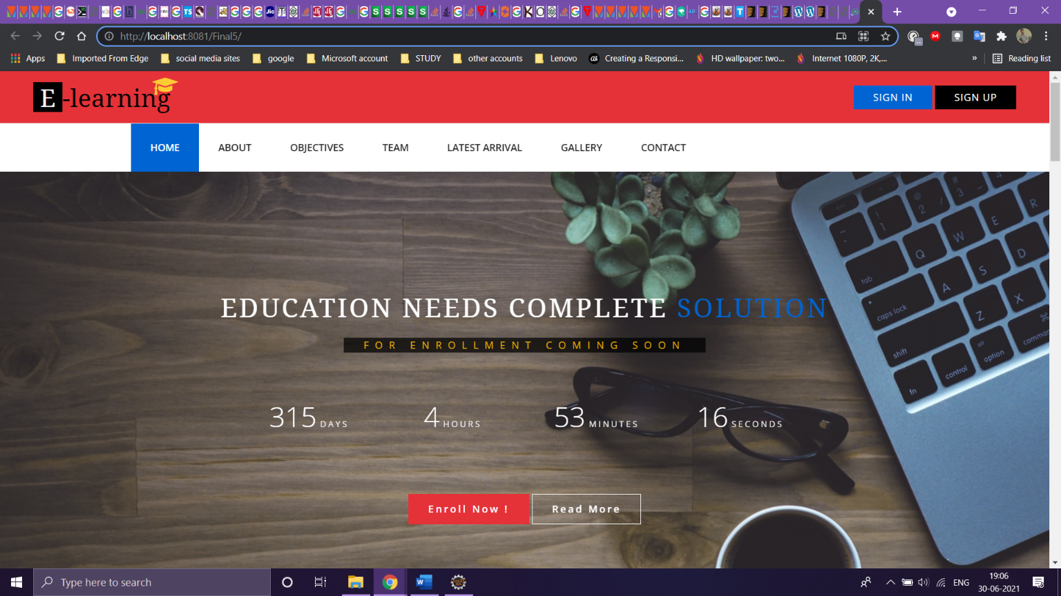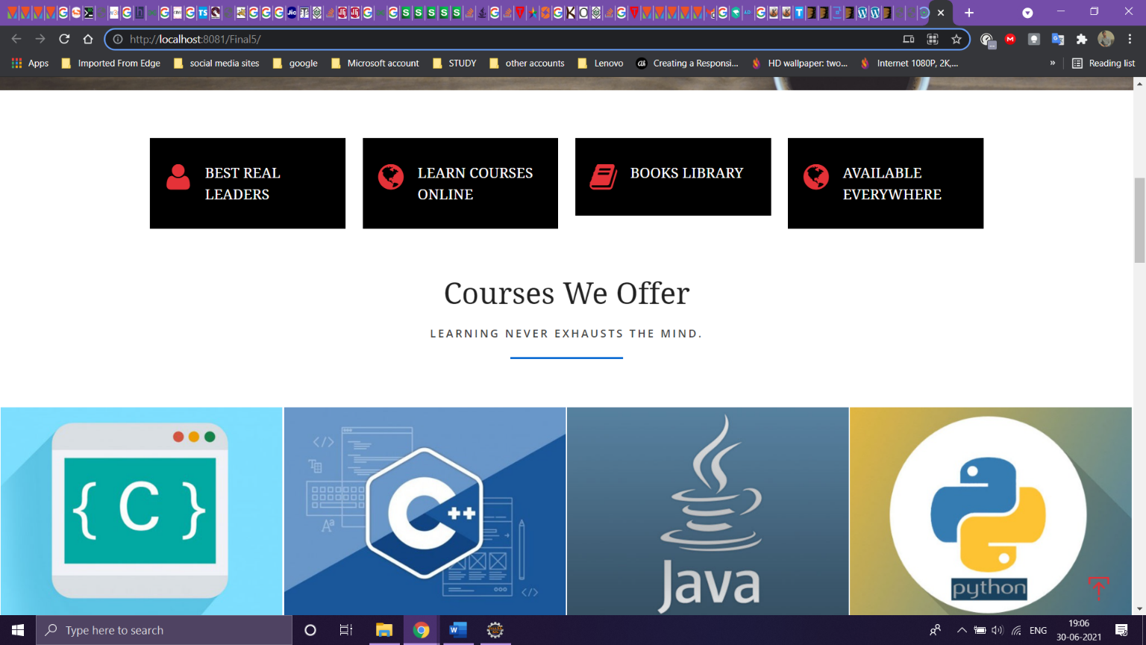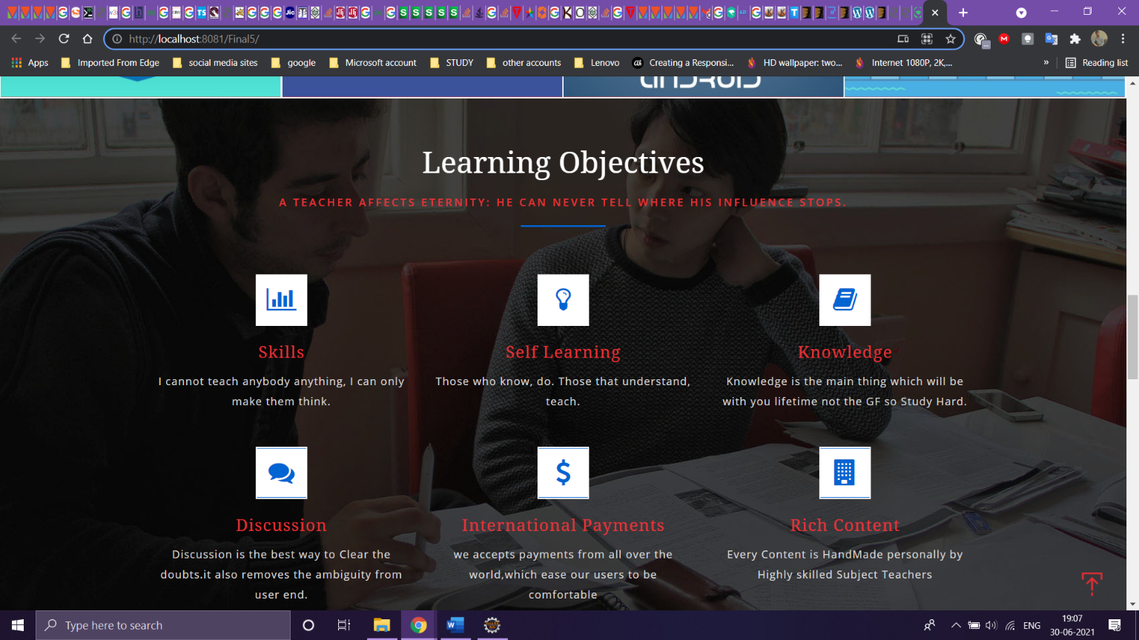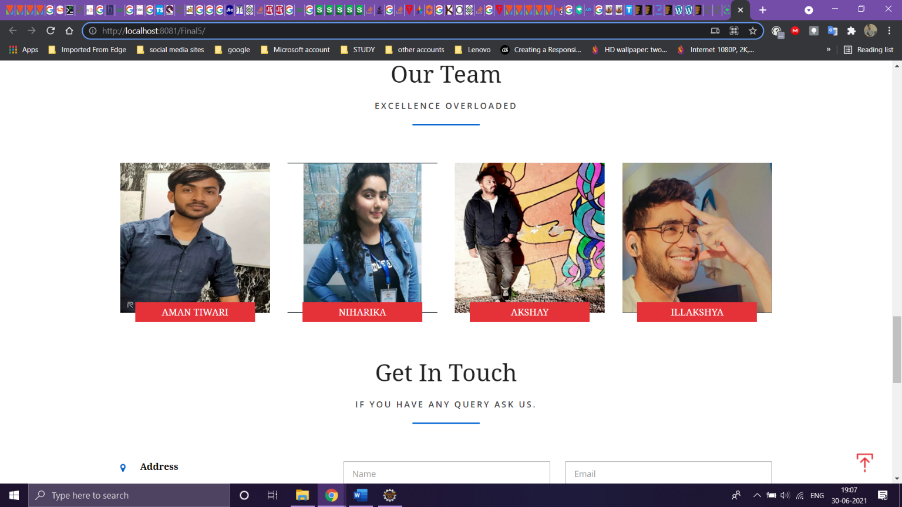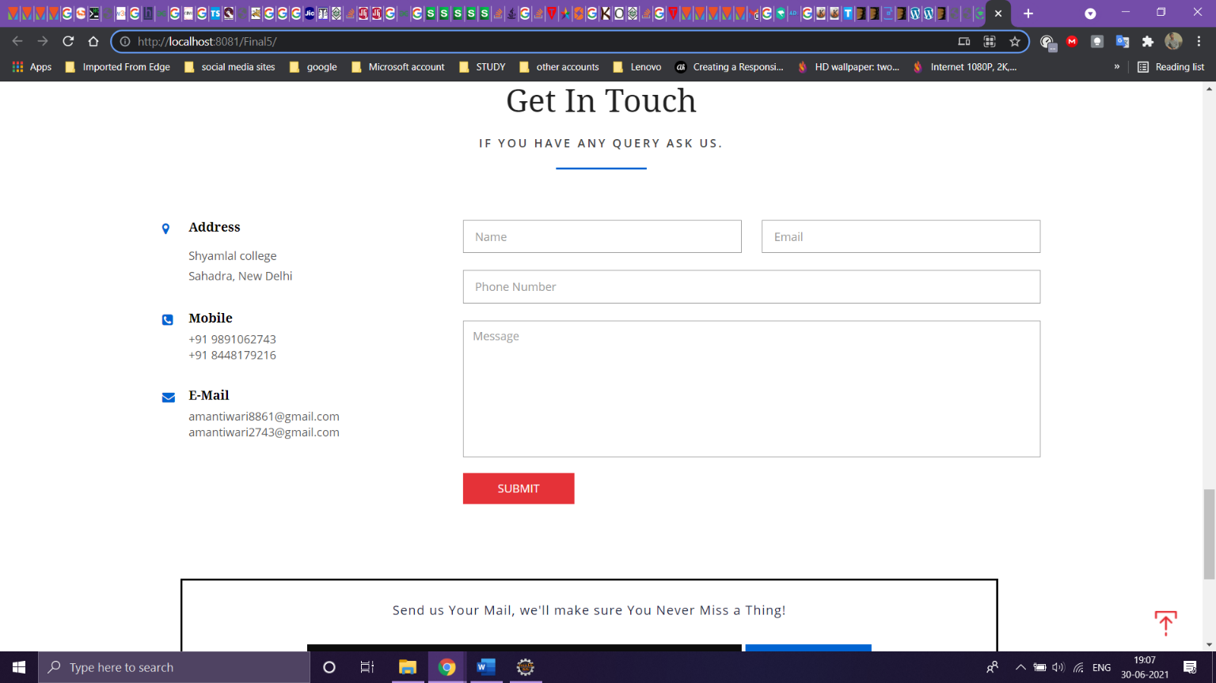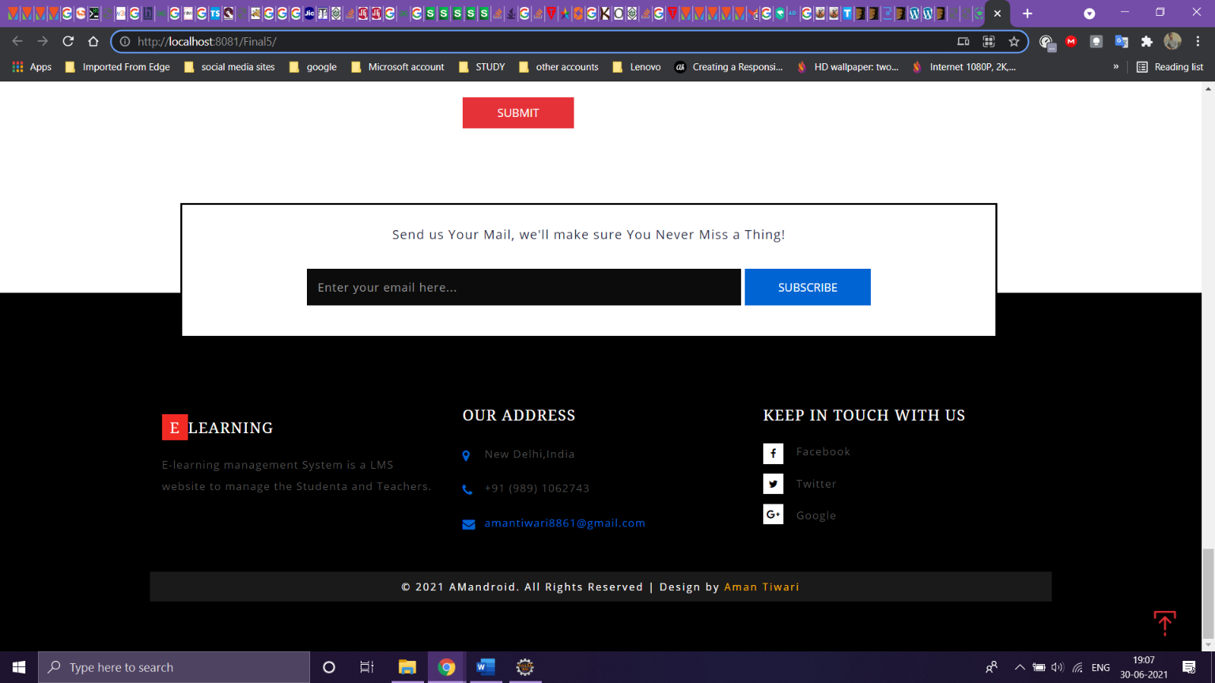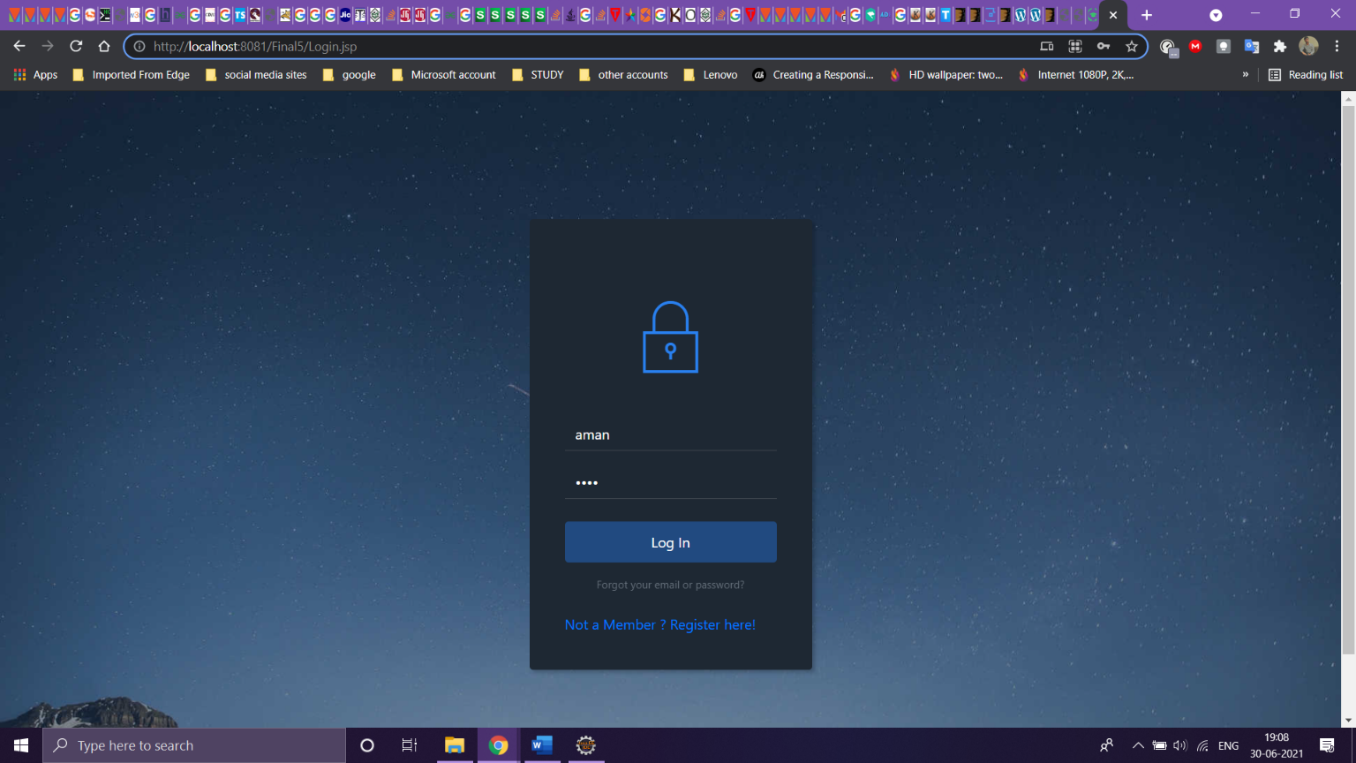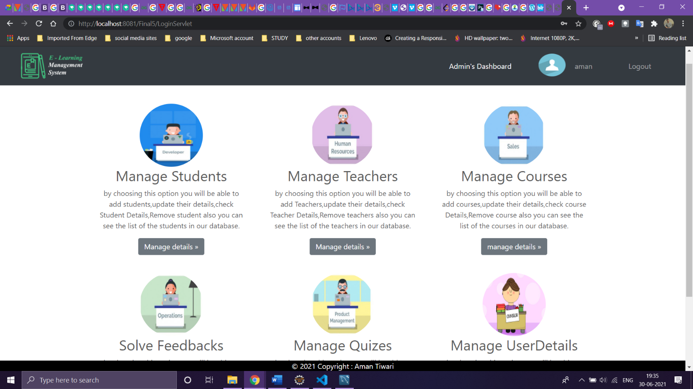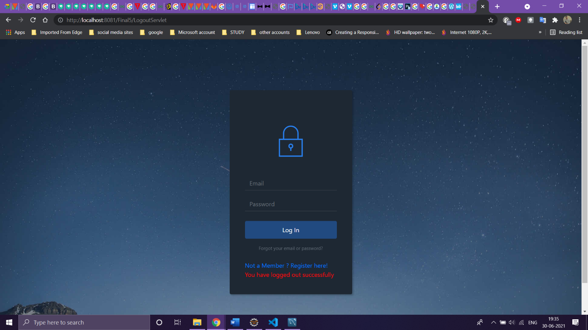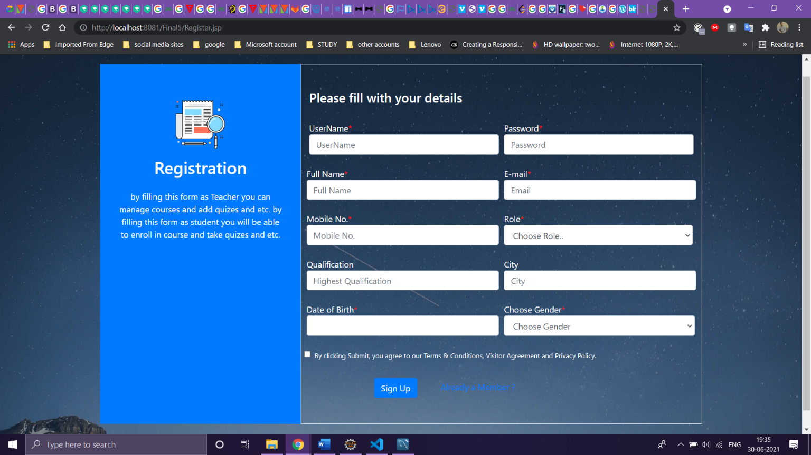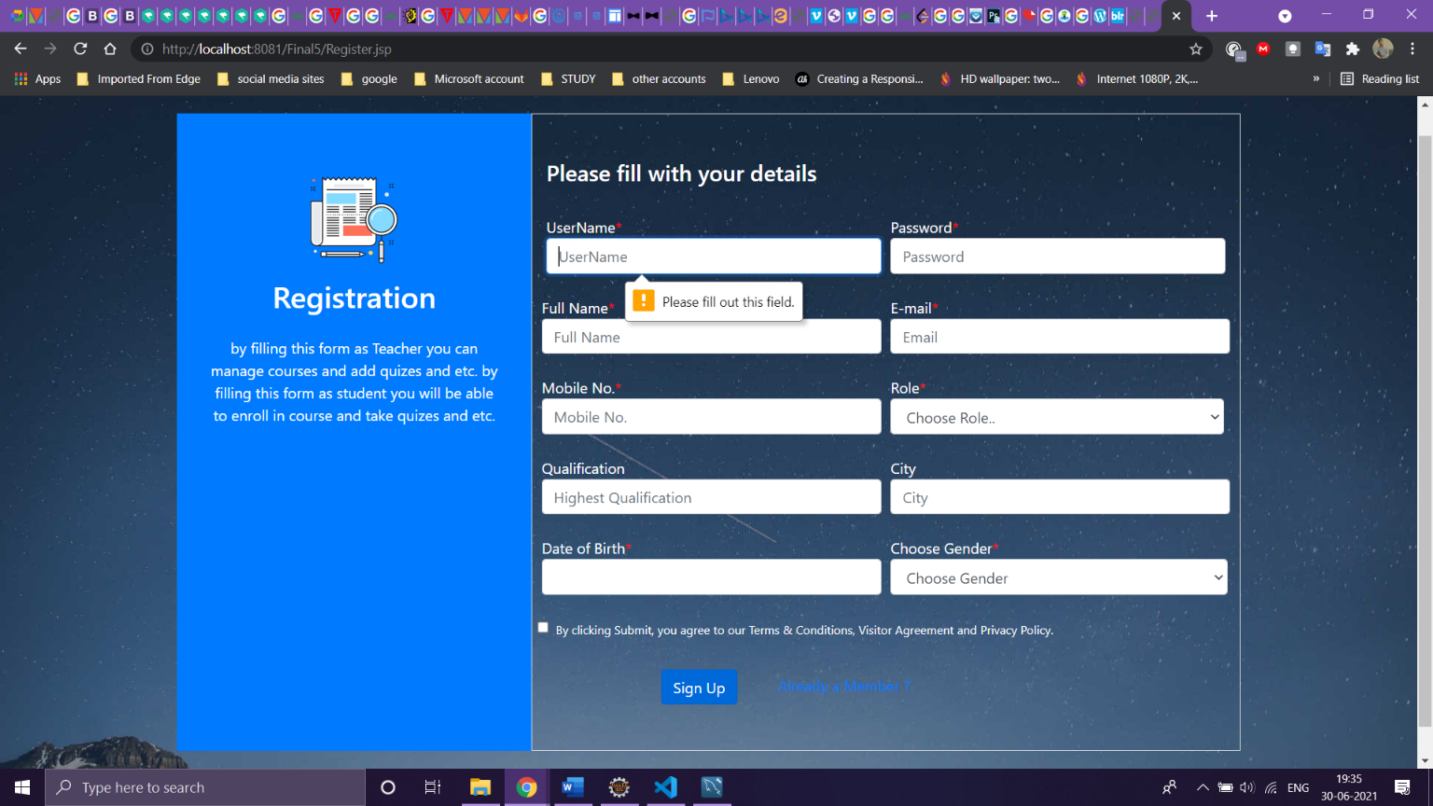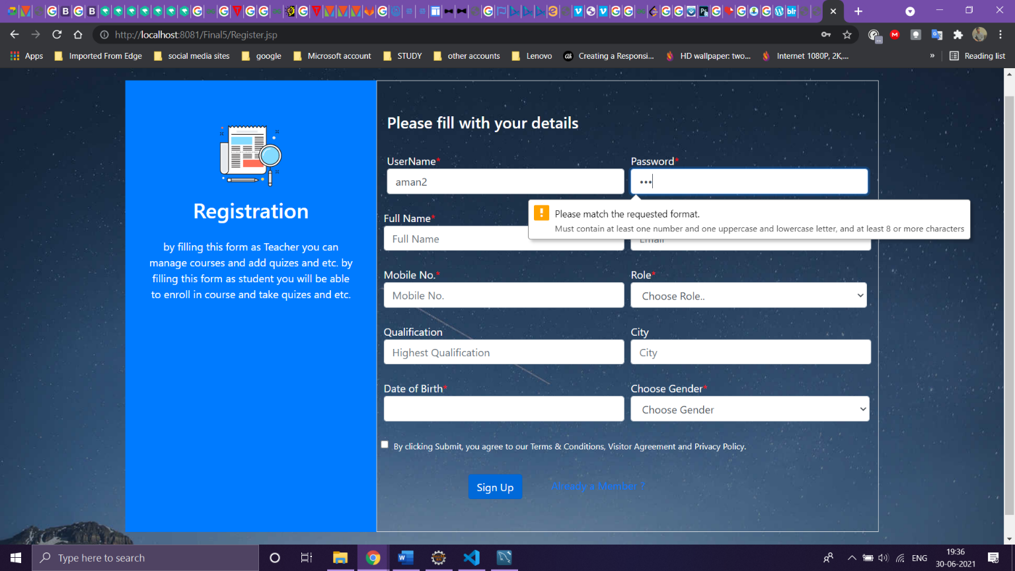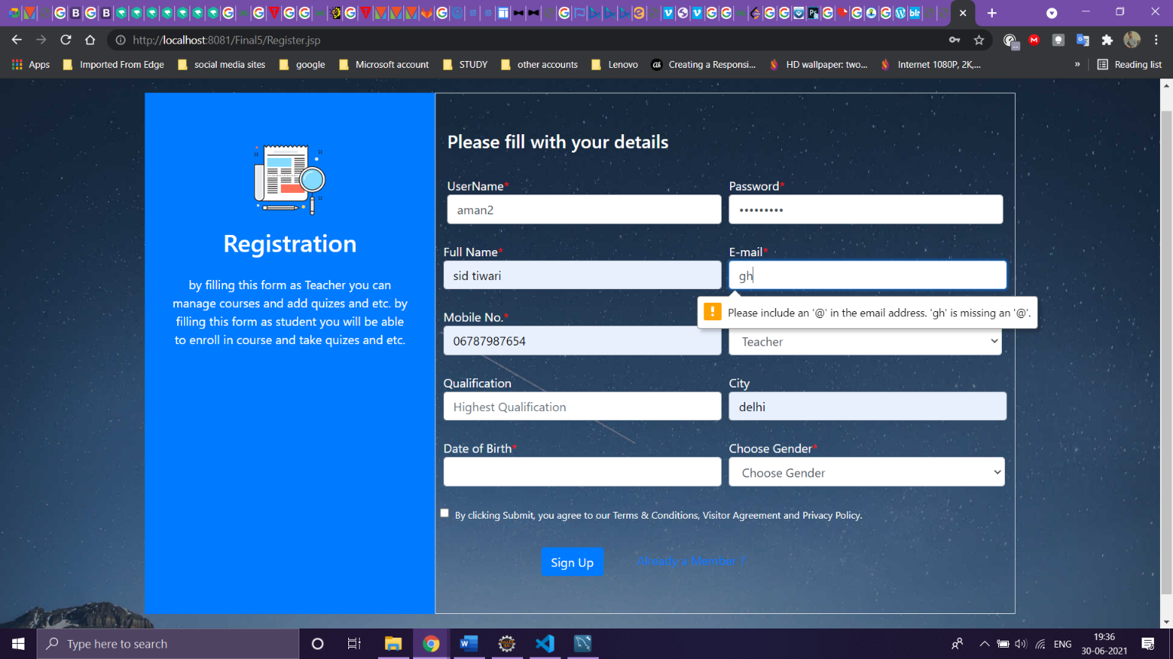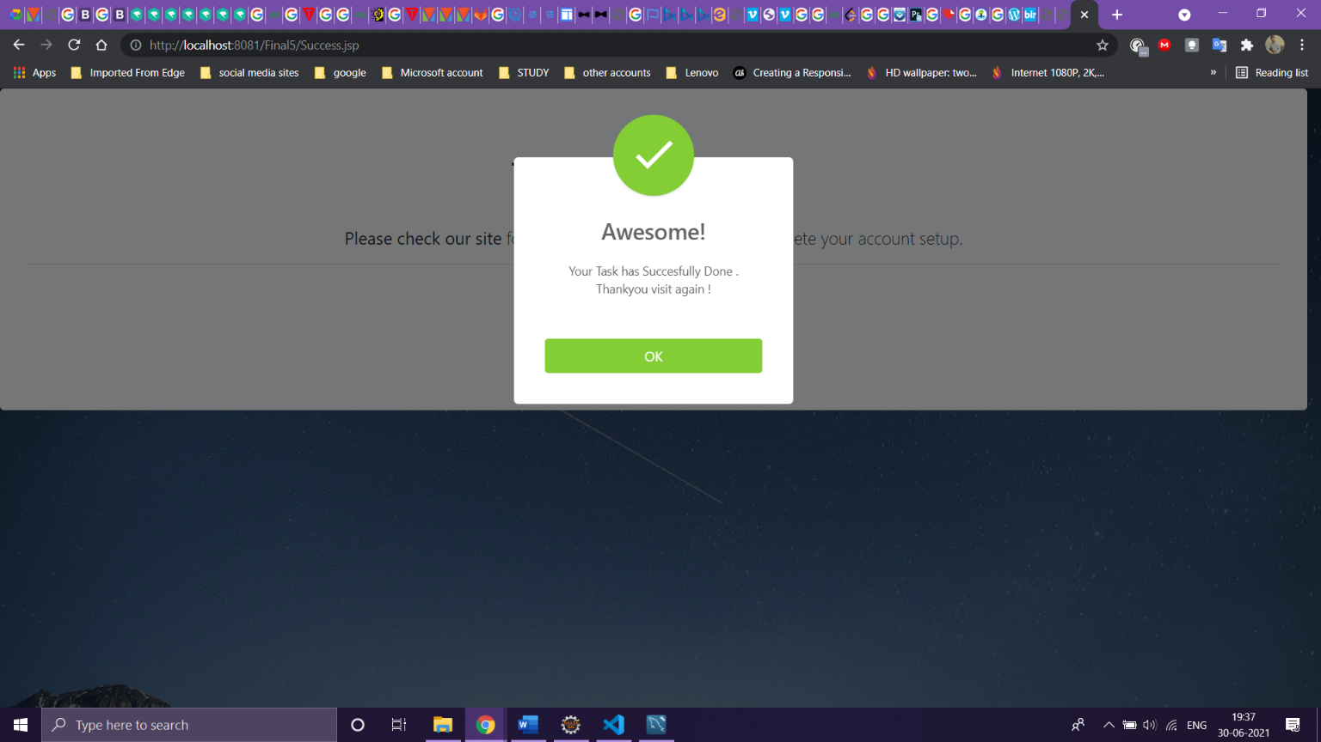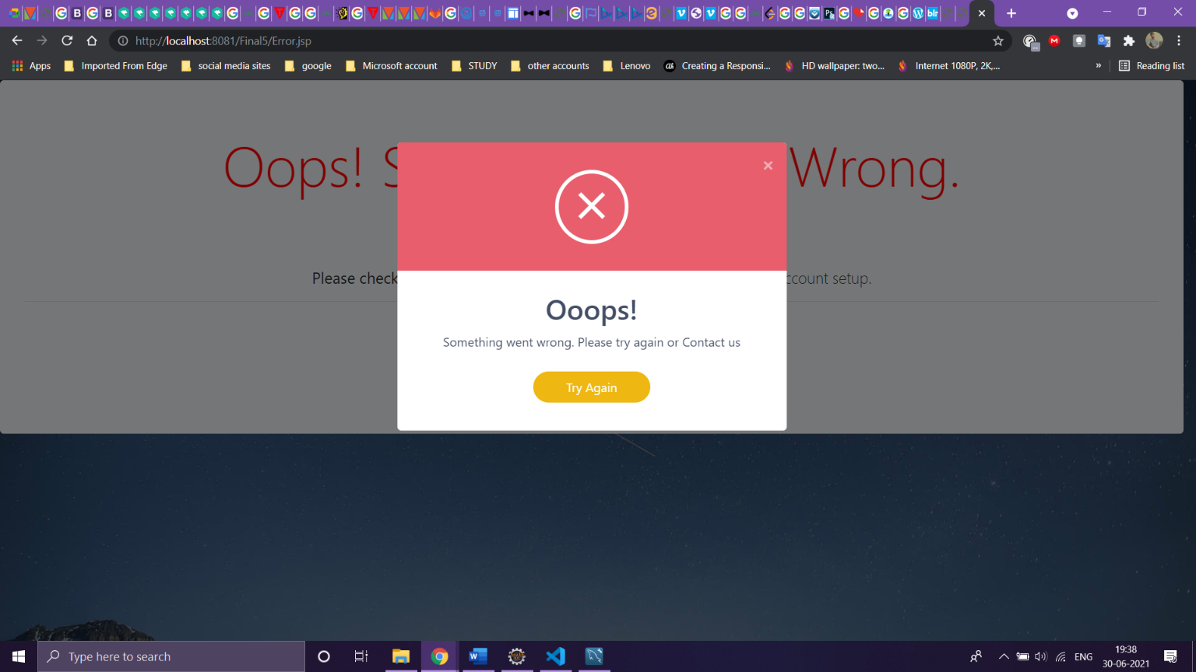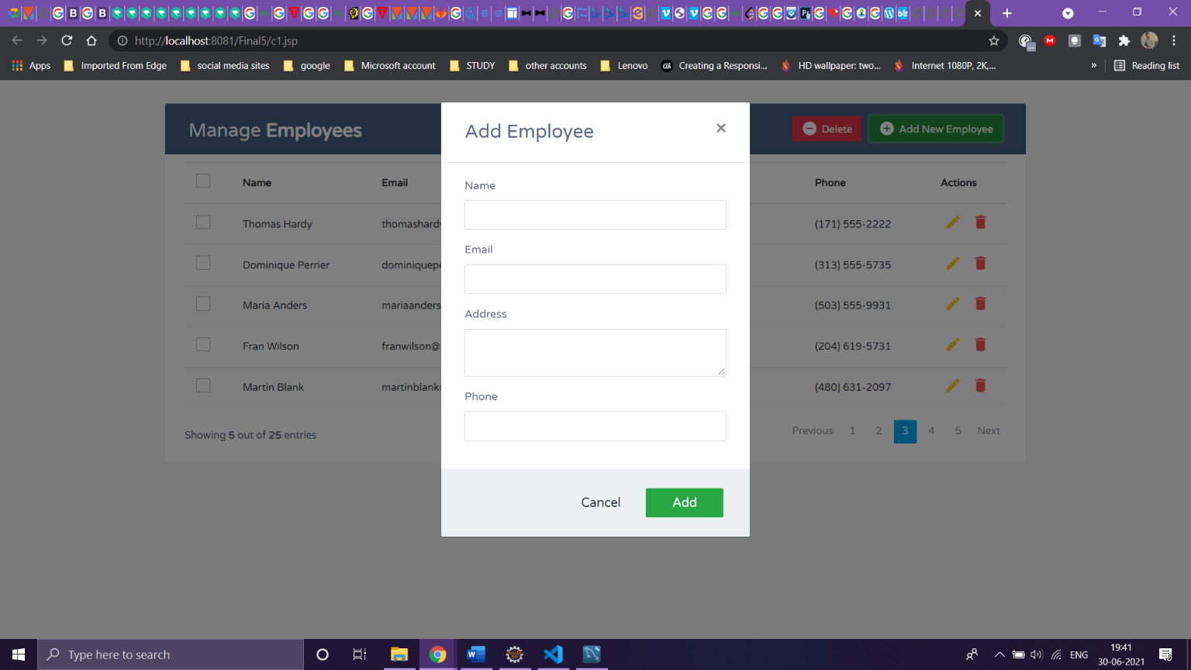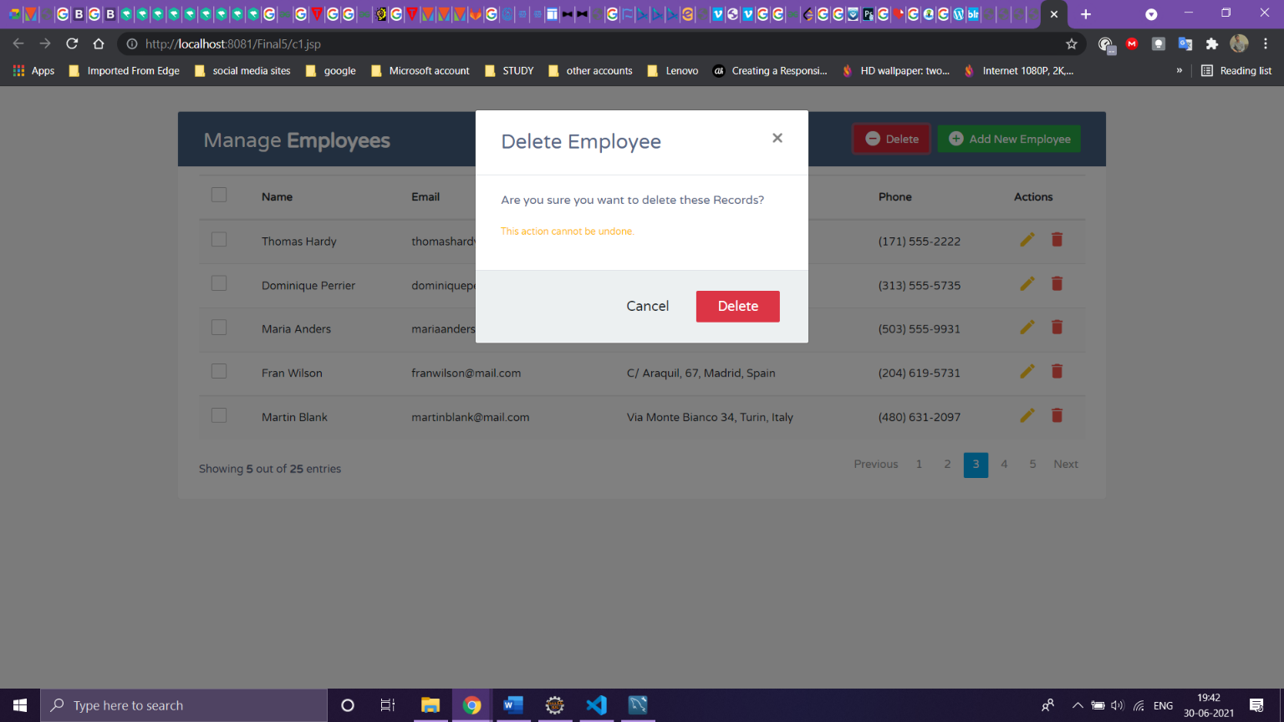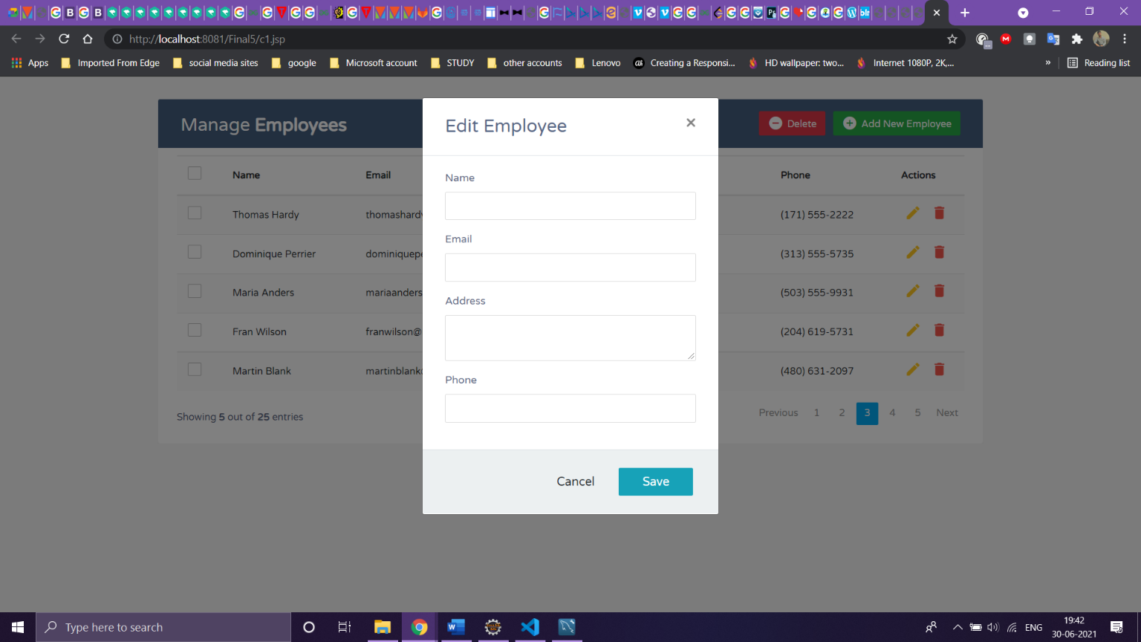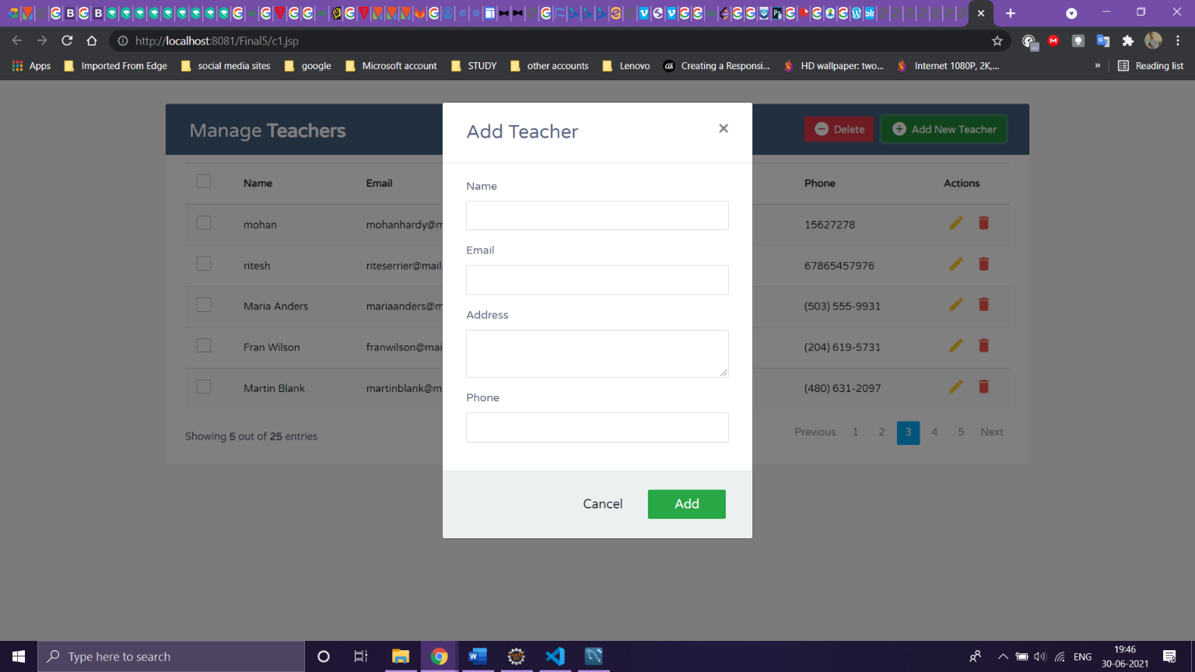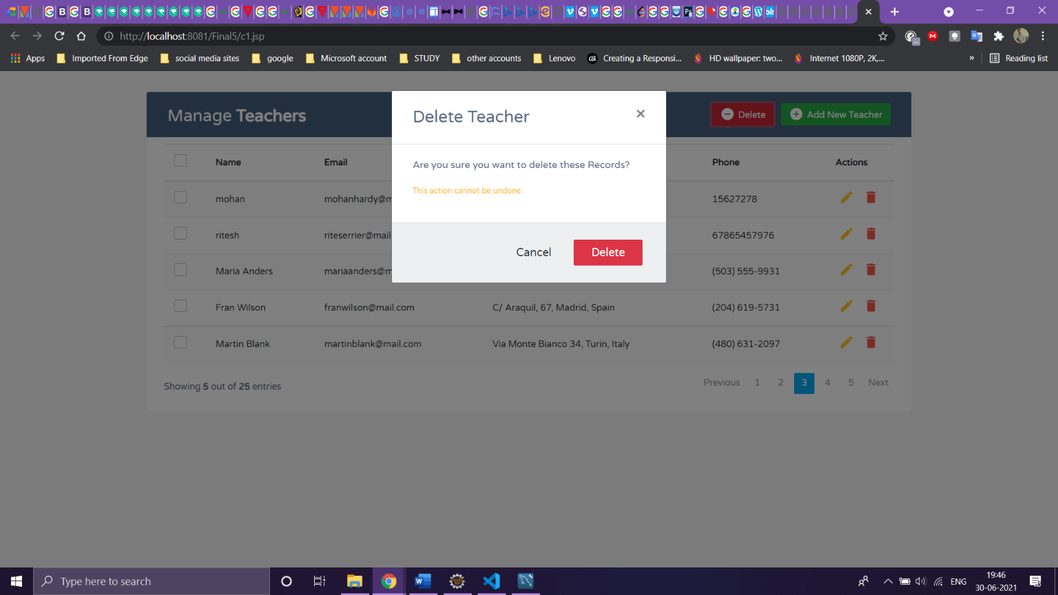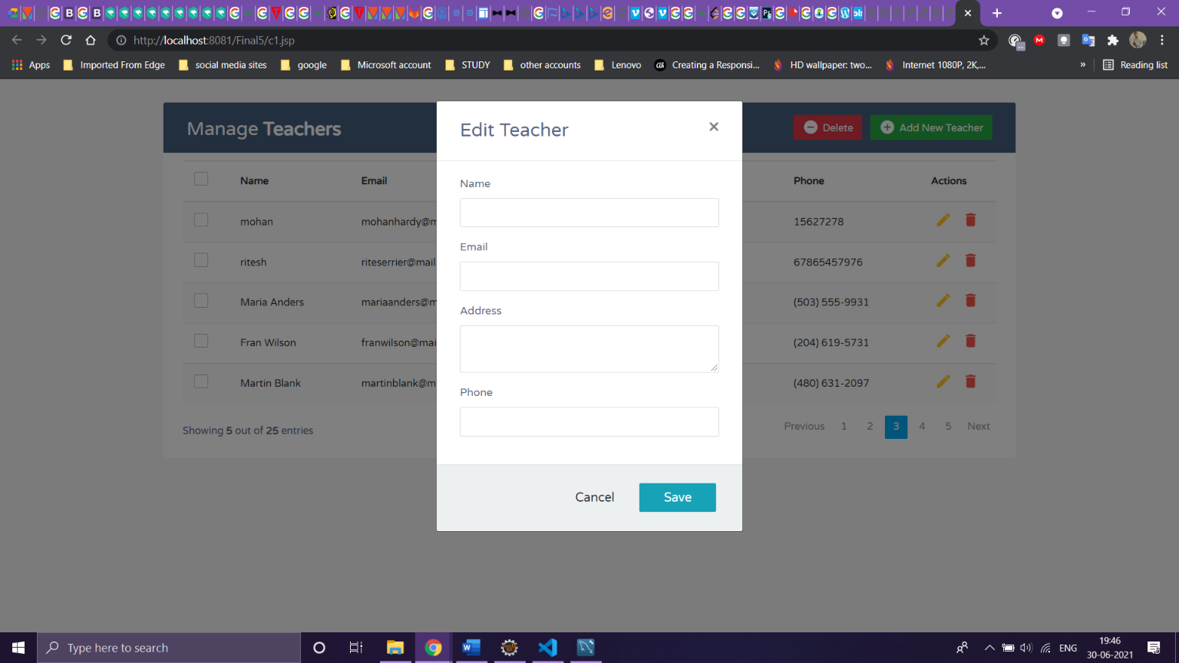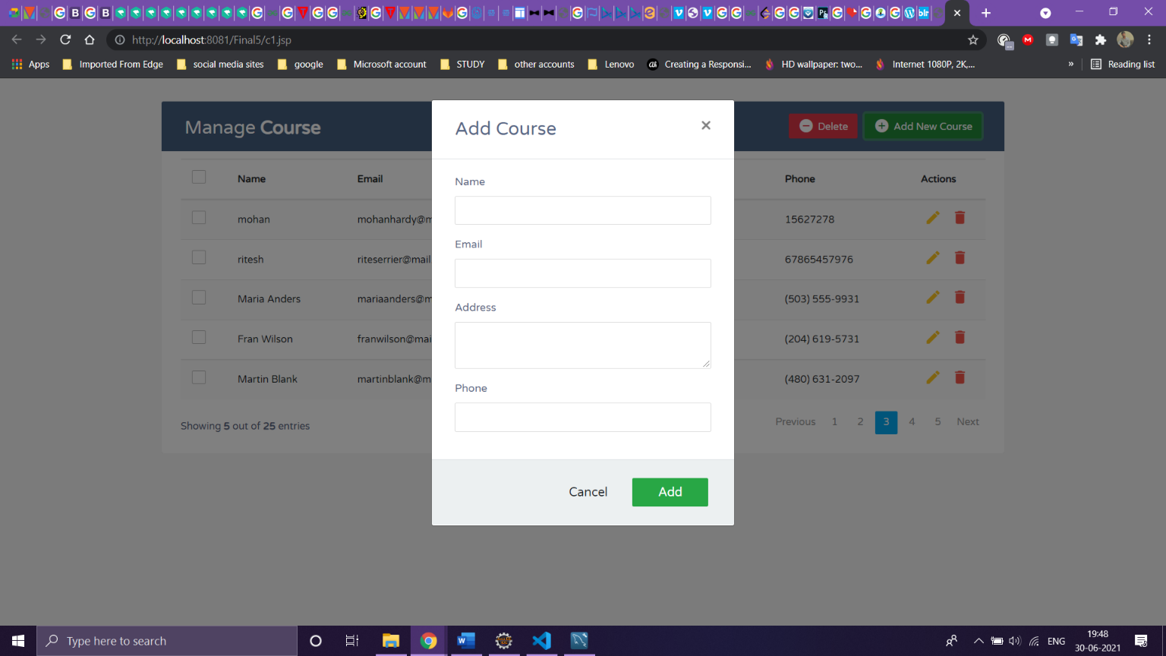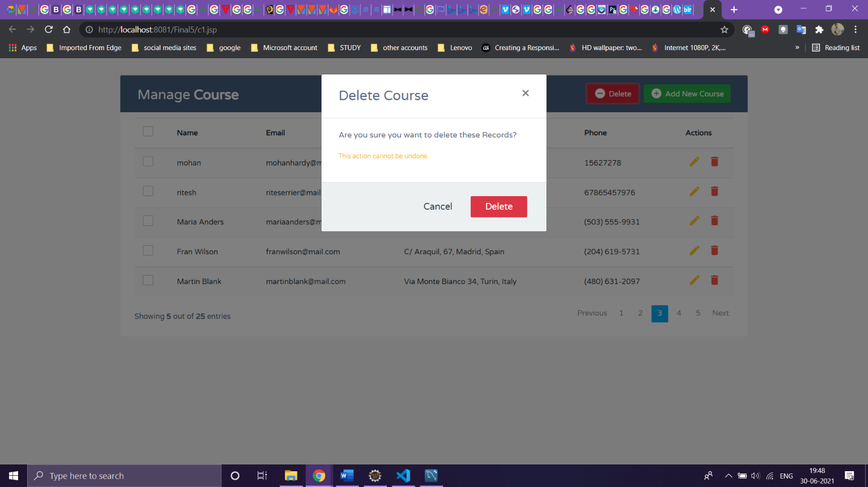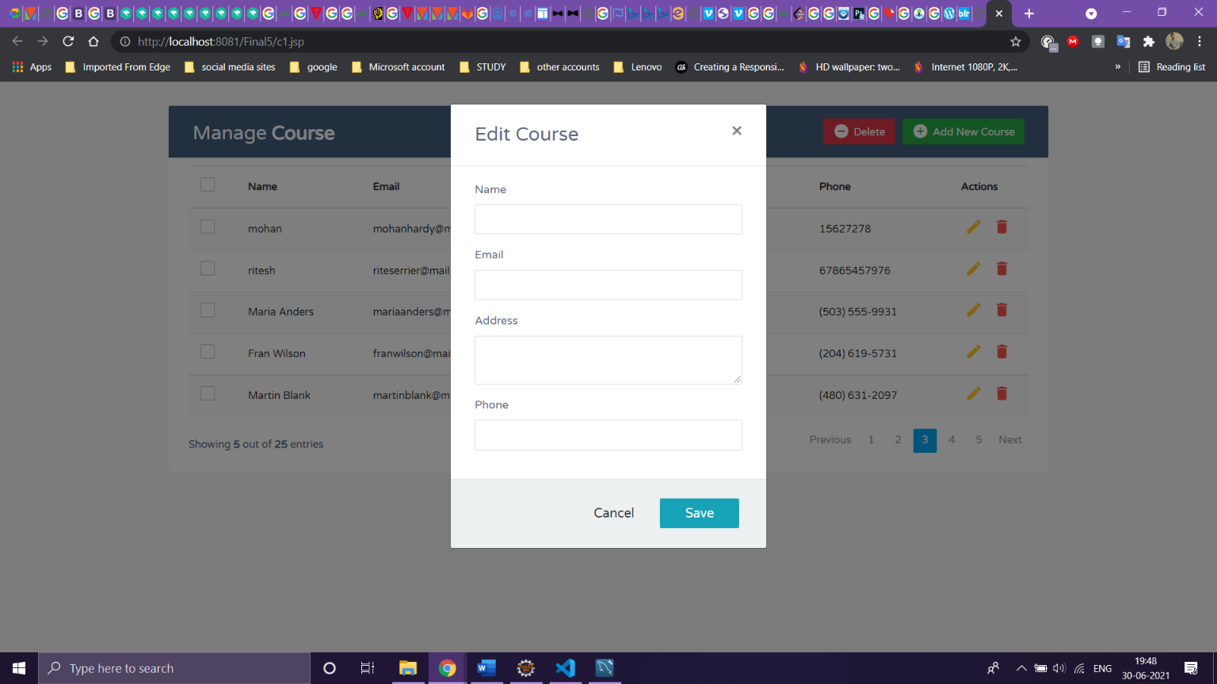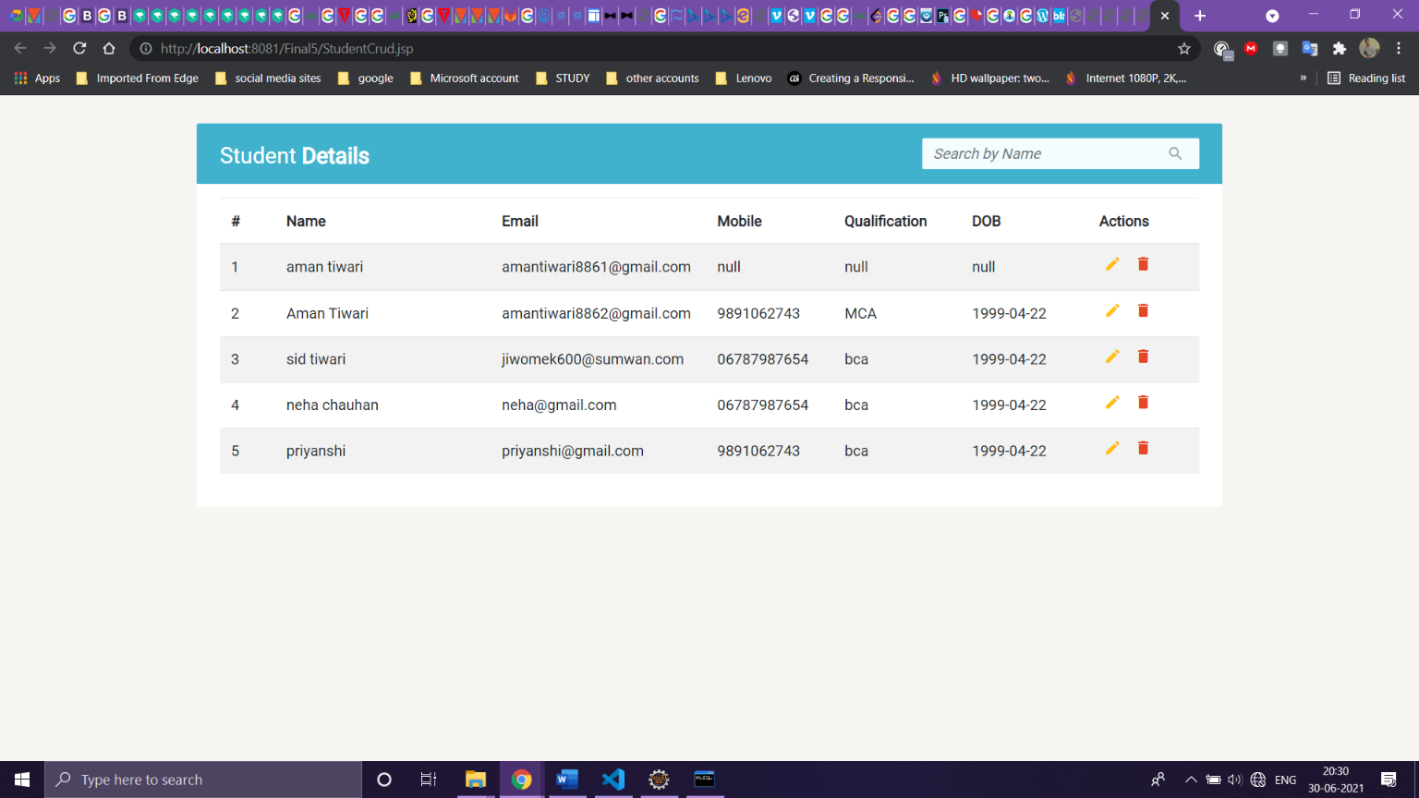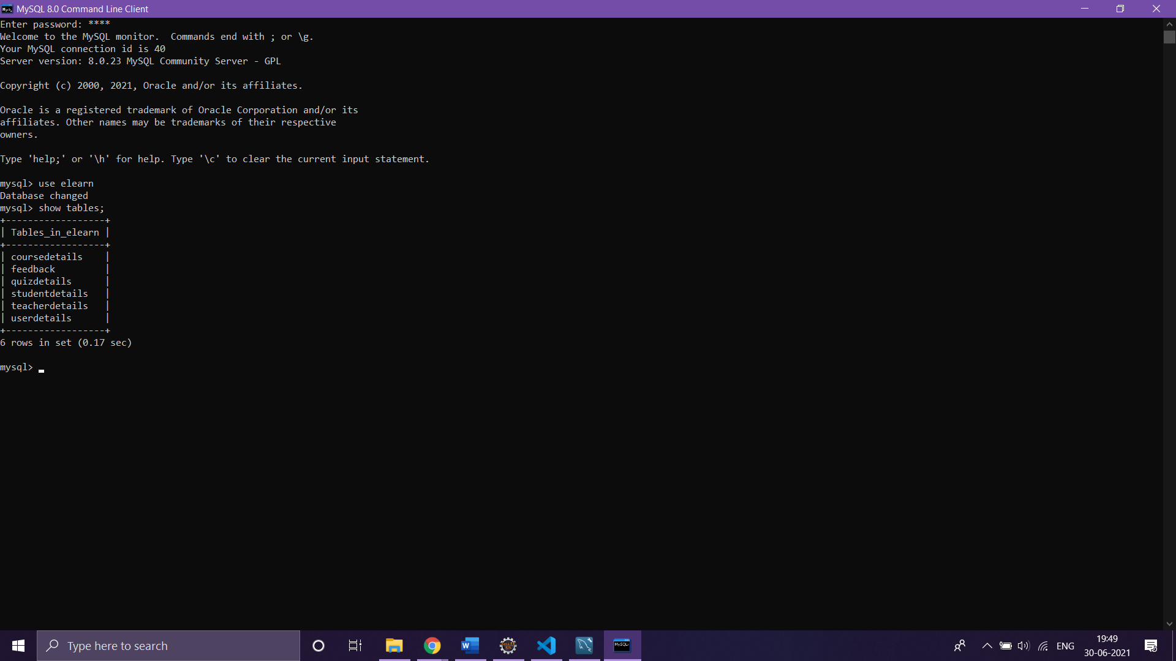

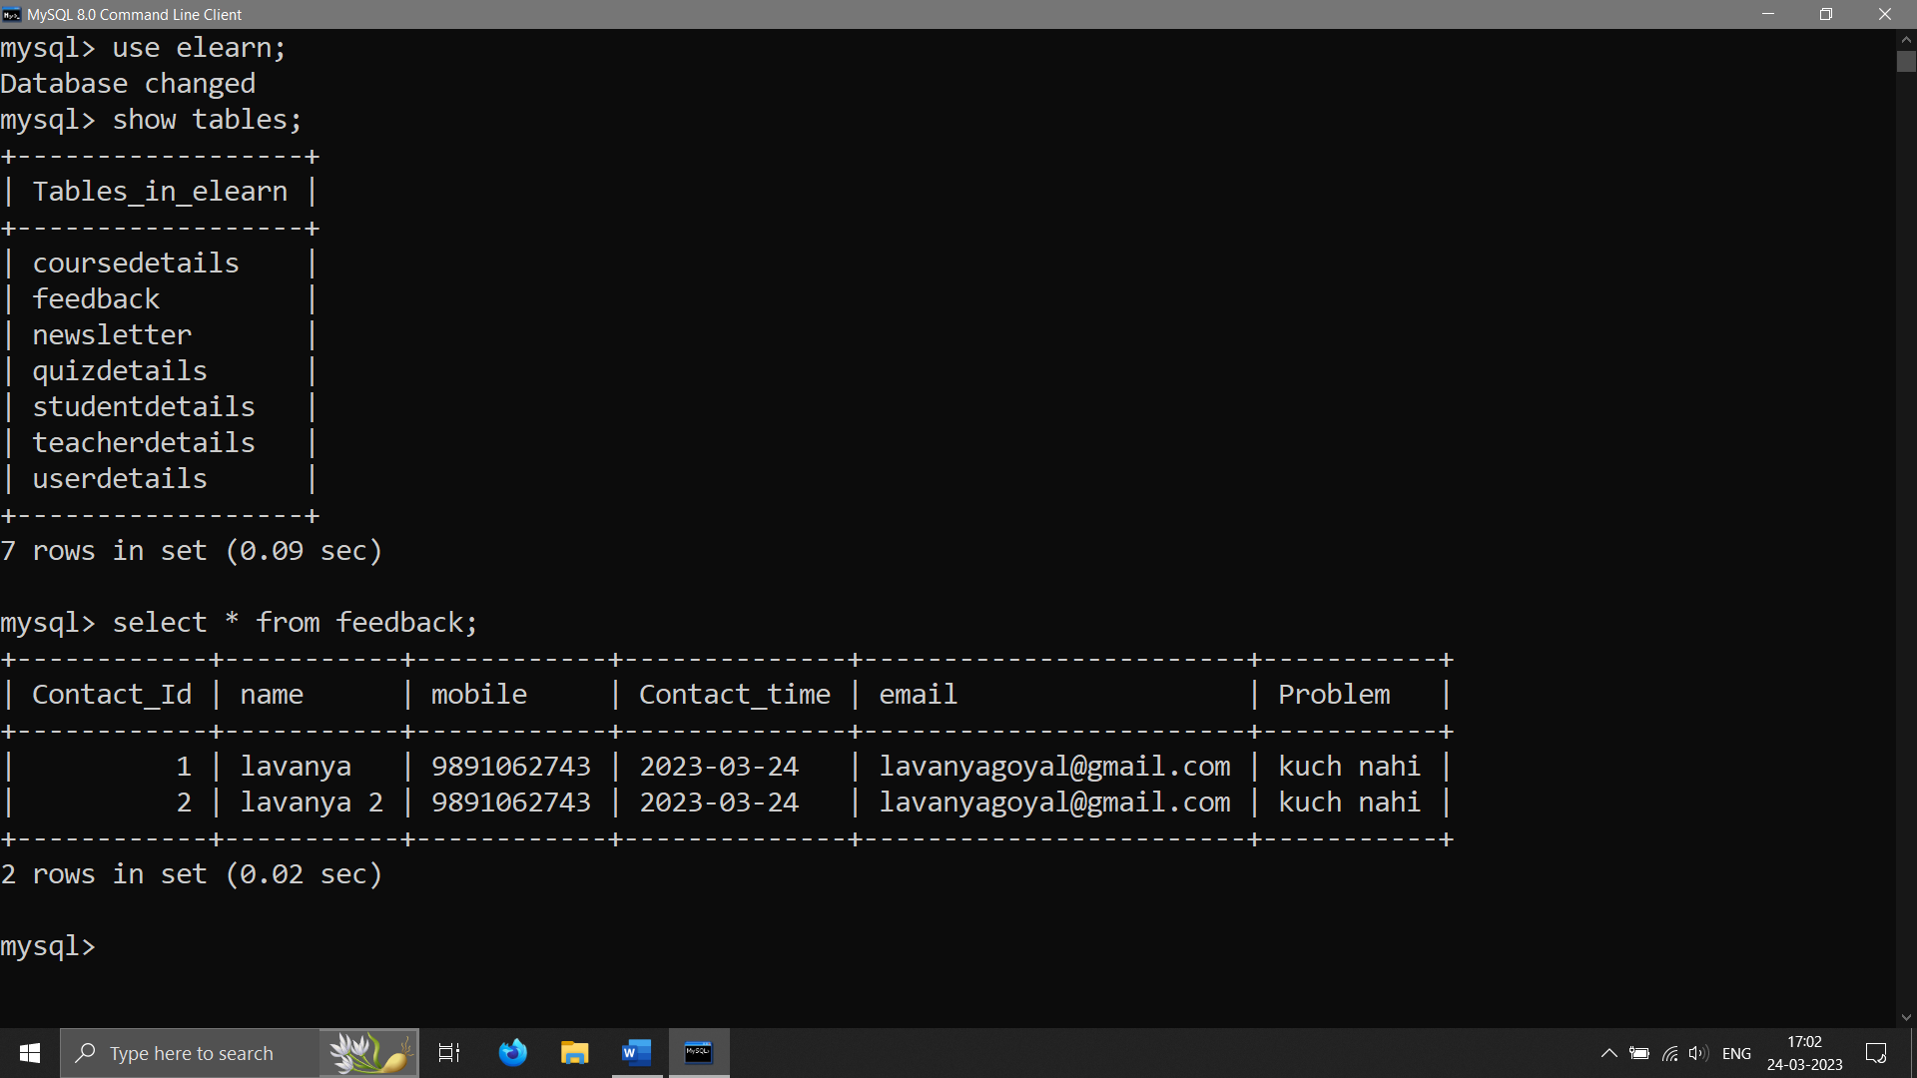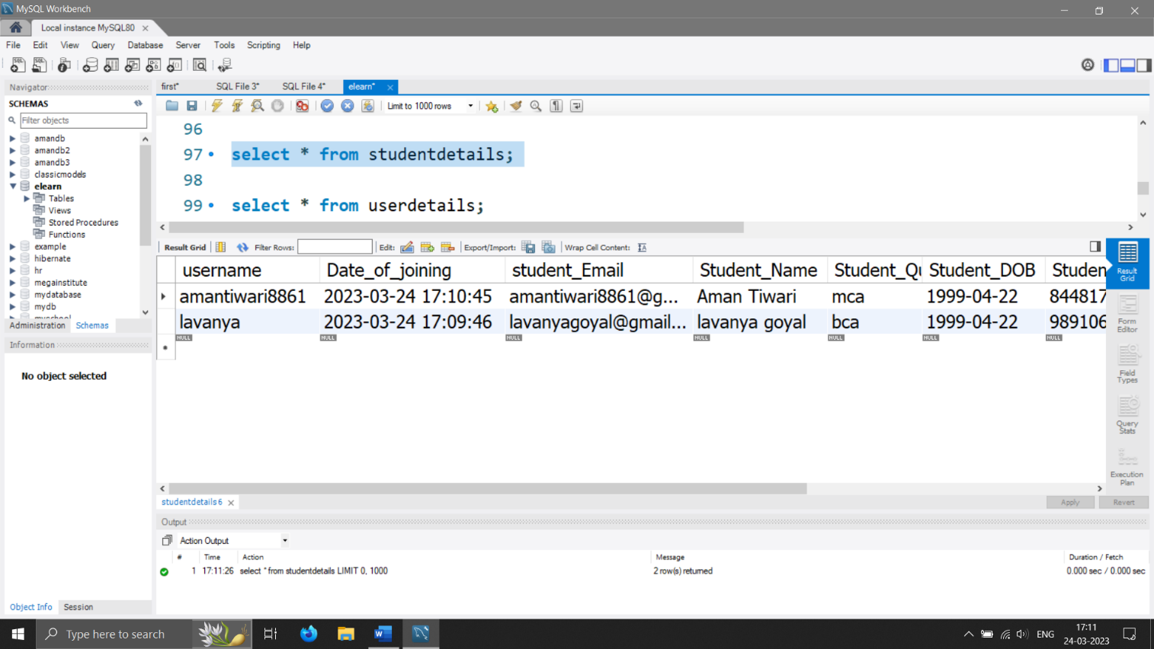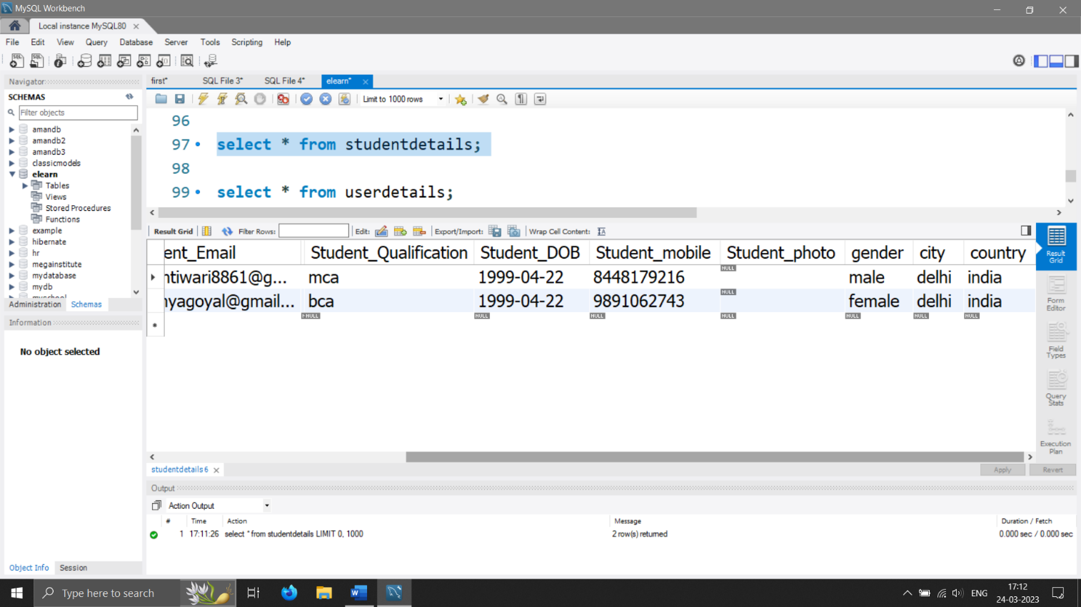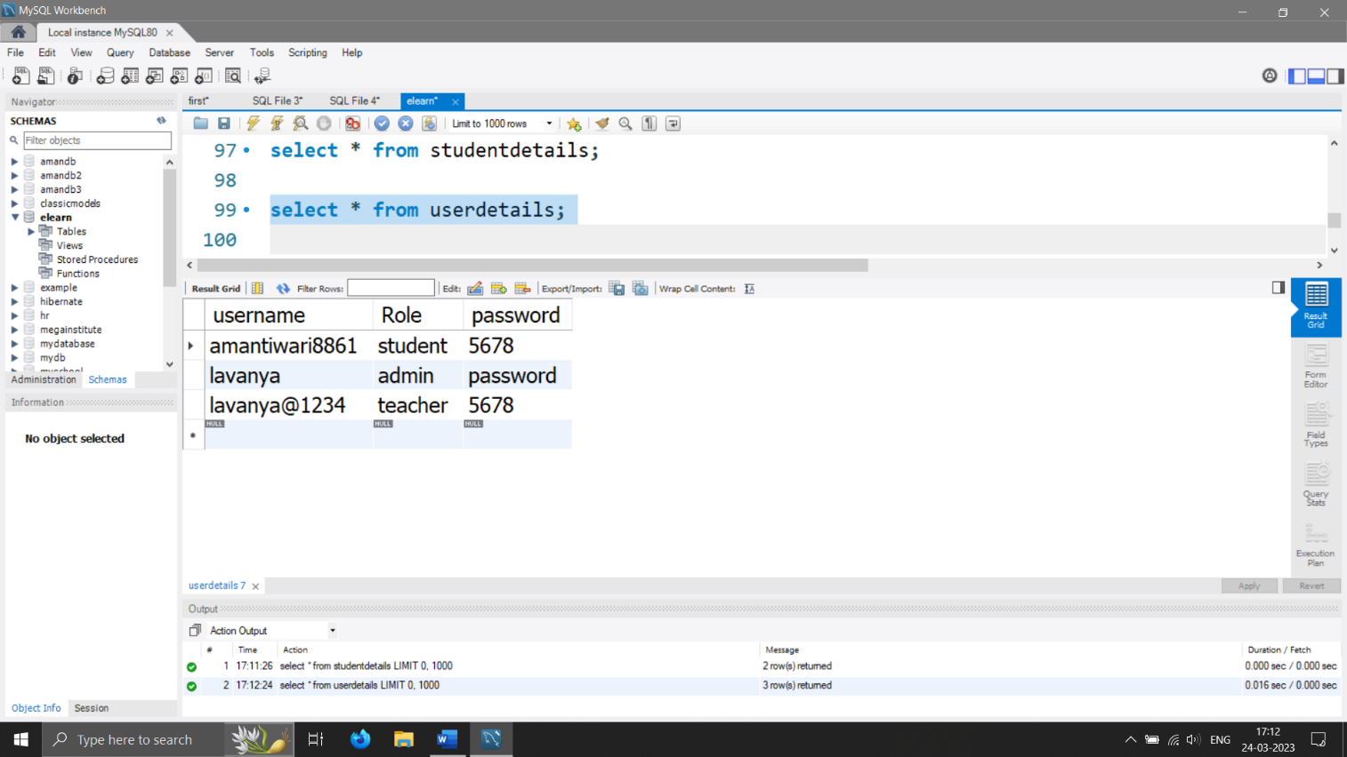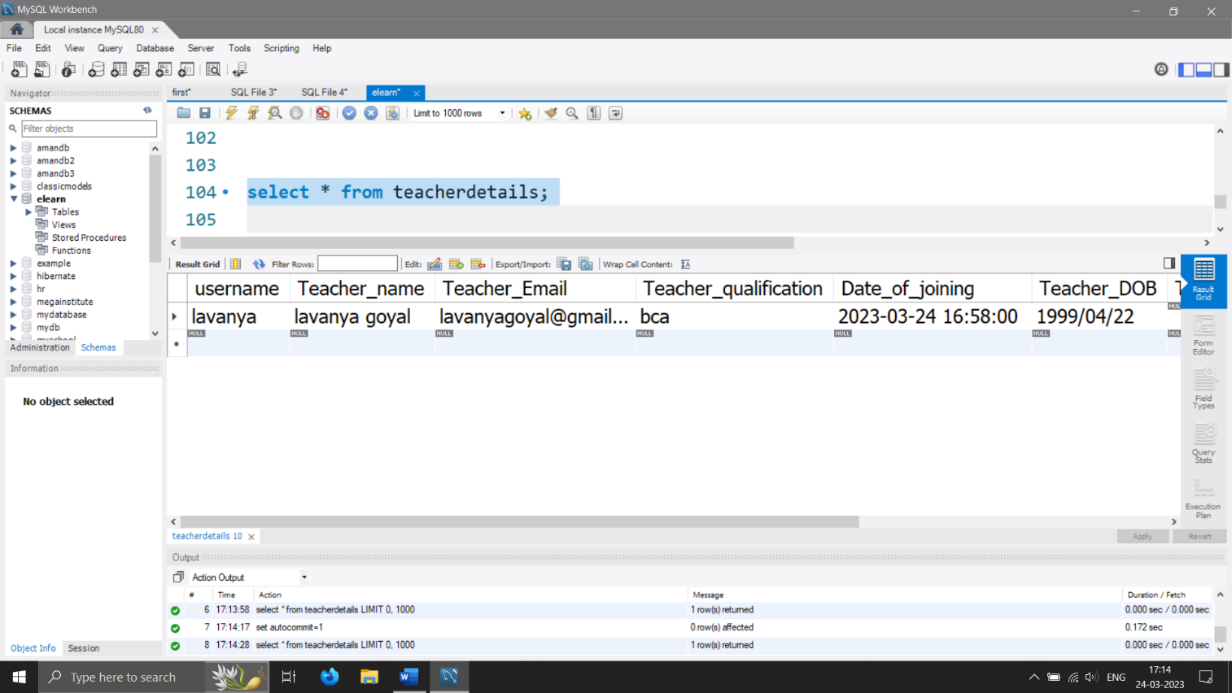

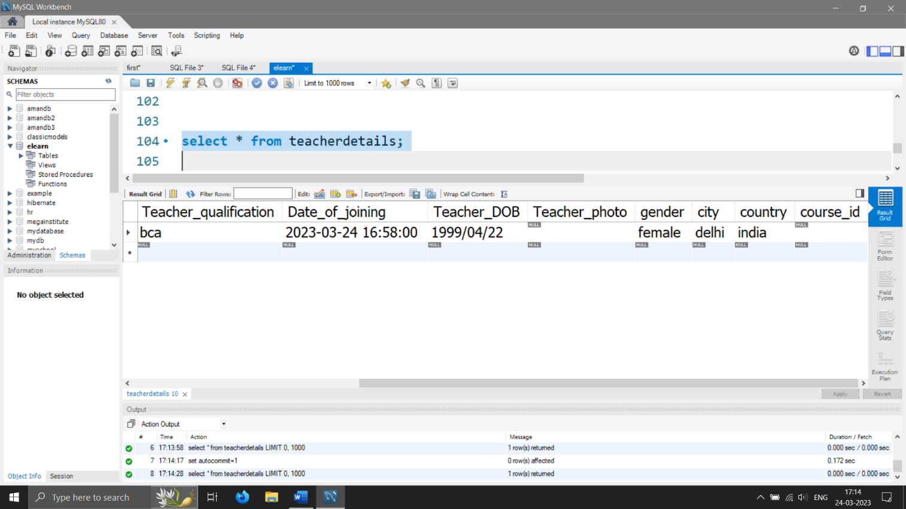

**10.IMPLEMENTATION OF SECURITY**

As computers and other digital devices have become essential to business and commerce, they have also increasingly become a target for attacks. In order for a company or an individual to use a computing device with confidence, they must first be assured that the device is not compromised in any way and that all communications will be secure. In this chapter, we will review the fundamental concepts of information System s security and discuss some of the measures that can be taken to mitigate security threats. We will begin with an overview focusing on how organizations can stay secure. Several different measures that a company can take to improve security will be discussed. We will then follow up by reviewing security precautions that individuals can take in order to secure their personal computing environment.

**The Information Security Triad: Confidentiality, Integrity, Availability (CIA)**

• **Confidentiality**

When protecting information, we want to be able to restrict access to those who are allowed to see it; everyone else should be disallowed from learning anything about its contents. This is the essence of confidentiality. For example, federal law requires that universities restrict access to private student information. The university must be sure that only those who are authorized have access to view the grade records.

• **Integrity**

Integrity is the assurance that the information being accessed has not been altered and truly represents what is intended. Just as a person with integrity means what he or she says and can be trusted to consistently represent the truth, information integrity means information truly represents its intended meaning. Information can lose its integrity through malicious intent, such as when someone who is not authorized makes a change to intentionally misrepresent something. An example of this would be when a hacker is hired to go into the university’s System and change a grade.

Integrity can also be lost unintentionally, such as when a computer power surge corrupts a file or someone authorized to make a change accidentally deletes a file or enters incorrect information.

• **Availability**

Information availability is the third part of the CIA triad. Availability means that information can be accessed and modified by anyone authorized to do so in an appropriate timeframe. Depending on the type of information, appropriate timeframe can mean different things. For example, a stock trader needs information to be available immediately, while a sales person may be happy to get sales numbers for the day in a report the next morning. Companies such as Amazon.com will require their servers to be available twenty-four hours a day, seven days a week. Other companies may not suffer if their web servers are down for a few minutes once in a while.

**Tools for Information Security**

In order to ensure the confidentiality, integrity, and availability of information, organizations can choose from a variety of tools. Each of these tools can be utilized as part of an overall information-security policy, which will be discussed in the next section.

• **Authentication**

The most common way to identify someone is through their physical appearance, but how do we identify someone sitting behind a computer screen or at the ATM? Tools for authentication are used to ensure that the person accessing the information is, indeed, who they present themselves to be.

Authentication can be accomplished by identifying someone through one or more of three factors: something they know, something they have, or something they are. For example, the most common form of authentication today is the user ID and password. In this case, the authentication is done by confirming something that the user knows (their ID and password). But this form of authentication is easy to compromise (see sidebar) and stronger forms of authentication are sometimes needed. Identifying someone only by something they have, such as a key or a card, can also be problematic. When that identifying token is lost or stolen, the identity can be easily stolen. The final factor, something you are, is much harder to compromise. This factor identifies a user through the use of a physical characteristic, such as an eye-scan or fingerprint. Identifying someone through their physical characteristics is called biometrics.

A more secure way to authenticate a user is to do multi-factor authentication. By combining two or more of the factors listed above, it becomes much more difficult for someone to misrepresent themselves.

• **Access Control**

Once a user has been authenticated, the next step is to ensure that they can only access the information resources that are appropriate. This is done through the use of access control. Access control determines which users are authorized to read, modify, add, and/or delete information. Several different access control models exist. Here we will discuss two: the access control list (ACL) and role-based access control (RBAC).

For each information resource that an organization wishes to manage, a list of users who have the ability to take specific actions can be created. This is an access control list, or ACL. For each user, specific capabilities are assigned, such as read, write, delete, or add. Only users with those capabilities are allowed to perform those functions. If a user is not on the list, they have no ability to even know that the information resource exists.

ACLs are simple to understand and maintain. However, they have several drawbacks. The primary drawback is that each information resource is managed separately, so if a security administrator wanted to add or remove a user to a large set of information resources, it would be quite difficult. And as the number of users and resources increase, ACLs become harder to maintain. This has led to an improved method of access control, called role-based access control, or RBAC. With RBAC, instead of giving specific users access rights to an information resource, users are assigned to roles and then those roles are assigned the access. This allows the administrators to manage users and roles separately, simplifying administration and, by extension, improving security.

• **Encryption**

Many times, an organization needs to transmit information over the Internet or transfer it on external media such as a CD or flash drive. In these cases, even with proper authentication and access control, it is possible for an unauthorized person to get access to the data. Encryption is a process of encoding data upon its transmission or storage so that only authorized individuals can read it. This encoding is accomplished by a computer program, which encodes the plain text that needs to be transmitted; then the recipient receives the cipher text and decodes it (decryption). In order for this to work, the sender and receiver need to agree on the method of encoding so that both parties can communicate properly. Both parties share the encryption key, enabling them to encode and decode each other’s messages. This is called symmetric key encryption. This type of encryption is problematic because the key is available in two different places.

An alternative to symmetric key encryption is public key encryption. In public key encryption, two keys are used: a public key and a private key. To send an encrypted message, you obtain the public key, encode the message, and send it. The recipient then uses the private key to decode it. The public key can be given to anyone who wishes to send the recipient a message. Each user simply needs one private key and one public key in order to secure messages. The private key is necessary in order to decrypt something sent with the public key.

**11.Limitation**

For me learning is about interactions and there are three categories of interactions involved.  
Learner – Content. This is the interaction between the learner and the content.  
Learner – Instructor. Conversations and correspondance between the learner and the instructor.  
Learner – Learner. Conversations, collaboration and correspondence between learners.

Most of my learning is, I believe,  based on the last two or the social aspects of learning and it’s these two that I believe are lacking in your typical LMS. For example. Imagine your at school and have a question for your teacher. You enter the building, navigate your way to the only room where questions can asked, its pitch black, you don’t know if there is anyone else there, you ask a question and then repeat the process later on to see if the question has been answered.  Now imagine IT have designed the building, the hallways, the room and the conversation protocols and you may have an understanding of how an LMS limits the scope of social discourse within it’s boundaries.

**12. FUTURE SCOPE AND ENHANCEMENT OF PROJECT**

In a nutshell, it can be summarized that the future scope of the project circles around maintaining information regarding:

* We can add printer in future.
* We can give more advance software for E-learning Management System including more facilities
* We will host the platform on online servers to make it accessible worldwide
* Integrate multiple load balancers to distribute the loads of the system
* Create the master and slave database structure to reduce the overload of the database queries
* Implement the backup mechanism for taking backup of codebase and database on regular basis on different servers

The above mentioned points are the enhancements which can be done to increase the applicability and usage of this project. Here we can maintain the records of Assignment and Student. Also, as it can be seen that now-a-days the players are versatile, i.e. so there is a scope for introducing a method to maintain the E-learning Management System. Enhancements can be done to maintain all the Assignment, Student, TEACHER, QUIZ, and QUESTION.

We have left all the options open so that if there is any other future requirement in the system by the user for the enhancement of the system then it is possible to implement them. In the last we would like to thanks all the persons involved in the development of the system directly or indirectly. We hope that the project will serve its purpose for which it is develop there by underlining success of process.

13.BIBLIOGRAPHY

**Websites**

* <https://www.mysqltutorial.org/>
* <https://www.tutorialspoint.com/>
* <https://javatpoint.com/>
* <https://W3schools.com/>
* <https://edureka.co/>

**Books**

* Black book Core and Advance java
* Head First (JAVA)
* HTML & CSS: Design and Build Web Sites
* Head First SQL: Your Brain on SQL
* SQL Bible, 2nd Edition (Paperback)
* Java The Complete Reference, 11th Edition - Herbert Scheldt